Good Shepherd Lutheran Church
Pastor: Rev. Katie Anderson | Music Director: Rev. Lois Swanson
Pastor’s Cell: (715) 245-1943 | Office Phone: (715) 387-2731
Pastor Email: gslcwi.pastor@gmail.com | Office Email: gslcwi.office@gmail.com
Website: GoodShepherdMarshfield.org | www.facebook.com/gslcwi
3rd Sunday after Pentecost
June 18, 2023, 9:00 am
Introduction to the day…
Moses tells the Israelites that they are called to be a priestly kingdom and a holy people. Jesus sends out the disciples as laborers into the harvest. In baptism we too are anointed for ministry, sharing God’s compassion with our needy world. From the Lord’s table we go forth to proclaim the good news, to heal the sick, and to share our bread with the hungry.
ANNOUNCEMENTS
GATHERING
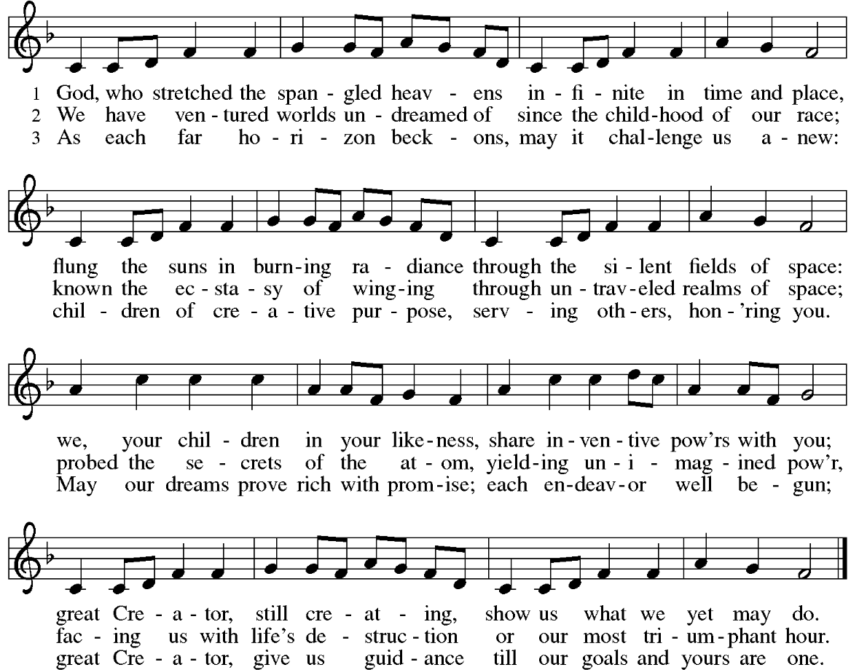
GATHERING SONG God, Who Stretched the Spangled Heavens ELW 771

CONFESSION AND FORGIVENESS
Blessed be the holy Trinity,☩ one God, who greets us in this and every season,
whose word never fails, whose promise is sure.
Amen.
Let us confess our sin in the presence of God and of our neighbors.
Merciful God,
we confess that we have sinned. We have hurt our community.
We have squandered your blessings. We have hoarded your bounty.
In the name of Jesus, forgive us and grant us your mercy.
Silence is kept for reflection.
Righteous God,
we confess that we have sinned. We have failed to be honest.
We have lacked the courage to speak. We have spoken falsely.
In the name of Jesus, forgive us and grant us your mercy.
Silence is kept for reflection.
God is a cup of cold water when we thirst. God offers boundless grace when we fail.
Claim the gift of God’s mercy: you are freed and forgiven in the name of ☩ Jesus Christ.
Amen.
PRAYER OF THE DAY
God of compassion, you have opened the way for us and brought us to yourself. Pour your love into our hearts, so that overflowing with joy, we may freely share the blessings of your realm and faithfully proclaim the good news of your Son, Jesus Christ, our Savior and Lord. Amen.
CHILDREN’S MESSAGE
SCRIPTURE READINGS
FIRST READING: Exodus 19:2-8a
²[The Israelites] had journeyed from Rephidim, entered the wilderness of Sinai, and camped in the wilderness; Israel camped there in front of the mountain.³Then Moses went up to God; the Lord called to him from the mountain, saying, “Thus you shall say to the house of Jacob, and tell the Israelites: ⁴You have seen what I did to the Egyptians, and how I bore you on eagles’ wings and brought you to myself. ⁵Now therefore, if you obey my voice and keep my covenant, you shall be my treasured possession out of all the peoples. Indeed, the whole earth is mine, ⁶but you shall be for me a priestly kingdom and a holy nation. These are the words that you shall speak to the Israelites.”
⁷So Moses came, summoned the elders of the people, and set before them all these words that the Lord had commanded him. ^{8a}The people all answered as one: “Everything that the Lord has spoken we will do.”
Word of God, word of life.
Thanks be to God.
PSALM: Psalm 100
¹Make a joyful noise to the Lord, all you lands!
²Serve the Lord with gladness; come into God’s presence with a song.
³Know that the Lord is God, our maker to whom we belong;
we are God’s people and the sheep of God’s pasture.
⁴Enter the gates of the Lord with thanksgiving and the courts with praise;
give thanks and bless God’s holy name.
⁵Good indeed is the Lord, whose steadfast love is everlasting,
whose faithfulness endures from age to age.
SECOND READING: Romans 5:1-8
¹Since we are justified by faith, we have peace with God through our Lord Jesus Christ, ²through whom we have obtained access to this grace in which we stand; and we boast in our hope of sharing the glory of God. ³And not only that, but we also boast in our sufferings, knowing that suffering produces endurance, ⁴and endurance produces character, and character produces hope, ⁵and hope does not disappoint us, because God’s love has been poured into our hearts through the Holy Spirit that has been given to us.
⁶For while we were still weak, at the right time Christ died for the ungodly. ⁷Indeed, rarely will anyone die for a righteous person—though perhaps for a good person someone might actually dare to die. ⁸But God proves his love for us in that while we still were sinners Christ died for us. Word of God, word of life.
Thanks be to God.
GOSPEL ACCLAMATION

GOSPEL: Matthew 9:35—10:8 [9-23]
³⁵Jesus went about all the cities and villages, teaching in their synagogues, and proclaiming the good news of the kingdom, and curing every disease and every sickness. ³⁶When he saw the crowds, he had compassion for them, because they were harassed and helpless, like sheep without a shepherd. ³⁷Then he said to his disciples, “The harvest is plentiful, but the laborers are few; ³⁸therefore ask the Lord of the harvest to send out laborers into his harvest.”
^{10:1}Then Jesus summoned his twelve disciples and gave them authority over unclean spirits, to cast them out, and to cure every disease and every sickness. ²These are the names of the twelve apostles: first, Simon, also known as Peter, and his brother Andrew; James son of Zebedee, and his brother John; ³Philip and Bartholomew; Thomas and Matthew the tax collector; James son of Alphaeus, and Thaddaeus; ⁴Simon the Cananaean, and Judas Iscariot, the one who betrayed him.
⁵These twelve Jesus sent out with the following instructions: “Go nowhere among the Gentiles, and enter no town of the Samaritans, ⁶but go rather to the lost sheep of the house of Israel. ⁷As you go, proclaim the good news, ‘The kingdom of heaven has come near.’ ⁸Cure the sick, raise the dead, cleanse the lepers, cast out demons. You received without payment; give without payment. [⁹Take no gold, or silver, or copper in your belts, ¹⁰no bag for your journey, or two tunics, or sandals, or a staff; for laborers deserve their food. ¹¹Whatever town or village you enter, find out who in it is worthy, and stay there until you leave. ¹²As you enter the house, greet it. ¹³If the house is worthy, let your peace come upon it; but if it is not worthy, let your peace return to you. ¹⁴If anyone will not welcome you or listen to your words, shake off the dust from your feet as you leave that house or town. ¹⁵Truly I tell you, it will be more tolerable for the land of Sodom and Gomorrah on the day of judgment than for that town.
¹⁶“See, I am sending you out like sheep into the midst of wolves; so be wise as serpents and innocent as doves. ¹⁷Beware of them, for they will hand you over to councils and flog you in their synagogues; ¹⁸and you will be dragged before governors and kings because of me, as a testimony to them and the Gentiles. ¹⁹When they hand you over, do not worry about how you are to speak or what you are to say; for what you are to say will be given to you at that time; ²⁰for it is not you who speak, but the Spirit of your Father speaking through you. ²¹Brother will betray brother to death, and a father his child, and children will rise against parents and have them put to death; ²²and you will be hated by all because of my name. But the one who endures to the end will be saved. ²³When they persecute you in one town, flee to the next; for truly I tell you, you will not have gone through all the towns of Israel before the Son of Man comes.”]
The gospel of the Lord.
Praise to you, O Christ.
SERMON
HYMN OF THE DAY Come, Thou Fount of Every Blessing ELW 807

APOSTLES’ CREED
I believe in God, the Father almighty,
creator of heaven and earth.
I believe in Jesus Christ, God's only Son, our Lord,
who was conceived by the power of the Holy Spirit,
born of the Virgin Mary,
suffered under Pontius Pilate,
was crucified, died, and was buried;
he descended to the dead.
On the third day he rose again;
he ascended into heaven,
he is seated at the right hand of the Father,
and he will come to judge the living and the dead.
I believe in the Holy Spirit,
the holy catholic Church,
the communion of saints,
the forgiveness of sins,
the resurrection of the body,
and the life everlasting. Amen
PRAYERS OF INTERCESSION
…God, in your mercy,
Hear our prayer.
Receive our prayers and answer us, O God, in the name of Jesus Christ.
Amen.
PEACE
The peace of Christ be with you always.
And also with you.
HOLY COMMUNION
OFFERING In addition to our normal offering, a Special Benevolence in June (collected in a special envelope) will go to Feed My Starving Children.
OFFERING SONG I Love to Tell the Story ELW 661

OFFERTORY PRAYER
God of field and forest, sea and sky,
you are the giver of all good things.
Sustain us with these gifts of your creation,
and multiply your graciousness in us,
that the world may be fed with your love,
through Jesus Christ, our Savior and Lord.
Amen.
GREAT THANKSGIVING
The Lord be with you.
And also with you.
Lift up your hearts.
We lift them to the Lord.
Let us give our thanks to the Lord our God.
It is right to give our thanks and praise.
HOLY, HOLY, HOLY (Sung) ELW 189

THANKSGIVING AT THE TABLE

God of our weary years, God of our silent tears,
you have brought us this far along the way.
In times of bitterness you did not abandon us,
but guided us into the path of love and light.
In every age you sent prophets
to make known your loving will for all humanity.
The cry of the poor has become your own cry;
our hunger and thirst for justice is your own desire.
In the fullness of time, you sent your chosen servant
to preach good news to the afflicted,
to break bread with the outcast and despised,
and to ransom those in bondage to prejudice and sin.
In the night in which he was betrayed,
our Lord Jesus took bread, and gave thanks;
broke it, and gave it to his disciples, saying:
Take and eat; this is my body, given for you.
Do this for the remembrance of me.
Again, after supper, he took the cup, gave thanks,
and gave it for all to drink, saying:
This cup is the new covenant in my blood,
shed for you and all people for the forgiveness of sin.
Do this for the remembrance of me.
For as often as we eat of this bread and drink from this cup
we proclaim the Lord’s death until he comes.
Christ has died.
Christ is risen.
Christ will come again.
Remembering, therefore, his death and resurrection,
we await the day when Jesus shall return
to free all the earth from the bonds of slavery and death.
Come, Lord Jesus! And let the church say, Amen.
Amen.
Send your Holy Spirit, our advocate,
to fill the hearts of all who share this bread and cup
with courage and wisdom to pursue love and justice in all the world.
Come, Spirit of freedom! And let the church say, Amen.
Amen.
Join our prayers and praise with your prophets and martyrs of every age,
that, rejoicing in the hope of the resurrection,
we might live in the freedom and hope of your Son.
Through him, with him, in him, in the unity of the Holy Spirit,
all glory and honor is yours, almighty Father, now and forever.
Amen.

THE LORD’S PRAYER
Our Father, who art in heaven,
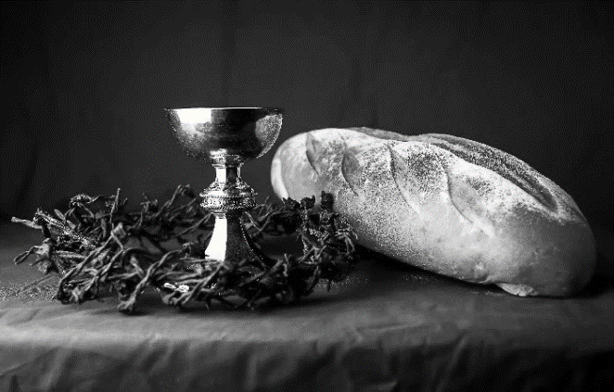
hallowed be thy name,
thy kingdom come,
thy will be done,
on earth as it is in heaven.
Give us this day our daily bread;
and forgive us our trespasses,
as we forgive those
who trespass against us;
and lead us not into temptation,
but deliver us from evil.
For thine is the kingdom,
and the power, and the glory,
forever and ever. Amen.
INVITATION TO COMMUNION - Certified gluten-free crackers are in the bowl on the communion plate.
All people are called to Christ’s table.
Come, eat what is good.
HOLY COMMUNION
PRAYER AFTER COMMUNION
We thank you, generous God, for the refreshment we have received
at your banquet table. Send us now to spread your generosity into all the world,
through the one who is our dearest treasure, Jesus Christ, our Savior and Lord.
Amen.
SENDING
BLESSING
The God who calls across the cosmos
and speaks in the smallest seed
☩ bless, keep, and sustain you
now and to the end of the age.
Amen.
SONG May the God of Hope Go with Us ACS 984

DISMISSAL
Go in peace. Share the harvest.
Thanks be to God.

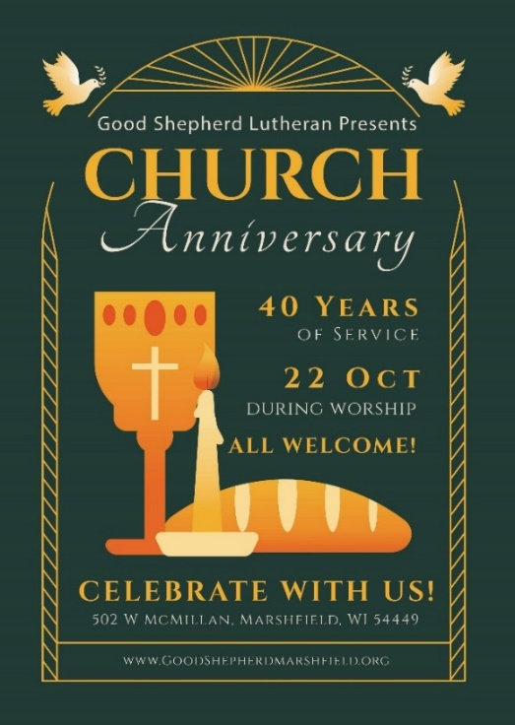
Upcoming Worship Assistants
 | Usher | Lector | Communion | Offering Counters
June 11 | Dave & Shelly Schneider | Shelly Schneider | Bob & Laurel Peterson | Pam Mundt | May Hill
June 18 | Keith & Michelle Stuttgen | Kris Tarter | Dave & Shelly Schneider | Dan Mundt | Jon Hill
June 25 | Kris Tarter | Laurel Peterson | Bruce & Nancy Tibbett | Nancy Leonard | Breanna Butler
July 2 | Chad & Audra Strasser | Nancy Leonard | John Wagner | Robin Beeman | David Schneider
Coming up at GSLC
Sunday, June 18 | 9:00 am | Outdoor Worship Service  - 3rd Sunday after Pentecost  - Matthew 9:35-10:8; The sending of the Twelve
Tuesday, June 20 | 2:00 pm | Chapel at Three Oaks
 | 7:00 pm | AA Meeting
Sunday, June 25 | 9:00 am | Worship Service  - 4th Sunday after Pentecost  Matthew 10:24-39; The cost of discipleship.

Office Summer Hours
Our office hours will vary this summer as staff are on vacation and schedules change. Please call ahead if you plan to stop by the office.

