Good Shepherd Lutheran Church
Pastor: Rev. Katie Anderson | Music Director: Rev. Lois Swanson
Pastor’s Cell: (715) 245-1943 | Office Phone: (715) 387-2731
Pastor Email: gslcwi.pastor@gmail.com | Office Email: gslcwi.office@gmail.com
Website: GoodShepherdMarshfield.org | www.facebook.com/gslcwi
2nd Sunday after Pentecost
June 11, 2023, 9:00 am
Introduction to the day…
Though Jesus was a devout Jew who practiced his faith, he was criticized for eating with tax collectors and sinners—the religiously nonobservant. Jesus criticizes the self-righteous and reminds us that mercy is to be at the heart of our religious practices. God continues to be made known in those on the margins of society, like Matthew the tax collector and the hemorrhaging woman. As we gather each Lord’s day, we receive the healing that makes us well and sends us forth to be signs of God’s mercy for the world.
ANNOUNCEMENTS
GATHERING
GATHERING SONG Morning Has Broken ELW 556

CONFESSION AND FORGIVENESS
Blessed be the holy Trinity,☩ one God, who greets us in this and every season,
whose word never fails, whose promise is sure.
Amen.
Let us confess our sin in the presence of God and of our neighbors.
Merciful God,
we confess that we have sinned. We have hurt our community.
We have squandered your blessings. We have hoarded your bounty.
In the name of Jesus, forgive us and grant us your mercy.
Silence is kept for reflection.
Righteous God,
we confess that we have sinned. We have failed to be honest.
We have lacked the courage to speak. We have spoken falsely.
In the name of Jesus, forgive us and grant us your mercy.
Silence is kept for reflection.
God is a cup of cold water when we thirst. God offers boundless grace when we fail.
Claim the gift of God’s mercy: you are freed and forgiven in the name of ☩ Jesus Christ.
Amen.
PRAYER OF THE DAY
O God, you are the source of life and the ground of our being. By the power of your Spirit bring healing to this wounded world, and raise us to the new life of your Son, Jesus Christ, our Savior and Lord. Amen.
CHILDREN’S MESSAGE
SCRIPTURE READINGS
FIRST READING: Hosea 5:15-6:6 1:1-2:4a
¹⁵I will return again to my place
until they acknowledge their guilt and seek my face.
In their distress they will beg my favor:
^{6:1}“Come, let us return to the Lord;
for it is he who has torn, and he will heal us;
he has struck down, and he will bind us up.
²After two days he will revive us;
on the third day he will raise us up,
that we may live before him.
³Let us know, let us press on to know the Lord;
his appearing is as sure as the dawn;
he will come to us like the showers,
like the spring rains that water the earth.”
⁴What shall I do with you, O Ephraim?
What shall I do with you, O Judah?
Your love is like a morning cloud,
like the dew that goes away early.
⁵Therefore I have hewn them by the prophets,
I have killed them by the words of my mouth,
and my judgment goes forth as the light.
⁶For I desire steadfast love and not sacrifice,
the knowledge of God rather than burnt offerings.
Word of God, word of life.
Thanks be to God.
PSALM: Psalm 50:7-15
⁷“Listen, my people, and I will speak: Israel, I will bear witness against you; for I am God, your God.
⁸I do not accuse you because of your sacrifices; your burnt offerings are always before me.
⁹I will not accept a calf from your stalls, nor goats from your pens;
¹⁰for all the wild animals of the forest are mine, the cattle on a thousand hills.
¹¹I know every bird of the mountains, and the creatures of the fields are mine.
¹²If I were hungry, I would not tell you,
for the whole world is mine and all that is in it.
¹³Do you think I eat the flesh of bulls,
or drink the blood of goats?
¹⁴Offer to God a sacrifice of thanksgiving
and make good your vows to the Most High.
¹⁵Call upon me in the day of trouble;
I will deliver you, and you shall honor me.
SECOND READING: Romans 4:13-25
¹³The promise that he would inherit the world did not come to Abraham or to his descendants through the law but through the righteousness of faith. ¹⁴If it is the adherents of the law who are to be the heirs, faith is null and the promise is void. ¹⁵For the law brings wrath; but where there is no law, neither is there violation.
¹⁶For this reason it depends on faith, in order that the promise may rest on grace and be guaranteed to all his descendants, not only to the adherents of the law but also to those who share the faith of Abraham (for he is the father of all of us, ¹⁷as it is written, “I have made you the father of many nations”)—in the presence of the God in whom he believed, who gives life to the dead and calls into existence the things that do not exist. ¹⁸Hoping against hope, he believed that he would become “the father of many nations,” according to what was said, “So numerous shall your descendants be.” ¹⁹He did not weaken in faith when he considered his own body, which was already as good as dead (for he was about a hundred years old), or when he considered the barrenness of Sarah’s womb. ²⁰No distrust made him waver concerning the promise of God, but he grew strong in his faith as he gave glory to God, ²¹being fully convinced that God was able to do what he had promised. ²²Therefore his faith “was reckoned to him as righteousness.” ²³Now the words, “it was reckoned to him,” were written not for his sake alone, ²⁴but for ours also. It will be reckoned to us who believe in him who raised Jesus our Lord from the dead, ²⁵who was handed over to death for our trespasses and was raised for our justification.
Word of God, word of life.
Thanks be to God.
GOSPEL ACCLAMATION

GOSPEL: Matthew 9:9-13, 18-26
⁹As Jesus was walking along, he saw a man called Matthew sitting at the tax booth; and he said to him, “Follow me.” And he got up and followed him.
¹⁰And as he sat at dinner in the house, many tax collectors and sinners came and were sitting with him and his disciples. ¹¹When the Pharisees saw this, they said to his disciples, “Why does your teacher eat with tax collectors and sinners?” ¹²But when he heard this, he said, “Those who are well have no need of a physician, but those who are sick. ¹³Go and learn what this means, ‘I desire mercy, not sacrifice.’ For I have come to call not the righteous but sinners.”
¹⁸While he was saying these things to them, suddenly a leader of the synagogue came in and knelt before him, saying, “My daughter has just died; but come and lay your hand on her, and she will live.” ¹⁹And Jesus got up and followed him, with his disciples. ²⁰Then suddenly a woman who had been suffering from hemorrhages for twelve years came up behind him and touched the fringe of his cloak, ²¹for she said to herself, “If I only touch his cloak, I will be made well.” ²²Jesus turned, and seeing her he said, “Take heart, daughter; your faith has made you well.” And instantly the woman was made well. ²³When Jesus came to the leader’s house and saw the flute players and the crowd making a commotion, ²⁴he said, “Go away; for the girl is not dead but sleeping.” And they laughed at him. ²⁵But when the crowd had been put outside, he went in and took her by the hand, and the girl got up. ²⁶And the report of this spread throughout that district.
The gospel of the Lord.
Praise to you, O Christ.
SERMON

HYMN OF THE DAY Healer of Our Every Ill ELW 612

APOSTLES’ CREED
I believe in God, the Father almighty,
creator of heaven and earth.
I believe in Jesus Christ, God's only Son, our Lord,
who was conceived by the power of the Holy Spirit,
born of the Virgin Mary,
suffered under Pontius Pilate,
was crucified, died, and was buried;
he descended to the dead.
On the third day he rose again;
he ascended into heaven,
he is seated at the right hand of the Father,
and he will come to judge the living and the dead.
I believe in the Holy Spirit,
the holy catholic Church,
the communion of saints,
the forgiveness of sins,
the resurrection of the body,
and the life everlasting. Amen
PRAYERS OF INTERCESSION
…God, in your mercy,
Hear our prayer.
Receive our prayers and answer us, O God, in the name of Jesus Christ.
Amen.
PEACE
The peace of Christ be with you always.
And also with you.

HOLY COMMUNION
OFFERING In addition to our normal offering, a Special Benevolence in June (collected in a special envelope) will go to Feed My Starving Children.
OFFERING SONG We Come to the Hungry Feast ELW 479

OFFERTORY PRAYER
God of field and forest, sea and sky,
you are the giver of all good things.
Sustain us with these gifts of your creation,
and multiply your graciousness in us,
that the world may be fed with your love,
through Jesus Christ, our Savior and Lord.
Amen.
GREAT THANKSGIVING
The Lord be with you.
And also with you.
Lift up your hearts.
We lift them to the Lord.
Let us give our thanks to the Lord our God.
It is right to give our thanks and praise.
HOLY, HOLY, HOLY (Sung) ELW 189

THANKSGIVING AT THE TABLE

God of our weary years, God of our silent tears,
you have brought us this far along the way.
In times of bitterness you did not abandon us,
but guided us into the path of love and light.
In every age you sent prophets
to make known your loving will for all humanity.
The cry of the poor has become your own cry;
our hunger and thirst for justice is your own desire.
In the fullness of time, you sent your chosen servant
to preach good news to the afflicted,
to break bread with the outcast and despised,
and to ransom those in bondage to prejudice and sin.
In the night in which he was betrayed,
our Lord Jesus took bread, and gave thanks;
broke it, and gave it to his disciples, saying:
Take and eat; this is my body, given for you.
Do this for the remembrance of me.
Again, after supper, he took the cup, gave thanks,
and gave it for all to drink, saying:
This cup is the new covenant in my blood,
shed for you and all people for the forgiveness of sin.
Do this for the remembrance of me.
For as often as we eat of this bread and drink from this cup
we proclaim the Lord’s death until he comes.
Christ has died.
Christ is risen.
Christ will come again.
Remembering, therefore, his death and resurrection,
we await the day when Jesus shall return
to free all the earth from the bonds of slavery and death.
Come, Lord Jesus! And let the church say, Amen.
Amen.
Send your Holy Spirit, our advocate,
to fill the hearts of all who share this bread and cup
with courage and wisdom to pursue love and justice in all the world.
Come, Spirit of freedom! And let the church say, Amen.
Amen.
Join our prayers and praise with your prophets and martyrs of every age,
that, rejoicing in the hope of the resurrection,
we might live in the freedom and hope of your Son.
Through him, with him, in him, in the unity of the Holy Spirit,
all glory and honor is yours, almighty Father, now and forever.
Amen.

THE LORD’S PRAYER
Our Father, who art in heaven,
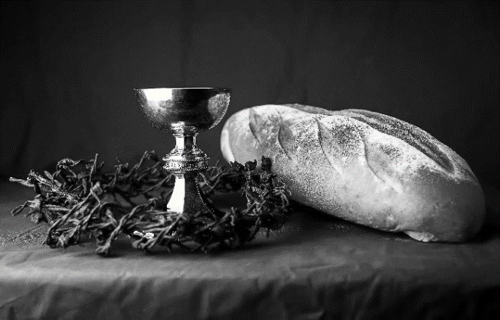
hallowed be thy name,
thy kingdom come,
thy will be done,
on earth as it is in heaven.
Give us this day our daily bread;
and forgive us our trespasses,
as we forgive those
who trespass against us;
and lead us not into temptation,
but deliver us from evil.
For thine is the kingdom,
and the power, and the glory,
forever and ever. Amen.
INVITATION TO COMMUNION - Certified gluten-free crackers are in the bowl on the communion plate.
All people are called to Christ’s table.
Come, eat what is good.
HOLY COMMUNION
PRAYER AFTER COMMUNION
We thank you, generous God, for the refreshment we have received
at your banquet table. Send us now to spread your generosity into all the world,
through the one who is our dearest treasure, Jesus Christ, our Savior and Lord.
Amen.
SENDING
BLESSING
The God who calls across the cosmos
and speaks in the smallest seed
☩ bless, keep, and sustain you
now and to the end of the age.
Amen.
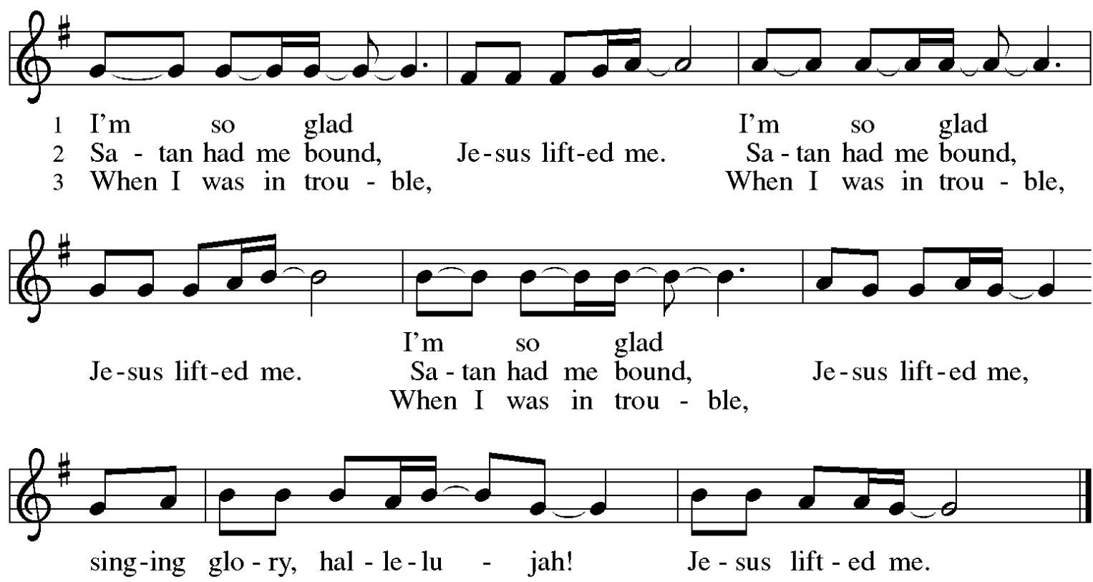
SONG I’m So Glad Jesus Lifted Me ELW 860

DISMISSAL
Go in peace. Share the harvest.
Thanks be to God.

Office Summer Hours
Our office hours will vary this summer as staff are on vacation and schedules change. Please call ahead if you plan to stop by the office.

Upcoming Worship Assistants
 | Usher | Lector | Communion | Offering Counters
June 11 | Dave & Shelly Schneider | Shelly Schneider | Bob & Laurel Peterson | Pam Mundt | May Hill
June 18 | Keith & Michelle Stuttgen | Kris Tarter | Dave & Shelly Schneider | Dan Mundt | Jon Hill
June 25 | Kris Tarter | Laurel Peterson | Bruce & Nancy Tibbett | Nancy Leonard | Breanna Butler
July 2 | Chad & Audra Strasser | Nancy Leonard | John Wagner | Robin Beeman | David Schneider
Coming up at GSLC
Sunday, June 11 | 9:00 am | Outdoor Worship Service  - 2nd Sunday after Pentecost  - Matthew 9:9-13, 18-26; Christ heals a woman and raises a synagogue leader’s daughter
Tuesday, June 13 | 6:30 pm | Council Meeting
 | 7:00 pm | AA Meeting
Wednesday, June 14 | 6:00 pm | Pub Theology
Friday, June 16 | 7:30 pm | - Outdoor Movie Night – How to Train Your Dragon
Sunday, June 18 | 9:00 am | Outdoor Worship Service  - 3rd Sunday after Pentecost  - Matthew 9:35-10:8; The sending of the Twelve
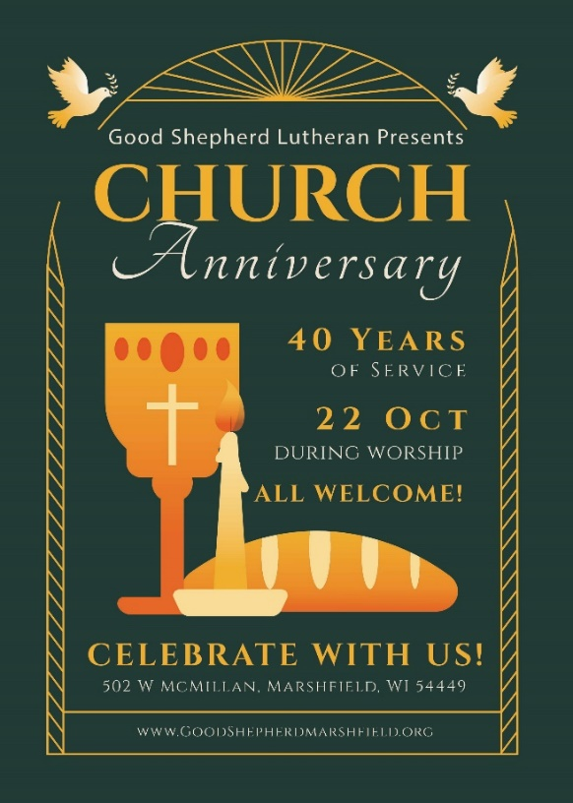

The next GSLC Council Meeting is Tuesday, June 13 at 6:30 pm.

