Good Shepherd Lutheran Church
Pastor: Rev. Katie Anderson | Music Director: Rev. Lois Swanson
Pastor’s Cell: (715) 245-1943 | Office Phone: (715) 387-2731
Pastor Email: gslcwi.pastor@gmail.com | Office Email: gslcwi.office@gmail.com
Website: GoodShepherdMarshfield.org | www.facebook.com/gslcwi
Sixth Sunday of Easter
May 14, 2023, 9:00 am
Introduction to the day…
Jesus does not abandon his followers. Through the Holy Spirit, Jesus comes to abide with his disciples of every generation. As Pentecost draws near, we are reminded that the risen Christ dwells in us as the Spirit of truth. We receive this Spirit in baptism and pray that in our gathering around the Lord’s table the Spirit will transform us to be the body of the risen Christ in the world.
ANNOUNCEMENTS
GATHERING
GATHERING SONG Our God is an Awesome God
1 Our God is an awesome God,  he reigns from heaven above  with wisdom, pow'r, and love—  Our God is an awesome God! | 3 Our God is our Savior who,  Died for us on the cross  Our God is our savior whom,  We’ll serve for ever more.
2 Our God is our Father who,  Cares for us ev’ry day  Our God is our Father whom  We seek in ev’ry way. | 4 Our God is our comforter who,  Works faith in our hearts  Our God is our comforter who  Helps us in ev’ry need.
Text: Rich Mullins (c) 1988 BMG Music Used by permission. CCLI LICENSE #669990
THANKSGIVING FOR BAPTISM
Blessed be the holy Trinity, ☩ one God,
by whose hand we are given new birth,
by whose speaking we are given new life.
Amen.
Joined to Christ in the waters of baptism,
we are welcomed, restored, and supported
as citizens of the new creation.
Let us give thanks for the gift of baptism.
Holy God,
holy and merciful,
holy and mighty,
you are the river of life,
you are the everlasting wellspring.
In mercy and might you have freed us from death
and raised us with Jesus, the firstborn of the dead.
In baptismal waters our old life is washed away,
and in them we are born anew.
Glory to you for oceans and lakes,
for rivers and streams.
Honor to you for waters that wash us clean,
quench our thirst, and nurture both crops and creatures.
Praise to you for the life-giving water of baptism,
the outpouring of the Spirit of the new creation.
Wash away our sin and all that separates us from you.
Empower our witness to your resurrection.
Strengthen our resolve in seeking justice for all.
Satisfy the world’s need through this living water.
Where drought dries the earth, bring refreshment.
Where despair prevails, grant hope.
Where chaos reigns, bring peace.
We ask this through Christ,
who with you and the Spirit reigns forever.
Amen.
PRAYER OF THE DAY
Almighty and ever-living God, you hold together all things in heaven and on earth. In your great mercy receive the prayers of all your children, and give to all the world the Spirit of your truth and peace, through Jesus Christ, our Savior and Lord, who lives and reigns with you and the Holy Spirit, one God, now and forever. Amen.
CHILDREN’S MESSAGE
SCRIPTURE READINGS
FIRST READING: Acts 17:22-31
²²Paul stood in front of the Areopagus and said, “Athenians, I see how extremely religious you are in every way. ²³For as I went through the city and looked carefully at the objects of your worship, I found among them an altar with the inscription, ‘To an unknown god.’ What therefore you worship as unknown, this I proclaim to you. ²⁴The God who made the world and everything in it, he who is Lord of heaven and earth, does not live in shrines made by human hands, ²⁵nor is he served by human hands, as though he needed anything, since he himself gives to all mortals life and breath and all things. ²⁶From one ancestor he made all nations to inhabit the whole earth, and he allotted the times of their existence and the boundaries of the places where they would live, ²⁷so that they would search for God and perhaps grope for him and find him—though indeed he is not far from each one of us. ²⁸For ‘In him we live and move and have our being’; as even some of your own poets have said,
‘For we too are his offspring.’
²⁹Since we are God’s offspring, we ought not to think that the deity is like gold, or silver, or stone, an image formed by the art and imagination of mortals. ³⁰While God has overlooked the times of human ignorance, now he commands all people everywhere to repent, ³¹because he has fixed a day on which he will have the world judged in righteousness by a man whom he has appointed, and of this he has given assurance to all by raising him from the dead.”
Word of God, word of life.
Thanks be to God.
PSALM: Psalm 66:8-20
⁸Bless our God, you peoples;
let the sound of praise be heard.
⁹Our God has kept us among the living
and has not allowed our feet to slip.
¹⁰For you, O God, have tested us;
you have tried us just as silver is tried.
¹¹You brought us into the net;
you laid heavy burdens upon our backs.
¹²You let people ride over our heads; we went through fire and water,
but you brought us out into a place of refreshment.
¹³I will enter your house with burnt offerings
and will pay you my vows—
¹⁴those that I promised with my lips
and spoke with my mouth when I was in trouble.
¹⁵I will offer you burnt offerings of fatlings with the smoke of rams;
I will give you oxen and goats.
¹⁶Come and listen, all you who believe,
and I will tell you what God has done for me.
¹⁷I called out to God with my mouth,
and praised the Lord with my tongue.
¹⁸If I had cherished evil in my heart,
the Lord would not have heard me;
¹⁹but in truth God has heard me
and has attended to the sound of my prayer.
²⁰Blessed be God, who has not rejected my prayer,
nor withheld unfailing love from me.
SECOND READING: 1 Peter 3:13-22
¹³Who will harm you if you are eager to do what is good? ¹⁴But even if you do suffer for doing what is right, you are blessed. Do not fear what they fear, and do not be intimidated, ¹⁵but in your hearts sanctify Christ as Lord. Always be ready to make your defense to anyone who demands from you an accounting for the hope that is in you; ¹⁶yet do it with gentleness and reverence. Keep your conscience clear, so that, when you are maligned, those who abuse you for your good conduct in Christ may be put to shame. ¹⁷For it is better to suffer for doing good, if suffering should be God’s will, than to suffer for doing evil. ¹⁸For Christ also suffered for sins once for all, the righteous for the unrighteous, in order to bring you to God. He was put to death in the flesh, but made alive in the spirit, ¹⁹in which also he went and made a proclamation to the spirits in prison, ²⁰who in former times did not obey, when God waited patiently in the days of Noah, during the building of the ark, in which a few, that is, eight persons, were saved through water. ²¹And baptism, which this prefigured, now saves you—not as a removal of dirt from the body, but as an appeal to God for a good conscience, through the resurrection of Jesus Christ, ²²who has gone into heaven and is at the right hand of God, with angels, authorities, and powers made subject to him.
Word of God, word of life.
Thanks be to God.
GOSPEL ACCLAMATION ELW 174
GOSPEL: John 14:15-21
[Jesus said to the disciples:] ¹⁵“If you love me, you will keep my commandments. ¹⁶And I will ask the Father, and he will give you another Advocate, to be with you forever. ¹⁷This is the Spirit of truth, whom the world cannot receive, because it neither sees him nor knows him. You know him, because he abides with you, and he will be in you.
¹⁸“I will not leave you orphaned; I am coming to you. ¹⁹In a little while the world will no longer see me, but you will see me; because I live, you also will live. ²⁰On that day you will know that I am in my Father, and you in me, and I in you. ²¹They who have my commandments and keep them are those who love me; and those who love me will be loved by my Father, and I will love them and reveal myself to them.”
The gospel of the Lord.
Praise to you, O Christ.
SERMON
HYMN OF THE DAY As a Mother Comforts Her Child ACS 1015

APOSTLES’ CREED
I believe in God, the Father almighty,
creator of heaven and earth.
I believe in Jesus Christ, God's only Son, our Lord,
who was conceived by the power of the Holy Spirit,
born of the Virgin Mary,
suffered under Pontius Pilate,
was crucified, died, and was buried;
he descended to the dead.
On the third day he rose again;
he ascended into heaven,
he is seated at the right hand of the Father,
and he will come to judge the living and the dead.
I believe in the Holy Spirit,
the holy catholic Church,
the communion of saints,
the forgiveness of sins,
the resurrection of the body,
and the life everlasting. Amen
PRAYERS OF INTERCESSION
…Hear us, O God.
Your mercy is great.
Rejoicing in the victory of Christ’s resurrection, we lift our prayers and praise to you, almighty and eternal God; through Jesus Christ, our risen Lord.
Amen.
PEACE
The peace of Christ be with you always.
And also with you.
HOLY COMMUNION
OFFERING In addition to our normal offering, a Special Benevolence in April (collected in a special envelope) will go to
OFFERING SONG Spirit of God, Descend upon My Heart ELW 800
OFFERTORY PRAYER
Generous God,
in this meal you offer your very self.
We give thanks for these gifts of the earth.
In the breaking of this bread
reveal to us the Risen One.
In the pouring of this wine
pour us out in service to the world;
through Christ our Lord.
Amen.
GREAT THANKSGIVING
The Lord be with you.
And also with you.
Lift up your hearts.
We lift them to the Lord.
Let us give our thanks to the Lord our God.
It is right to give our thanks and praise.

HOLY, HOLY, HOLY (Sung)
Holy, holy, holy Lord, God of pow’r God of might,
heaven and earth are full of your glory.
Hosanna, hosanna, hosanna in the highest.
Blessed is he who comes in the name of the Lord.
Hosanna in the highest.
Words: Hans Peterson, 2008 Dakota Road Music, Used by permission. CCLI License # 669990
THANKSGIVING AT THE TABLE

Blessed are you, O God of the universe.
Your mercy is everlasting
and your faithfulness endures from age to age.
Praise to you for creating the heavens and the earth.
Praise to you for saving the earth from the waters of the flood.
Praise to you for bringing the Israelites safely through the sea.
Praise to you for leading your people through the wilderness
to the land of milk and honey.
Praise to you for the words and deeds of Jesus, your anointed one.
Praise to you for the death and resurrection of Christ.
Praise to you for your Spirit poured out on all nations.
In the night in which he was betrayed,
our Lord Jesus took bread, and gave thanks;
broke it, and gave it to his disciples, saying:
Take and eat; this is my body, given for you.
Do this for the remembrance of me.
Again, after supper, he took the cup, gave thanks,
and gave it for all to drink, saying:
This cup is the new covenant in my blood,
shed for you and for all people for the forgiveness of sin.
Do this for the remembrance of me.

With this bread and cup
we remember our Lord’s passover from death to life
as we proclaim the mystery of faith:
Christ has died.
Christ is risen.
Christ will come again.
O God of resurrection and new life:
Pour out your Holy Spirit on us
and on these gifts of bread and wine.
Bless this feast.
Grace our table with your presence.
Come, Holy Spirit.
Reveal yourself to us in the breaking of the bread.
Raise us up as the body of Christ for the world.
Breathe new life into us.
Send us forth,
burning with justice, peace, and love.
Come, Holy Spirit.
With your holy ones of all times and places,
with the earth and all its creatures,
with sun and moon and stars,
we praise you, O God,
blessed and holy Trinity,
now and forever.
Amen.

THE LORD’S PRAYER
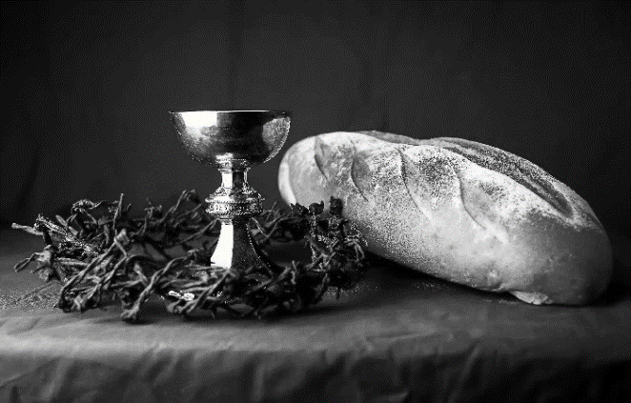
Our Father, who art in heaven,
hallowed be thy name,
thy kingdom come,
thy will be done,
on earth as it is in heaven.
Give us this day our daily bread;
and forgive us our trespasses,
as we forgive those
who trespass against us;
and lead us not into temptation,
but deliver us from evil.
For thine is the kingdom,
and the power, and the glory,
forever and ever. Amen.
INVITATION TO COMMUNION - Certified gluten-free crackers are in the bowl on the communion plate.
Come and know Christ,
broken and poured out for you.
HOLY COMMUNION

PRAYER AFTER COMMUNION
Gracious God,
in you we live and move and have our being.
With your word and this meal of grace,
you have nourished our life together.
Strengthen us to show your love
and serve the world in Jesus’ name.
Amen.
SENDING
BLESSING
The God of all,
who raised ☩ Jesus from the dead,
bless you by the power of the Holy Spirit
to live in the new creation.
Amen.
SONG Make Me an Instrument
Refrain
Make me an instrument of your love. Let me be a channel from above.
Make me an instrument of your love, an instrument of your love.
When a friend is in need of an open heart, let me be there, oh let me be there.
When a friend is lost with nowhere to go, let me be there. Refrain
When someone is hungry, when someone is cold, let me be there, oh let me be there.
When someone needs help to carry their load, let me be there. Refrain
If someone should wonder is God still alive, let me be there, oh let me be there.
If someone should wonder does God really care, let me be there. Refrain
Words and music by Larry Olson and Karol Baer. Copyright 1989 Dakota Road Music. Used by permission. CCLI LICENSE #669990
DISMISSAL
Go in peace. Serve the Risen One.
Thanks be to God.
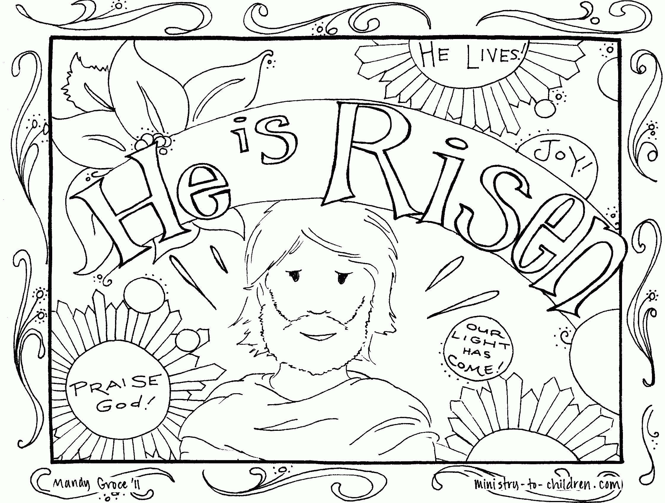
Upcoming Worship Assistants
 | Usher | Lector | Communion | Offering Counters
May 14 | Susan Schoolman | Leslie Mader | Nancy Leonard  Rob Mader | Dan Mundt | Jon Hill
May 21 | Dave & Sue Schraeder | Nancy Tibbett | Andrea Hovick  Sarah Kopitzke | Nancy Leonard | Breanna Butler
May 28 | Dennis & Linda Schuttee | Christine Tipping | Dave & Shelly Schneider | Robin Beeman | David Schneider
June 4 | Gene & Linda Schrieber | Julie Will | Dan & Pam Mundt | Heidi Binder | Kami Weis
June 11 | Dave & Shelly Schneider | Shelly Schneider | Bob & Laurel Peterson | Pam Mundt | May Hill
Coming up at GSLC
Sunday, May 14 | 9:00 am | Worship Service  - Sixth Sunday of Easter  - John 14:15-21; Christ our advocate  - Guest Pastor: Joyce Heintz
Tuesday, May 16 | 2:00 pm | Chapel at Three Oaks
 | 7:00 pm | AA meeting in the fellowship hall
Sunday, May 21 | 9:00 am | Worship Service  - Seventh Sunday of Easter  - John 17:1-11; Christ’s prayer for his disciples  - Graduation Recognition  - Special Guest Micaela Conlon-Bue of Children’s Wisconsin/Family Resource Center of Marshfield

Church Directory Pictures
will be taken on
Sunday, May 21
following worship.
We will be recognizing our high school graduates during worship on Sunday, May 21
A quick ELECTION MEETING will take place on June 4 following church.
