INVITATION TO COMMUNION
The risen Christ dwells with us here.
All who are hungry, all who are thirsty, come.
HOLY COMMUNION
O God, you have called your servants to ventures of which we cannot see the ending, by paths as yet untrodden, through perils unknown. Give us faith to go out with good courage, not knowing where we go, but only that your hand is leading us and your love supporting us; through Jesus Christ our Lord.
Amen
BLESSING
Let us bless the Lord.
Thanks be to God.
The peace of God, which surpasses all understanding, keep our hearts and our minds in Christ Jesus.
Amen.
CLOSING HYMN Will You Let Me Be Your Servant ELW 659
(You are encouraged to share the peace of Christ with one another.)
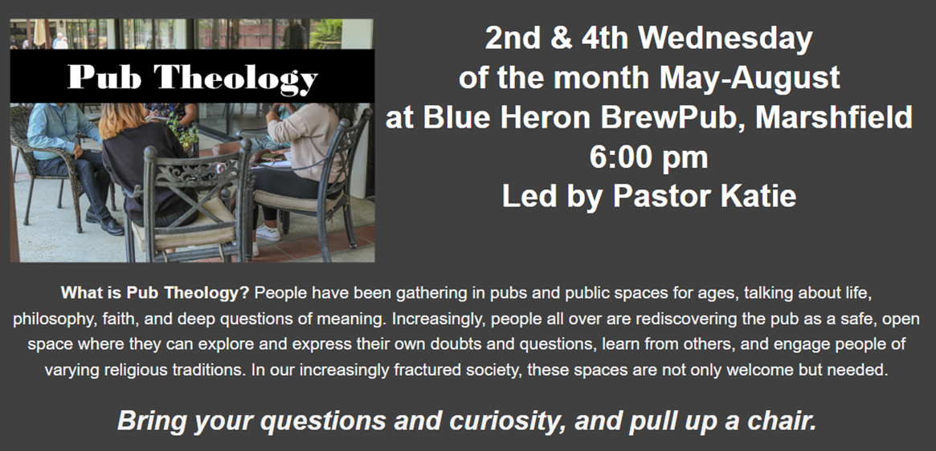
Good Shepherd Lutheran Church
Pastor: Rev Katie Anderson | Music Director: Rev Lois Swanson
502 West McMillian Street, Marshfield | Office Phone: (715) 387-2731
Pastor Email: gslcwi.pastor@gmail.com | Office Email: gslcwi.office@gmail.com
Website: GoodShepherdMarshfield.org | www.facebook.com/gslcwi

Wednesday Service (following order of service from ELW 309, Evening Prayer)
May 3, 2023, 7:00 pm
Welcome and Announcements
OPENING
SERVICE OF LIGHT (HOLDEN EVENING PRAYER)

HYMN OF LIGHT Open Now Thy Gates of Beauty ELW 533
THANKSGIVING OF LIGHT
The Lord be with you.
And also with you.
Let us give thanks to the Lord our God.
We give you thanks, O God, for in the beginning you called light into being, and you set light in the sky to govern night and day.
In a pillar of cloud by day and a pillar of fire by night you led your people into freedom. Enlighten our darkness by the light of your Christ: may your Word be a lamp to our feet and a light to our path; for you are merciful, and you love your whole creation, and with all your creatures we give you glory, through your Son Jesus Christ, in the unity of the Holy Spirit, now and forever.
Amen
PSALMODY: Psalm 100
¹Make a joyful noise to the LORD, all the earth.
²Worship the LORD with gladness;
come into his presence with singing.
³Know that the LORD is God.
It is he that made us, and we are his;
we are his people, and the sheep of his pasture.
⁴Enter his gates with thanksgiving,
and his courts with praise.
Give thanks to him, bless his name.
⁵For the LORD is good;
his steadfast love endures forever,
and his faithfulness to all generations.
HYMN Earth and All Stars ELW 731
WORD: Matthew 20:17-28
¹⁷While Jesus was going up to Jerusalem, he took the twelve disciples aside by themselves, and said to them on the way, ¹⁸See, we are going up to Jerusalem, and the Son of Man will be handed over to the chief priests and scribes, and they will condemn him to death; ¹⁹then they will hand him over to the Gentiles to be mocked and flogged and crucified; and on the third day he will be raised."
²⁰Then the mother of the sons of Zebedee came to him with her sons, and kneeling before him, she asked a favor of him. ²¹And he said to her, "What do you want?" She said to him, "Declare that these two sons of mine will sit, one at your right hand and one at your left, in your kingdom." ²²But Jesus answered, "You do not know what you are asking. Are you able to drink the cup that I am about to drink?" They said to him, "We are able." ²³He said to them, "You will indeed drink my cup, but to sit at my right hand and at my left, this is not mine to grant, but it is for those for whom it has been prepared by my Father."
²⁴When the ten heard it, they were angry with the two brothers. ²⁵But Jesus called them to him and said, "You know that the rulers of the Gentiles lord it over them, and their great ones are tyrants over them. ²⁶It will not be so among you; but whoever wishes to be great among you must be your servant, ²⁷and whoever wishes to be first among you must be your slave; ²⁸just as the Son of Man came not to be served but to serve, and to give his life a ransom for many."
REFLECTION
Jesus said, I am the Light of the world.
Whoever follows me will never walk in darkness.

OFFERING In addition to our normal offering, a Special Benevolence in May is Mary’s Place of Central WI. Their mission is to provide shelter to those in need, offer hope to the hopeless, and seek to help people find restoration.
HOLY COMMUNION
PRAYERS (ELW 316-317)
In peace, let us pray to the Lord.
Lord, have mercy.
…Let us pray to the Lord
Lord, have mercy.
Help, save, comfort, and defend us gracious Lord.
Giving thanks for all who have gone before us and are at rest rejoicing in the communion of all the saints, we commend ourselves, one another, and our whole life to you, through Christ our Lord.
To you, O Lord.
JESUS SPEAKS FROM THE TABLE
In the night in which he was betrayed, our Lord Jesus took bread, and gave thanks; broke it, and gave it to his disciples, saying: Take and eat; this is my body, given for you. Do this for the remembrance of me.
Again, after supper, he took the cup, gave thanks, and gave it for all to drink, saying: This cup is the new covenant in my blood, shed for you and for all people for the forgiveness of sin. Do this for the remembrance of me.
LORD’S PRAYER
Our Father, who art in heaven,
hallowed be thy name,
thy kingdom come,
thy will be done,
on earth as it is in heaven.
Give us this day our daily bread;
and forgive us our trespasses,
as we forgive those
who trespass against us;
and lead us not into temptation,
but deliver us from evil.
For thine is the kingdom,
and the power, and the glory,
forever and ever.
Amen.

