Good Shepherd Lutheran Church
Pastor: Rev. Katie Anderson | Music Director: Rev. Lois Swanson
Pastor’s Cell: (715) 245-1943 | Office Phone: (715) 387-2731
Pastor Email: gslcwi.pastor@gmail.com | Office Email: gslcwi.office@gmail.com
Website: GoodShepherdMarshfield.org | www.facebook.com/gslcwi
Confirmation/Fifth Sunday of Easter
May 7, 2023, 9:00 am
Introduction to the day…
As we continue to celebrate the fifty days of Easter, today’s gospel includes Jesus’ promise that he goes to prepare a place for his followers in his Father’s house. Our baptism commissions us to share Jesus’ mission in the world. As 1 Peter reminds us, we are a holy people, called to proclaim the one who called us out of darkness into light. In words and deeds we bear witness to the risen Christ—our way, our truth, our life.
ANNOUNCEMENTS
GATHERING
GATHERING SONG How Majestic Is Your Name (sing 2 times)
O Lord, our Lord, how majestic is Your name in all the earth.
O Lord, our Lord, how majestic is Your name in all the earth.
O Lord, we praise Your name. O Lord, we magnify Your name;
Prince of Peace, Mighty God, Oh Lord God Almighty!
Smith, Michael W. EMI Christian Music Publishing © 1981 Meadowgreen Music Company (Admin. by EMI Christian Music Publishing) CCLI License No. 669990
THANKSGIVING FOR BAPTISM
Blessed be the holy Trinity, ☩ one God,
by whose hand we are given new birth,
by whose speaking we are given new life.
Amen.
Joined to Christ in the waters of baptism,
we are welcomed, restored, and supported
as citizens of the new creation.
Let us give thanks for the gift of baptism.
Holy God,
holy and merciful,
holy and mighty,
you are the river of life,
you are the everlasting wellspring.
In mercy and might you have freed us from death
and raised us with Jesus, the firstborn of the dead.
In baptismal waters our old life is washed away,
and in them we are born anew.
Glory to you for oceans and lakes,
for rivers and streams.
Honor to you for waters that wash us clean,
quench our thirst, and nurture both crops and creatures.
Praise to you for the life-giving water of baptism,
the outpouring of the Spirit of the new creation.
Wash away our sin and all that separates us from you.
Empower our witness to your resurrection.
Strengthen our resolve in seeking justice for all.
Satisfy the world’s need through this living water.
Where drought dries the earth, bring refreshment.
Where despair prevails, grant hope.
Where chaos reigns, bring peace.
We ask this through Christ,
who with you and the Spirit reigns forever.
Amen.
PRAYER OF THE DAY
Almighty God, your Son Jesus Christ is the way, the truth, and the life. Give us grace to love one another, to follow in the way of his commandments, and to share his risen life with all the world, for he lives and reigns with you and the Holy Spirit, one God, now and forever. Amen.
CHILDREN’S MESSAGE
BAPTISM Damon Blanchard
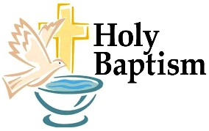
(see insert) Son of Derek & Nicole Blanchard
SCRIPTURE READINGS
FIRST READING: Acts 7:55-60
⁵⁵Filled with the Holy Spirit, [Stephen] gazed into heaven and saw the glory of God and Jesus standing at the right hand of God. ⁵⁶“Look,” he said, “I see the heavens opened and the Son of Man standing at the right hand of God!” ⁵⁷But they covered their ears, and with a loud shout all rushed together against him. ⁵⁸Then they dragged him out of the city and began to stone him; and the witnesses laid their coats at the feet of a young man named Saul. ⁵⁹While they were stoning Stephen, he prayed, “Lord Jesus, receive my spirit.” ⁶⁰Then he knelt down and cried out in a loud voice, “Lord, do not hold this sin against them.” When he had said this, he died.
Word of God, word of life.
Thanks be to God.
PSALM: Psalm 31:1-5, 15-16
¹In you, O Lord, have I taken refuge; let me never be put to shame;
deliver me in your righteousness.
²Incline your ear to me;
make haste to deliver me.
³Be my strong rock, a castle to keep me safe, for you are my crag and my stronghold;
for the sake of your name, lead me and guide me.
⁴Take me out of the net that they have secretly set for me,
for you are my tower of strength.
⁵Into your hands I commend my spirit,
for you have redeemed me, O Lord, God of truth.
¹⁵My times are in your hand;
rescue me from the hand of my enemies, and from those who persecute me.
¹⁶Let your face shine upon your servant;
save me in your steadfast love.”
SECOND READING: 1 Peter 2:2-10
²Like newborn infants, long for the pure, spiritual milk, so that by it you may grow into salvation—³if indeed you have tasted that the Lord is good.
⁴Come to him, a living stone, though rejected by mortals yet chosen and precious in God’s sight, and ⁵like living stones, let yourselves be built into a spiritual house, to be a holy priesthood, to offer spiritual sacrifices acceptable to God through Jesus Christ. ⁶For it stands in scripture:
“See, I am laying in Zion a stone,
a cornerstone chosen and precious;
and whoever believes in him will not be put to shame.”
⁷To you then who believe, he is precious; but for those who do not believe,
“The stone that the builders rejected
has become the very head of the corner,”
⁸and
“A stone that makes them stumble,
and a rock that makes them fall.”
They stumble because they disobey the word, as they were destined to do.
⁹But you are a chosen race, a royal priesthood, a holy nation, God’s own people, in order that you may proclaim the mighty acts of him who called you out of darkness into his marvelous light.
¹⁰Once you were not a people,
but now you are God’s people;
once you had not received mercy,
but now you have received mercy.
Word of God, word of life.
Thanks be to God.
GOSPEL ACCLAMATION ELW 174
GOSPEL: John 14:1-14
[Jesus said to the disciples:] ¹“Do not let your hearts be troubled. Believe in God, believe also in me. ²In my Father’s house there are many dwelling places. If it were not so, would I have told you that I go to prepare a place for you? ³And if I go and prepare a place for you, I will come again and will take you to myself, so that where I am, there you may be also. ⁴And you know the way to the place where I am going.” ⁵Thomas said to him, “Lord, we do not know where you are going. How can we know the way?” ⁶Jesus said to him, “I am the way, and the truth, and the life. No one comes to the Father except through me. ⁷If you know me, you will know my Father also. From now on you do know him and have seen him.”
⁸Philip said to him, “Lord, show us the Father, and we will be satisfied.” ⁹Jesus said to him, “Have I been with you all this time, Philip, and you still do not know me? Whoever has seen me has seen the Father. How can you say, ‘Show us the Father’? ¹⁰Do you not believe that I am in the Father and the Father is in me? The words that I say to you I do not speak on my own; but the Father who dwells in me does his works. ¹¹Believe me that I am in the Father and the Father is in me; but if you do not, then believe me because of the works themselves. ¹²Very truly, I tell you, the one who believes in me will also do the works that I do and, in fact, will do greater works than these, because I am going to the Father. ¹³I will do whatever you ask in my name, so that the Father may be glorified in the Son. ¹⁴If in my name you ask me for anything, I will do it.”
The gospel of the Lord.
Praise to you, O Christ.
SERMON
HYMN OF THE DAY Borning Cry ELW 732
AFFIRMATION OF BAPTISM & CONFIRMATION
Confirmation Class of 2023
Christopher Stuttgen, Luke 1:37, For nothing will be impossible with God.
(The Confirmation youth gather at the Baptismal font)
Dear friends, we give thanks for the gift of baptism and for Christopher, one with us in the body of Christ, who is making public affirmation of his baptism.
Let us pray.
Merciful God, we thank you for Christopher,
whom you have made your own by water and the Word in baptism.
You have called him to yourself,
enlightened him with the gifts of your Spirit,
and nourished him in the community of faith.
Uphold your servant in the gifts and promises of baptism,
and unite the hearts of all whom you have brought to new birth.
We ask this in the name of Christ.
Amen.
PROFESSION OF FAITH
Do you renounce the devil and all the forces that defy God?
Christopher: I renounce them.
Do you renounce the powers of this world that rebel against God?
Christopher: I renounce them.
Do you renounce the ways of sin that draw you from God?
Christopher: I renounce them.
AFFIRMATION
You have made public profession of your faith. Do you intend to continue in the
covenant God made with you in holy baptism:
to live among God’s faithful people,
to hear the word of God and share in the Lord’s supper,
to proclaim the good news of God in Christ through word and deed,
to serve all people, following the example of Jesus,
and to strive for justice and peace in all the earth?
Christopher: I do, and I ask God to help and guide me.
People of God, do you promise to support Christopher and pray for him in his life in Christ?
We do, and we ask God to help and guide us.
Let us pray.
We give you thanks, O God, that through water and the Holy Spirit, you give us new birth, cleanse us from sin, and raise us to eternal life.
(Confirmation youth, parents and sponsors gather at the altar for the blessing)
Father in heaven, for Jesus’ sake, stir up in Christopher the gift of your Holy Spirit; confirm his faith, guide his life, empower him in his serving, give him patience in suffering, and bring him to everlasting life.
Amen.
Let us rejoice with our brother in Christ.
We rejoice with you in the life of baptism.
Together we will give thanks and praise to God
and proclaim the good news to all the world.
Do you or someone you know need an extra prayer said? There are PRAYER REQUEST CARDS
on the table in the narthex. Requests can be kept confidential, with Pastor, or can be made public to the congregation via Shepherd Staff email and in prayer at worship.

PRAYERS OF INTERCESSION
…Hear us, O God.
Your mercy is great.
Rejoicing in the victory of Christ’s resurrection, we lift our prayers and praise to you, almighty and eternal God; through Jesus Christ, our risen Lord.
Amen.
PEACE
The peace of Christ be with you always.
And also with you.
HOLY COMMUNION
OFFERING In addition to our normal offering, a Special Benevolence in May (collected in a special envelope) will go to Mary’s Place of Central WI. Their mission is to provide shelter to those in need, offer hope to the hopeless, and seek to help people find restoration.
OFFERING SONG I am the Bread of Life ELW 486
OFFERTORY PRAYER
Generous God,
in this meal you offer your very self.
We give thanks for these gifts of the earth.
In the breaking of this bread
reveal to us the Risen One.
In the pouring of this wine
pour us out in service to the world;
through Christ our Lord.
Amen.
GREAT THANKSGIVING
The Lord be with you.
And also with you.
Lift up your hearts.
We lift them to the Lord.
Let us give our thanks to the Lord our God.
It is right to give our thanks and praise.
HOLY, HOLY, HOLY (Sung)
Holy, holy, holy Lord, God of pow’r God of might,
heaven and earth are full of your glory.
Hosanna, hosanna, hosanna in the highest.
Blessed is he who comes in the name of the Lord.
Hosanna in the highest.
Words: Hans Peterson, 2008 Dakota Road Music, Used by permission. CCLI License # 669990
THANKSGIVING AT THE TABLE

Blessed are you, O God of the universe.
Your mercy is everlasting
and your faithfulness endures from age to age.
Praise to you for creating the heavens and the earth.
Praise to you for saving the earth from the waters of the flood.
Praise to you for bringing the Israelites safely through the sea.
Praise to you for leading your people through the wilderness
to the land of milk and honey.
Praise to you for the words and deeds of Jesus, your anointed one.
Praise to you for the death and resurrection of Christ.
Praise to you for your Spirit poured out on all nations.
In the night in which he was betrayed,
our Lord Jesus took bread, and gave thanks;
broke it, and gave it to his disciples, saying:
Take and eat; this is my body, given for you.
Do this for the remembrance of me.
Again, after supper, he took the cup, gave thanks,
and gave it for all to drink, saying:
This cup is the new covenant in my blood,
shed for you and for all people for the forgiveness of sin.
Do this for the remembrance of me.

With this bread and cup
we remember our Lord’s passover from death to life
as we proclaim the mystery of faith:
Christ has died.
Christ is risen.
Christ will come again.
O God of resurrection and new life:
Pour out your Holy Spirit on us
and on these gifts of bread and wine.
Bless this feast.
Grace our table with your presence.
Come, Holy Spirit.
Reveal yourself to us in the breaking of the bread.
Raise us up as the body of Christ for the world.
Breathe new life into us.
Send us forth,
burning with justice, peace, and love.
Come, Holy Spirit.
With your holy ones of all times and places,
with the earth and all its creatures,
with sun and moon and stars,
we praise you, O God,
blessed and holy Trinity,
now and forever.
Amen.

THE LORD’S PRAYER
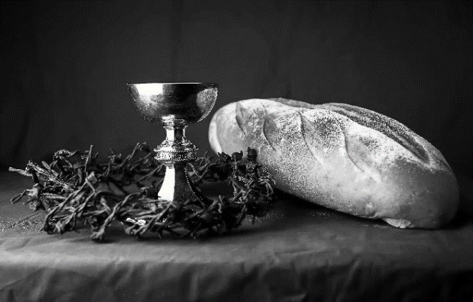
Our Father, who art in heaven,
hallowed be thy name,
thy kingdom come,
thy will be done,
on earth as it is in heaven.
Give us this day our daily bread;
and forgive us our trespasses,
as we forgive those
who trespass against us;
and lead us not into temptation,
but deliver us from evil.
For thine is the kingdom,
and the power, and the glory,
forever and ever. Amen.
INVITATION TO COMMUNION - Certified gluten-free crackers are in the bowl on the communion plate.
Come and know Christ,
broken and poured out for you.
HOLY COMMUNION
PRAYER AFTER COMMUNION
Gracious God,
in you we live and move and have our being.
With your word and this meal of grace,
you have nourished our life together.
Strengthen us to show your love
and serve the world in Jesus’ name.
Amen.
SENDING
BLESSING
The God of all,
who raised ☩ Jesus from the dead,
bless you by the power of the Holy Spirit
to live in the new creation.
Amen.
SONG Go in Peace and Serve the Lord
Go in peace and serve the Lord. God is calling you today.
Go and tell Gospel news everywhere. Go in peace and serve the Lord.
God is calling you today to bring truth and love to every nation
Handt Hanson

DISMISSAL
Go in peace. Serve the Risen One.
Thanks be to God.
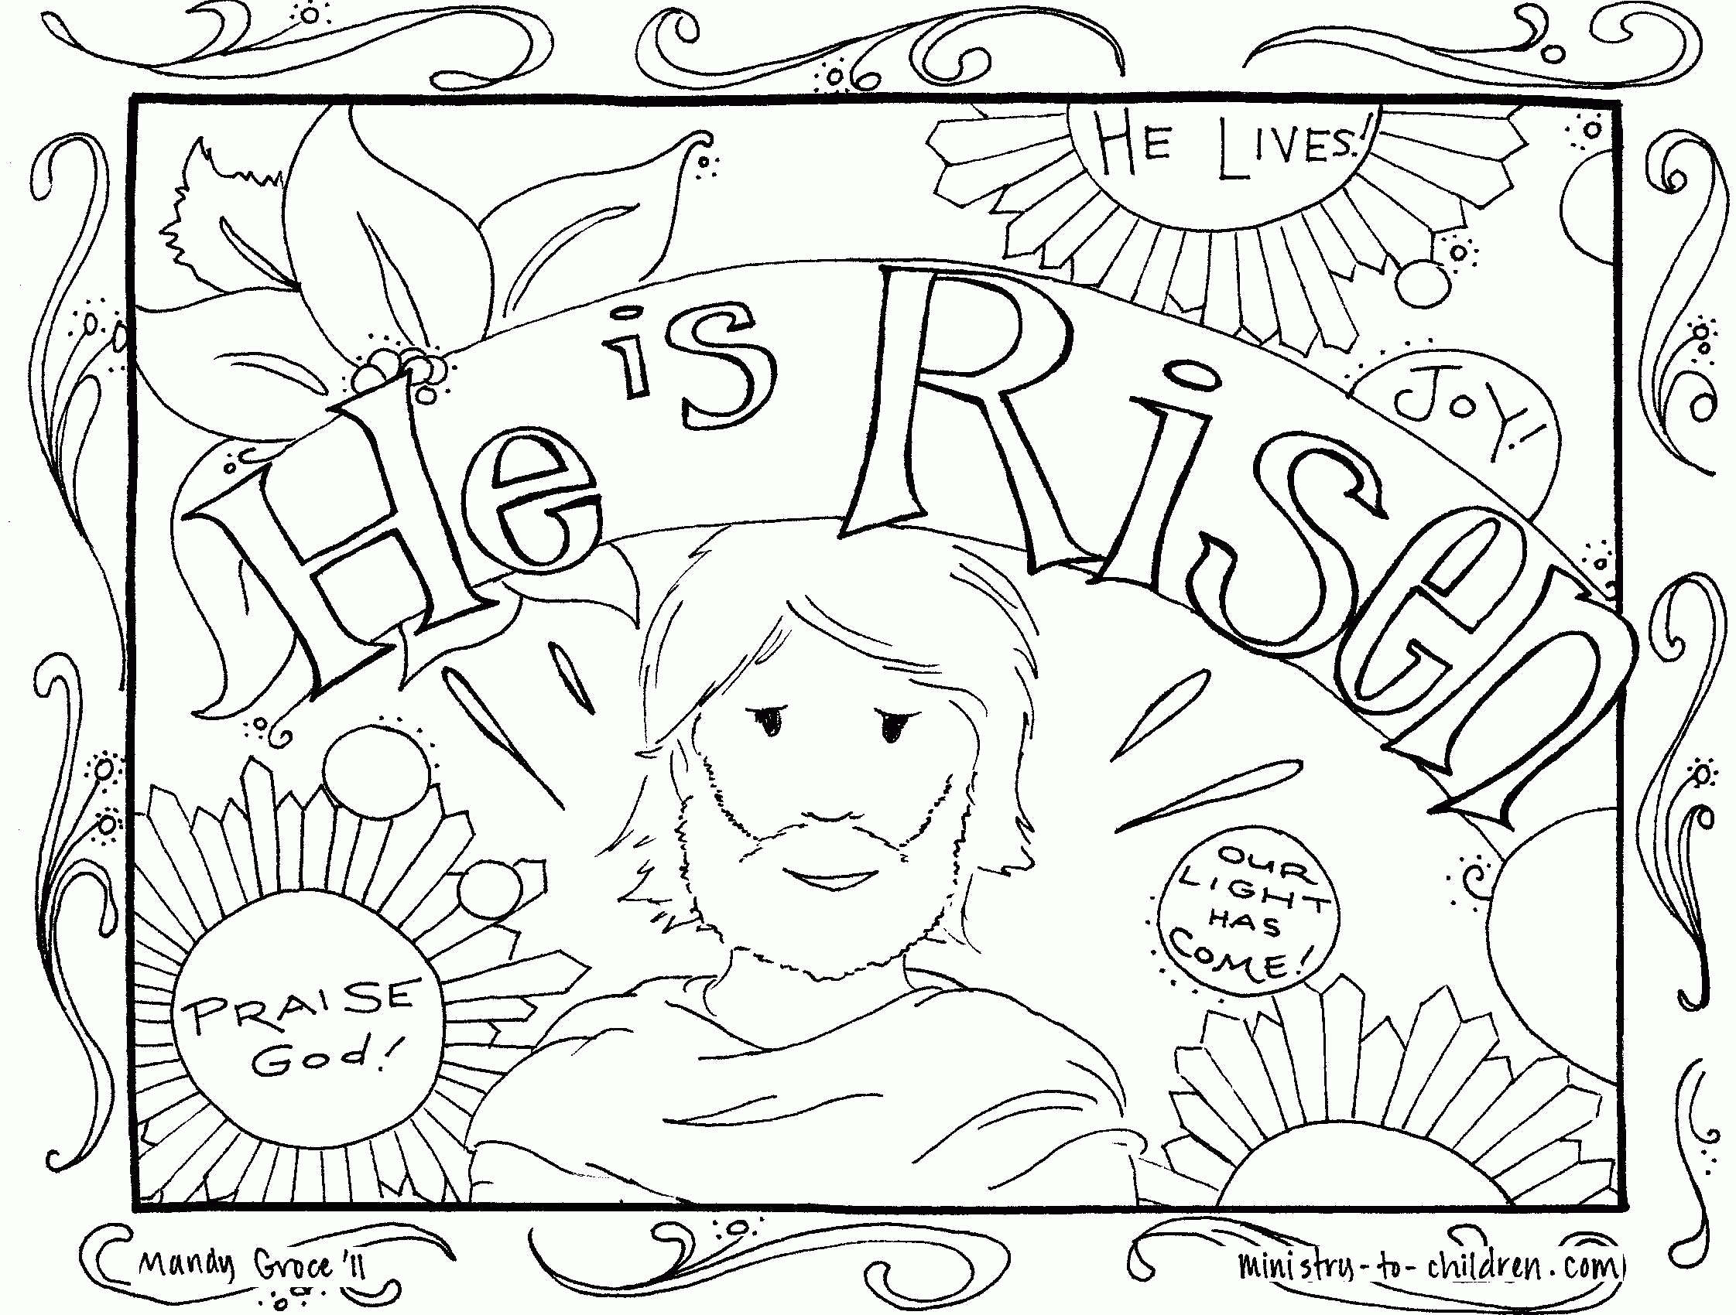
GSLC Council has provided a light snack following worship today to celebrate the Baptism of Damon and the Confirmation of Christopher.
All are welcome!
Upcoming Worship Assistants
 | Usher | Lector | Communion | Offering Counters
May 7  Confirmation | May & Jon Hill | Linda Schrieber | Dave & Sue Schraeder | Pam Mundt | May Hill
May 14 | Susan Schoolman | Nancy Tibbett | Dave & Shelly Schneider | Dan Mundt | Jon Hill
May 21 | Dave & Sue Schraeder | Leslie Mader | Andrea Hovick  Sarah Kopitzke | Nancy Leonard | Breanna Butler
May 28 | Dennis & Linda Schuttee | Christine Tipping | Tammy Neumann  Nancy Leonard | Robin Beeman | David Schneider

Coming up at GSLC
Sunday, May 7 | 9:00 am | Worship Service  - Confirmation: Christopher Stuttgen  - Baptism: Damon Blanchard  Last Sunday School of the year
Tuesday, May 9 | 6:30 pm | Council Meeting
 | 7:00 pm | AA meeting in the fellowship hall
Wednesday, May 10 | 6:00 pm | “Pub Theology” at Blue Heron BrewPub
Sunday, May 14 | 9:00 am | Worship Service  - Sixth Sunday of Easter  - John 14:15-21; Christ our advocate  Guest Pastor:
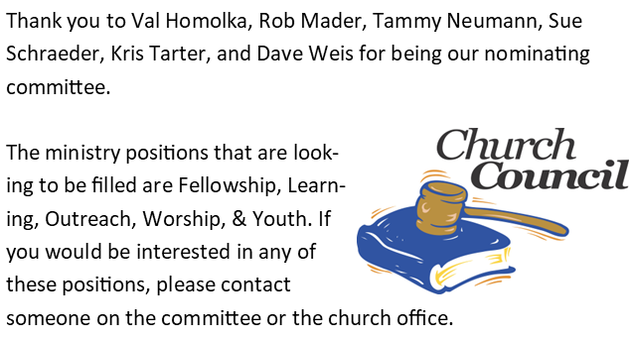
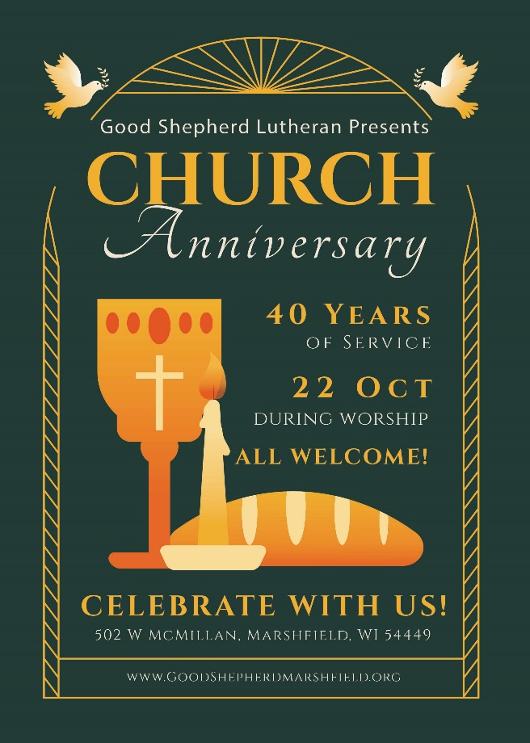
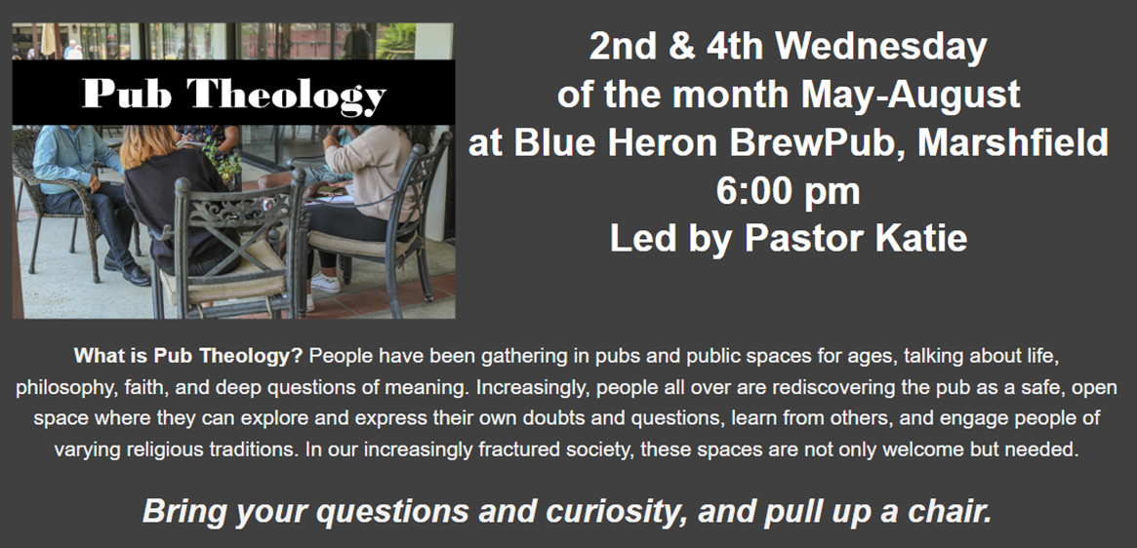
GSLC Council Meeting
on Tuesday, May 9, at 6:30 pm.

