INVITATION TO COMMUNION
The risen Christ dwells with us here.
All who are hungry, all who are thirsty, come.
HOLY COMMUNION
O God, you have called your servants to ventures of which we cannot see the ending, by paths as yet untrodden, through perils unknown. Give us faith to go out with good courage, not knowing where we go, but only that your hand is leading us and your love supporting us; through Jesus Christ our Lord.
Amen
BLESSING
Let us bless the Lord.
Thanks be to God.
The peace of God, which surpasses all understanding, keep our hearts and our minds in Christ Jesus.
Amen.
CLOSING HYMN You Have come Down to the Lakeshore ELW 817
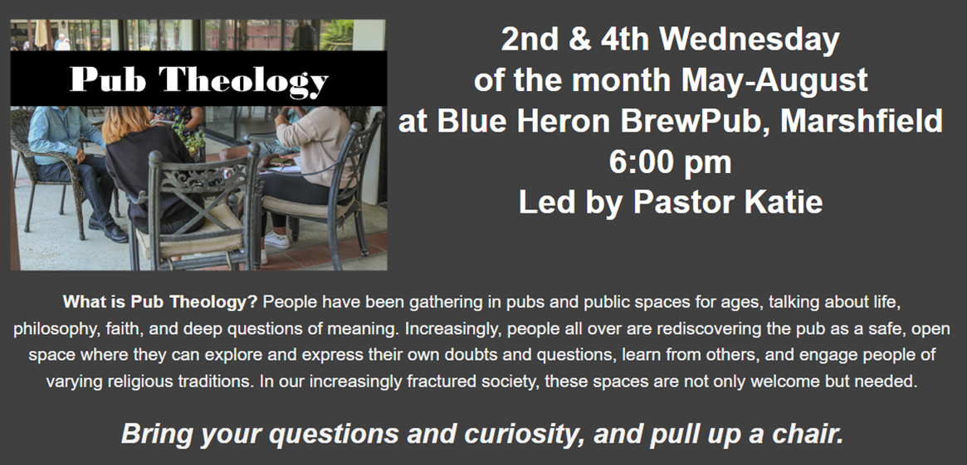
(You are encouraged to share the peace of Christ with one another.)
Good Shepherd Lutheran Church
Pastor: Rev Katie Anderson | Music Director: Rev Lois Swanson
502 West McMillian Street, Marshfield | Office Phone: (715) 387-2731
Pastor Email: gslcwi.pastor@gmail.com | Office Email: gslcwi.office@gmail.com
Website: GoodShepherdMarshfield.org | www.facebook.com/gslcwi

Wednesday Service (following order of service from ELW 309, Evening Prayer)
April 26, 2023, 7:00 pm
Welcome and Announcements
OPENING
SERVICE OF LIGHT (HOLDEN EVENING PRAYER)

HYMN OF LIGHT The Day You Gave Us, Lord, Has Ended ELW 569
THANKSGIVING OF LIGHT
The Lord be with you.
And also with you.
Let us give thanks to the Lord our God.
We give you thanks, O God, for in the beginning you called light into being, and you set light in the sky to govern night and day.
In a pillar of cloud by day and a pillar of fire by night you led your people into freedom. Enlighten our darkness by the light of your Christ: may your Word be a lamp to our feet and a light to our path; for you are merciful, and you love your whole creation, and with all your creatures we give you glory, through your Son Jesus Christ, in the unity of the Holy Spirit, now and forever.
Amen

PSALMODY: Psalm 134
¹Come, bless the LORD, all you servants of the LORD,
who stand by night in the house of the LORD!
²Lift up your hands to the holy place,
and bless the LORD.
³May the LORD, maker of heaven and earth,
bless you from Zion.
HYMN How Great Thou Art ELW 856
WORD: John 21:1-14
¹After these things Jesus showed himself again to the disciples by the Sea of Tiberias; and he showed himself in this way. ²Gathered there together were Simon Peter, Thomas called the Twin, Nathanael of Cana in Galilee, the sons of Zebedee, and two others of his disciples. ³Simon Peter said to them, "I am going fishing." They said to him, "We will go with you." They went out and got into the boat, but that night they caught nothing.
⁴Just after daybreak, Jesus stood on the beach; but the disciples did not know that it was Jesus. ⁵Jesus said to them, "Children, you have no fish, have you?" They answered him, "No." ⁶He said to them, "Cast the net to the right side of the boat, and you will find some." So they cast it, and now they were not able to haul it in because there were so many fish. ⁷That disciple whom Jesus loved said to Peter, "It is the Lord!" When Simon Peter heard that it was the Lord, he put on some clothes, for he was naked, and jumped into the sea. ⁸But the other disciples came in the boat, dragging the net full of fish, for they were not far from the land, only about a hundred yards off.
⁹When they had gone ashore, they saw a charcoal fire there, with fish on it, and bread. ¹⁰Jesus said to them, "Bring some of the fish that you have just caught." ¹¹So Simon Peter went aboard and hauled the net ashore, full of large fish, a hundred fifty-three of them; and though there were so many, the net was not torn. ¹²Jesus said to them, "Come and have breakfast." Now none of the disciples dared to ask him, "Who are you?" because they knew it was the Lord. ¹³Jesus came and took the bread and gave it to them, and did the same with the fish. ¹⁴This was now the third time that Jesus appeared to the disciples after he was raised from the dead.
REFLECTION
Jesus said, I am the Light of the world.
Whoever follows me will never walk in darkness.

OFFERING In addition to our normal offering, a Special Benevolence in April (collected in a special envelope) will go to Orenda Center - PDC. They are dedicated to the safety and empowerment of those impacted by domestic abuse and sexual assault.
HOLY COMMUNION
PRAYERS (ELW 316-317)
In peace, let us pray to the Lord.
Lord, have mercy.
…Let us pray to the Lord
Lord, have mercy.
Help, save, comfort, and defend us gracious Lord.
Giving thanks for all who have gone before us and are at rest rejoicing in the communion of all the saints, we commend ourselves, one another, and our whole life to you, through Christ our Lord.
To you, O Lord.
JESUS SPEAKS FROM THE TABLE
In the night in which he was betrayed, our Lord Jesus took bread, and gave thanks; broke it, and gave it to his disciples, saying: Take and eat; this is my body, given for you. Do this for the remembrance of me.
Again, after supper, he took the cup, gave thanks, and gave it for all to drink, saying: This cup is the new covenant in my blood, shed for you and for all people for the forgiveness of sin. Do this for the remembrance of me.
LORD’S PRAYER
Our Father, who art in heaven,
hallowed be thy name,
thy kingdom come,
thy will be done,
on earth as it is in heaven.
Give us this day our daily bread;
and forgive us our trespasses,
as we forgive those
who trespass against us;
and lead us not into temptation,
but deliver us from evil.
For thine is the kingdom,
and the power, and the glory,
forever and ever.
Amen.

