Good Shepherd Lutheran Church
Pastor: Rev. Katie Anderson | Music Director: Rev. Lois Swanson
Pastor’s Cell: (715) 245-1943 | Office Phone: (715) 387-2731
Pastor Email: gslcwi.pastor@gmail.com | Office Email: gslcwi.office@gmail.com
Website: GoodShepherdMarshfield.org | www.facebook.com/gslcwi
Easter Sunday
April 9, 2023, 9:00 am
Introduction to the day…
This is the day the Lord has made! Christ is risen, and through him all creation is made new! Indeed, “God shows no partiality” (Acts 10:34): Christ’s resurrection truly brings life to everyone. We sing hymns of praise, gather around sacred words, and proclaim God’s faithfulness, power, and love in the feast of holy communion. With the women at the tomb, we are astonished, elated, and grateful. We depart with joy to proclaim the good news of God’s endless love.
ANNOUNCEMENTS
GATHERING
GATHERING SONG Jesus Christ is Risen Today ELW 365
THANKSGIVING FOR BAPTISM
Blessed be the holy Trinity, ☩ one God,
by whose hand we are given new birth,
by whose speaking we are given new life.
Amen.
Joined to Christ in the waters of baptism,
we are welcomed, restored, and supported
as citizens of the new creation.
Let us give thanks for the gift of baptism.
Holy God,
holy and merciful,
holy and mighty,
you are the river of life,
you are the everlasting wellspring.
In mercy and might you have freed us from death
and raised us with Jesus, the firstborn of the dead.
In baptismal waters our old life is washed away,
and in them we are born anew.
Glory to you for oceans and lakes,
for rivers and streams.
Honor to you for waters that wash us clean,
quench our thirst, and nurture both crops and creatures.
Praise to you for the life-giving water of baptism,
the outpouring of the Spirit of the new creation.
Wash away our sin and all that separates us from you.
Empower our witness to your resurrection.
Strengthen our resolve in seeking justice for all.
Satisfy the world’s need through this living water.
Where drought dries the earth, bring refreshment.
Where despair prevails, grant hope.
Where chaos reigns, bring peace.
We ask this through Christ,
who with you and the Spirit reigns forever.
Amen.

PRAYER OF THE DAY
O God, you gave your only Son to suffer death on the cross for our redemption, and by his glorious resurrection, you delivered us from the power of death. Make us die every day to sin, that we may live with him forever in the joy of the resurrection, through your Son, Jesus Christ our Lord, who lives and reigns with you and the Holy Spirit, one God, now and forever. Amen.
CHILDREN’S MESSAGE
SCRIPTURE READINGS
FIRST READING: Acts 10:34-43
³⁴Peter began to speak to [the people]: “I truly understand that God shows no partiality, ³⁵but in every nation anyone who fears him and does what is right is acceptable to him. ³⁶You know the message he sent to the people of Israel, preaching peace by Jesus Christ—he is Lord of all. ³⁷That message spread throughout Judea, beginning in Galilee after the baptism that John announced: ³⁸how God anointed Jesus of Nazareth with the Holy Spirit and with power; how he went about doing good and healing all who were oppressed by the devil, for God was with him. ³⁹We are witnesses to all that he did both in Judea and in Jerusalem. They put him to death by hanging him on a tree; ⁴⁰but God raised him on the third day and allowed him to appear, ⁴¹not to all the people but to us who were chosen by God as witnesses, and who ate and drank with him after he rose from the dead. ⁴²He commanded us to preach to the people and to testify that he is the one ordained by God as judge of the living and the dead. ⁴³All the prophets testify about him that everyone who believes in him receives forgiveness of sins through his name.”
Word of God, word of life.
Thanks be to God.
PSALM: Psalm 118:1-2, 14-24
¹Give thanks to the Lord, for the Lord is good;
God’s mercy endures forever.
²Let Israel now declare,
“God’s mercy endures forever.”
¹⁴The Lord is my strength and my song,
and has become my salvation.
¹⁵Shouts of rejoicing and salvation echo in the tents of the righteous:
“The right hand of the Lord acts valiantly!
¹⁶The right hand of the Lord is exalted!
The right hand of the Lord acts valiantly!”
¹⁷I shall not die, but live,
and declare the works of the Lord.
¹⁸The Lord indeed punished me sorely,
but did not hand me over to death.
¹⁹Open for me the gates of righteousness;
I will enter them and give thanks to the Lord.
²⁰“This is the gate of the Lord;
here the righteous may enter.”
²¹I give thanks to you, for you have answered me
and you have become my salvation.
²²The stone that the builders rejected
has become the chief cornerstone.
²³By the Lord has this been done;
it is marvelous in our eyes.
²⁴This is the day that the Lord has made;
let us rejoice and be glad in it.

SECOND READING: Colossians 3:1-4
¹If you have been raised with Christ, seek the things that are above, where Christ is, seated at the right hand of God. ²Set your minds on things that are above, not on things that are on earth, ³for you have died, and your life is hidden with Christ in God. ⁴When Christ who is your life is revealed, then you also will be revealed with him in glory.
Word of God, word of life.
Thanks be to God.
GOSPEL ACCLAMATION ELW 174
GOSPEL: Matthew 28:1-10
¹After the sabbath, as the first day of the week was dawning, Mary Magdalene and the other Mary went to see the tomb. ²And suddenly there was a great earthquake; for an angel of the Lord, descending from heaven, came and rolled back the stone and sat on it. ³His appearance was like lightning, and his clothing white as snow. ⁴For fear of him the guards shook and became like dead men. ⁵But the angel said to the women, “Do not be afraid; I know that you are looking for Jesus who was crucified. ⁶He is not here; for he has been raised, as he said. Come, see the place where he lay. ⁷Then go quickly and tell his disciples, ‘He has been raised from the dead, and indeed he is going ahead of you to Galilee; there you will see him.’ This is my message for you.” ⁸So they left the tomb quickly with fear and great joy, and ran to tell his disciples. ⁹Suddenly Jesus met them and said, “Greetings!” And they came to him, took hold of his feet, and worshiped him. ¹⁰Then Jesus said to them, “Do not be afraid; go and tell my brothers to go to Galilee; there they will see me.”
The gospel of the Lord.
Praise to you, O Christ.
SERMON
HYMN OF THE DAY Now the Green Blade Rises ELW 379
NICENE CREED
We believe in one God,
the Father, the Almighty,
maker of heaven and earth,
of all that is, seen and unseen.
We believe in one Lord, Jesus Christ,
the only Son of God,
eternally begotten of the Father,
God from God, Light from Light,
true God from true God,
begotten, not made,
of one Being with the Father;
through him all things were made.
For us and for our salvation
he came down from heaven,
was incarnate of the Holy Spirit and the virgin Mary
and became truly human.
For our sake he was crucified under Pontius Pilate;
he suffered death and was buried.
On the third day he rose again
in accordance with the scriptures;
he ascended into heaven
and is seated at the right hand of the Father.
He will come again in glory to judge the living and the dead,
and his kingdom will have no end.
We believe in the Holy Spirit, the Lord, the giver of life,
who proceeds from the Father and the Son,*
who with the Father and the Son is worshiped and glorified,
who has spoken through the prophets.
We believe in one holy catholic and apostolic church.
We acknowledge one baptism for the forgiveness of sins.
We look for the resurrection of the dead,
and the life of the world to come. Amen.
PRAYERS OF INTERCESSION
…Risen Lord, in your mercy,
hear our prayer.
Rejoicing in the victory of Christ’s resurrection, we lift our prayers and praise to you, almighty and eternal God; through Jesus Christ, our risen Lord.
Amen.
PEACE
The peace of Christ be with you always.
And also with you.
HOLY COMMUNION
OFFERING In addition to our normal offering, a Special Benevolence in April (collected in a special envelope) will go to Orenda Center - PDC. They are dedicated to the safety and empowerment of those impacted by domestic abuse and sexual assault.
OFFERING SONG Christ Is Alive! Let Christians Sing ELW 389
OFFERTORY PRAYER
Generous God,
in this meal you offer your very self.
We give thanks for these gifts of the earth.
In the breaking of this bread
reveal to us the Risen One.
In the pouring of this wine
pour us out in service to the world;
through Christ our Lord.
Amen.
GREAT THANKSGIVING
The Lord be with you.
And also with you.
Lift up your hearts.
We lift them to the Lord.
Let us give our thanks to the Lord our God.
It is right to give our thanks and praise.
HOLY, HOLY, HOLY (Sung)
Holy, holy, holy Lord, God of pow’r God of might,
heaven and earth are full of your glory.
Hosanna, hosanna, hosanna in the highest.
Blessed is he who comes in the name of the Lord.
Hosanna in the highest.
Words: Hans Peterson, 2008 Dakota Road Music, Used by permission. CCLI License # 669990

THANKSGIVING AT THE TABLE

Blessed are you, O God of the universe.
Your mercy is everlasting
and your faithfulness endures from age to age.
Praise to you for creating the heavens and the earth.
Praise to you for saving the earth from the waters of the flood.
Praise to you for bringing the Israelites safely through the sea.
Praise to you for leading your people through the wilderness
to the land of milk and honey.
Praise to you for the words and deeds of Jesus, your anointed one.
Praise to you for the death and resurrection of Christ.
Praise to you for your Spirit poured out on all nations.
In the night in which he was betrayed,
our Lord Jesus took bread, and gave thanks;
broke it, and gave it to his disciples, saying:
Take and eat; this is my body, given for you.
Do this for the remembrance of me.
Again, after supper, he took the cup, gave thanks,
and gave it for all to drink, saying:
This cup is the new covenant in my blood,
shed for you and for all people for the forgiveness of sin.
Do this for the remembrance of me.

With this bread and cup
we remember our Lord’s passover from death to life
as we proclaim the mystery of faith:
Christ has died.
Christ is risen.
Christ will come again.
O God of resurrection and new life:
Pour out your Holy Spirit on us
and on these gifts of bread and wine.
Bless this feast.
Grace our table with your presence.
Come, Holy Spirit.
Reveal yourself to us in the breaking of the bread.
Raise us up as the body of Christ for the world.
Breathe new life into us.
Send us forth,
burning with justice, peace, and love.
Come, Holy Spirit.
With your holy ones of all times and places,
with the earth and all its creatures,
with sun and moon and stars,
we praise you, O God,
blessed and holy Trinity,
now and forever.
Amen.

THE LORD’S PRAYER
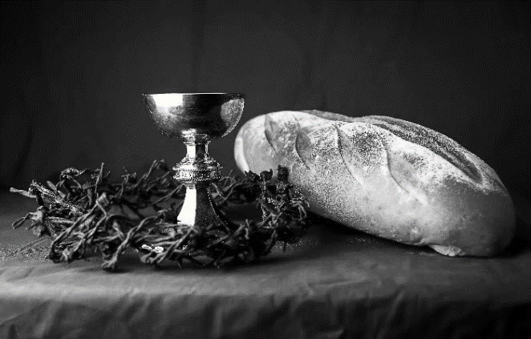
Our Father, who art in heaven,
hallowed be thy name,
thy kingdom come,
thy will be done,
on earth as it is in heaven.
Give us this day our daily bread;
and forgive us our trespasses,
as we forgive those
who trespass against us;
and lead us not into temptation,
but deliver us from evil.
For thine is the kingdom,
and the power, and the glory,
forever and ever. Amen.
INVITATION TO COMMUNION - Certified gluten-free crackers are in the bowl on the communion plate.
Come and know Christ,
broken and poured out for you.
HOLY COMMUNION
PRAYER AFTER COMMUNION
Gracious God,
in you we live and move and have our being.
With your word and this meal of grace,
you have nourished our life together.
Strengthen us to show your love
and serve the world in Jesus’ name.
Amen.
SENDING
BLESSING
The God of all,
who raised ☩ Jesus from the dead,
bless you by the power of the Holy Spirit
to live in the new creation.
Amen.
SONG My Life is in You, Lord
My life is in You, Lord, my strength is in You, Lord,  My hope is in You, Lord, in You, it's in You.  My life is in You, Lord, my strength is in You, Lord,  My hope is in You, Lord, in You, it's in You. | I will praise You with all of my life,  I will praise You with all of my strength.  With all of my life. With all of my strength.  All of my hope is in You.  in You, it's in You, my life!
(Daniel Gardnerc/o Integrity Music, Inc.) CCLI License No. 669990
DISMISSAL
Go in peace. Serve the Risen One.
Thanks be to God.
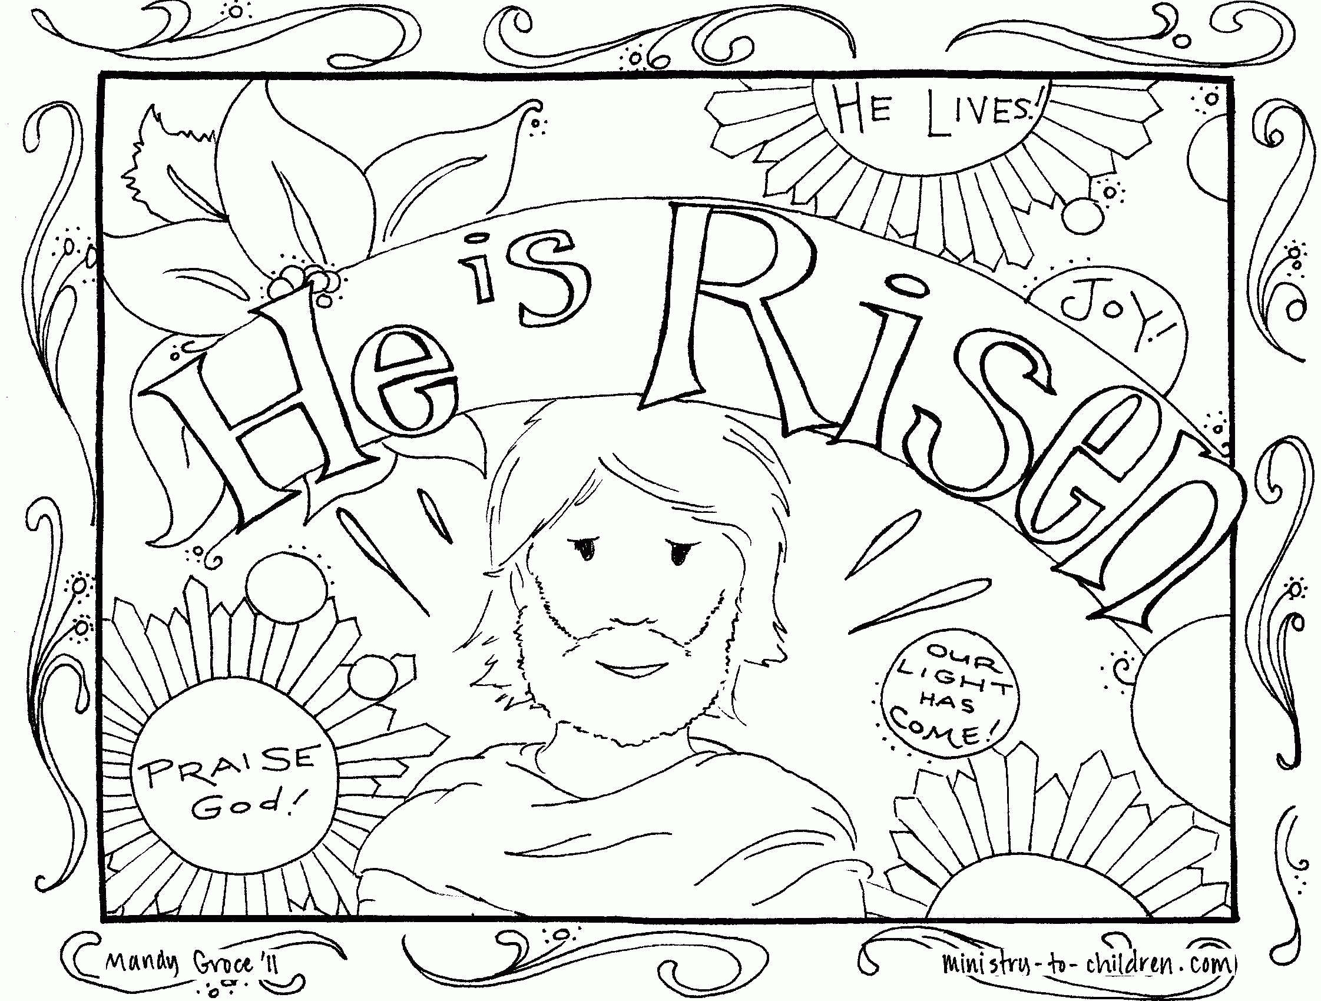
Upcoming Worship Assistants
 | Usher | Lector | Communion | Offering Counters
April 9  Easter | Brett & Breanna Butler | Andrea Hovick | Dave & Sue Schraeder | Dan Mundt | Jon Hill
April 16 | Ben & Jannalee Lindquist | Julie Will | Bruce & Nancy Tibbett | Nancy Leonard | Breanna Butler
April 23 | Ron Rothfusz | Shelly Schneider | Bob & Laurel Peterson | Robin Beeman | Dave Schneider

Coming up at GSLC
Sunday, April 9 | 9:00 am | Easter Worship Service
Tuesday, April 11 | 9:30-10:30 am | Children’s of WI playgroup – all parents & children under 4 welcome
 | 6:30 pm | GSLC Council Meeting
 | 7:00 pm | AA meeting in the fellowship hall
Wednesday, April 12 | 7:00 pm | Midweek Worship Service – Lead by Holly Pisors
Sunday, April 16 | 9:00 am | Worship Service—Guest Pastor Joyce Heintz  - Second Sunday of Easter  - John 20:19-31; Beholding the wounds of the risen Christ.  Sunday School

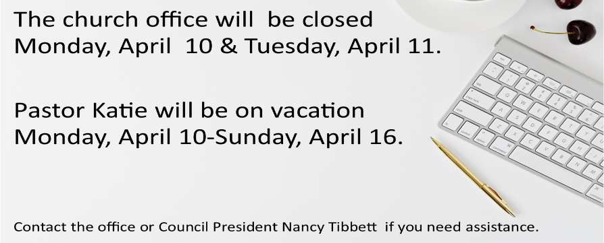

Easter Garden Donations
Carol Copet
in celebration of a Happy Easter
Rob & Leslie Mader
in honor of our children, Erin & Bethany
Dan & Pam Mundt
in memory of Gerry & Chuck Parsch and Gladys & Emil Mundt
in memory of Christopher Mundt
Chuck & Mary Schlafke
in celebration of a Happy Easter
Dave & Shelly Schneider
in celebration of Evan, Zoe, Erin & Taylor Schneider
Dave & Sue Schraeder
in celebration of our family & church family
Keith & Michelle Stuttgen
in celebration of Samantha, Maria, Christopher, & Danielle
John & Jane Wagner
in memory of Christopher Wagner

