Good Shepherd Lutheran Church
Pastor: Rev. Katie Anderson | Music Director: Rev. Lois Swanson
Pastor’s Cell: (715) 245-1943 | Office Phone: (715) 387-2731
Pastor Email: gslcwi.pastor@gmail.com | Office Email: gslcwi.office@gmail.com
Website: GoodShepherdMarshfield.org | www.facebook.com/gslcwi
Maundy Thursday
Thursday, April 6, 2023, 7:00 pm
This evening our Lenten observance comes to an end, and we gather with Christians around the world to celebrate the Three Days of Jesus’ death and resurrection. Tonight we remember Christ’s last meal with his disciples, but the central focus is his commandment that we live out the promise embodied in this meal. As Jesus washed his disciples’ feet, so we are called to give and receive love in humble service to one another. Formed into a new body in Christ through this holy meal, we are transformed by the mercy we have received and carry it into the world. Departing worship in solemn silence, we anticipate the coming days.
CALL TO WORSHIP
Brothers and sisters, I invite you to wiggle your toes.
Gently roll your ankles, and let the tension go.
Participating in their First Communion tonight are:
- Connor Bulgrin
- Finn Leurquin
- Ben Schindler
And if you do have dust on your feet,
shake it off, for here you are clean.
And now, brothers and sisters, I invite you to flex your legs.
I invite you to touch your kneecap, wiggle, and stretch.
Recollect any times you stood on holy ground,
or moments when you stood for one who needed you around.
Now, brothers and sisters, I invite you to open your hands.
Stretch your fingers wide and close them again.
Notice that there are no holes in your palms,
and remember that, ultimately, love has won.
And now, brothers and sisters, take a deep breath.
For we are in sacred space—here we are kept.
You belong to me, and I belong to you.
So let us prepare our hearts for remembrance and truth.
OPENING PRAYER
God, we lay you down, and you rise again.
We pack you up, but you don’t stay within.
We walk away, and you trail our heels.
We lock up our hearts, try to force you to steal.
We put you in our pockets, but you radiate peace.
We bury our hearts, but you continue to beat.
We hold our breath, but you make us breathe.
We try to sleep, but you find our dreams.
We deny your name, and still you’re there.
We paid them in silver, and still you care.
We turn our backs, but you don’t go anywhere.
We throw stones, and you whisper a prayer.
God, we have pushed you out in every way,
again and again, countless times per day.
And you still say our names like lines from a love song,
refusing to deny that we belong.
So forgive us, we pray,
because tomorrow will be the same.
We will lay you down, and you will rise again.
We will pack you up; please don’t stay within.
Amen.
LESSON 1: WATER
SING Lord Whose Love in Humble Service ELW 712
READ: John 13:1-11
¹Now before the festival of the Passover, Jesus knew that his hour had come to depart from this world and go to the Father. Having loved his own who were in the world, he loved them to the end. ²The devil had already put it into the heart of Judas son of Simon Iscariot to betray him. And during supper ³Jesus, knowing that the Father had given all things into his hands, and that he had come from God and was going to God, ⁴got up from the table, took off his outer robe, and tied a towel around himself. ⁵Then he poured water into a basin and began to wash the disciples' feet and to wipe them with the towel that was tied around him. ⁶He came to Simon Peter, who said to him, "Lord, are you going to wash my feet?" ⁷Jesus answered, "You do not know now what I am doing, but later you will understand." ⁸Peter said to him, "You will never wash my feet." Jesus answered, "Unless I wash you, you have no share with me." ⁹Simon Peter said to him, "Lord, not my feet only but also my hands and my head!" ¹⁰Jesus said to him, "One who has bathed does not need to wash, except for the feet, but is entirely clean. And you are clean, though not all of you." ¹¹For he knew who was to betray him; for this reason he said, "Not all of you are clean."
REFLECT
RESPOND: Hand Washing/Remembrance of Baptism (Ubi Caritas et Amor ELW 642)
LESSON 2: BREAD
SING For the Bread Which You Have Broken ELW 494
READ: Matthew 26:17-30
¹⁷On the first day of Unleavened Bread the disciples came to Jesus, saying, "Where do you want us to make the preparations for you to eat the Passover?" ¹⁸He said, "Go into the city to a certain man, and say to him, 'The Teacher says, My time is near; I will keep the Passover at your house with my disciples.'" ¹⁹So the disciples did as Jesus had directed them, and they prepared the Passover meal.
²⁰When it was evening, he took his place with the twelve; ²¹and while they were eating, he said, "Truly I tell you, one of you will betray me." ²²And they became greatly distressed and began to say to him one after another, "Surely not I, Lord?" ²³He answered, "The one who has dipped his hand into the bowl with me will betray me. ²⁴The Son of Man goes as it is written of him, but woe to that one by whom the Son of Man is betrayed! It would have been better for that one not to have been born." ²⁵Judas, who betrayed him, said, "Surely not I, Rabbi?" He replied, "You have said so."
²⁶While they were eating, Jesus took a loaf of bread, and after blessing it he broke it, gave it to the disciples, and said, "Take, eat; this is my body." ²⁷Then he took a cup, and after giving thanks he gave it to them, saying, "Drink from it, all of you; ²⁸for this is my blood of the covenant, which is poured out for many for the forgiveness of sins. ²⁹I tell you, I will never again drink of this fruit of the vine until that day when I drink it new with you in my Father's kingdom."
³⁰When they had sung the hymn, they went out to the Mount of Olives.
REFLECT
RESPOND: Communion
Jesus Speaks From The Table
In the night in which he was betrayed, our Lord Jesus took bread, and gave thanks; broke it, and gave it to his disciples, saying: Take and eat; this is my body given for you. Do this for the remembrance of me.
Again, after supper, he took the cup, gave thanks, and gave it for all to drink, saying: This is the new covenant in my blood, shed for you and for all people for the forgiveness of sin. Do this for the remembrance of me.

The Lord’s Prayer
Our Father, who art in heaven,
hallowed be thy name,
thy kingdom come,
thy will be done,
on earth as it is in heaven.
Give us this day our daily bread;
and forgive us our trespasses,
as we forgive those
who trespass against us;
and lead us not into temptation,
but deliver us from evil.
For thine is the kingdom,
and the power, and the glory,
forever and ever.
Amen.
Invitation To Communion
Come and receive Jesus,
our strength in the wilderness.
We celebrate with these children, Connor, Finn, and Ben, receiving their First Communion today. May God give them joyful hearts, open hands, and the courage to come to the table as their actual selves. We believe that Jesus is fully present in this meal--over, under, around, through the bread and wine--so that we can't receive it without getting the gifts of Jesus, too. The logistics are a mystery and God's to tend. We simply trust that where Jesus shows up, there is forgiveness, salvation and new life that comes from heaven.
Prayer After Communion
Lord Jesus, in a wonderful sacrament
you strengthen us with the saving power
of your suffering, death, and resurrection.
May this sacrament of your body and blood
so work in us that the fruits of your redemption
will show forth in the way we live,
for you live and reign with the Father and the Holy Spirit,
one God, now and forever.
Amen.
LESSON 3: SILVER
SING Thirty Pieces Of Silver See insert
READ: John 13:21-30; Matthew 26:14-16
²¹After saying this Jesus was troubled in spirit, and declared, "Very truly, I tell you, one of you will betray me." ²²The disciples looked at one another, uncertain of whom he was speaking. ²³One of his disciples — the one whom Jesus loved — was reclining next to him; ²⁴Simon Peter therefore motioned to him to ask Jesus of whom he was speaking. ²⁵So while reclining next to Jesus, he asked him, "Lord, who is it?" ²⁶Jesus answered, "It is the one to whom I give this piece of bread when I have dipped it in the dish." So when he had dipped the piece of bread, he gave it to Judas son of Simon Iscariot. ²⁷After he received the piece of bread, Satan entered into him. Jesus said to him, "Do quickly what you are going to do." ²⁸Now no one at the table knew why he said this to him. ²⁹Some thought that, because Judas had the common purse, Jesus was telling him, "Buy what we need for the festival"; or, that he should give something to the poor. ³⁰So, after receiving the piece of bread, he immediately went out. And it was night.
¹⁴Then one of the twelve, who was called Judas Iscariot, went to the chief priests ¹⁵and said, "What will you give me if I betray him to you?" They paid him thirty pieces of silver. ¹⁶And from that moment he began to look for an opportunity to betray him.
REFLECT
RESPOND: Offering and Confession
OFFERING In addition our normal offering, a Special Benevolence in April (collected in an envelope on the narthex table) will go to PDC – Orenda Center. PDC is dedicated to the safety and empowerment of those impacted by domestic abuse and sexual assault.
OFFERTORY PRAYER
God our provider, you have not fed us with bread alone, but with words of grace and life. Bless us and these your gifts, which we receive from your bounty, through Jesus Christ our Lord. Amen.
Friends in Christ, in this Lenten season we have heard our Lord's call to struggle against sin, death, and the devil--all that keeps us from loving God and each other. This is the struggle to which we were called at baptism.
CONFESSION
Within the community of the church, God never wearies of forgiving sin and giving the peace of reconciliation. On this night, we have been washed in the water that renews, and reminds us of the waters of our baptism where we are named and claimed as God's beloved children. We have joined in the meal where Jesus welcomes all--saint and sinner alike. We have been the ones to put our own gain ahead of love and service for others.
God, who drew forth Jesus from the dead, forgives us of all our sins and raises us to new life. May God strengthen you with the power of the Holy Spirit to live out the love and service of Jesus Christ for all.
Amen
STRIPPING OF THE ALTAR
After the Eucharist is celebrated it is customary to “strip the altar,’ which symbolizes the abandonment of Jesus by his disciples and the stripping of Jesus by the soldiers before his crucifixion. It represents the humiliation of Jesus and the consequences of sin as a preparation for the celebration of new life.
The sacramental elements and vessels, linens, paraments, banners, and books are removed from the worship space as we read Psalm 22 which can be found in your hymnal.
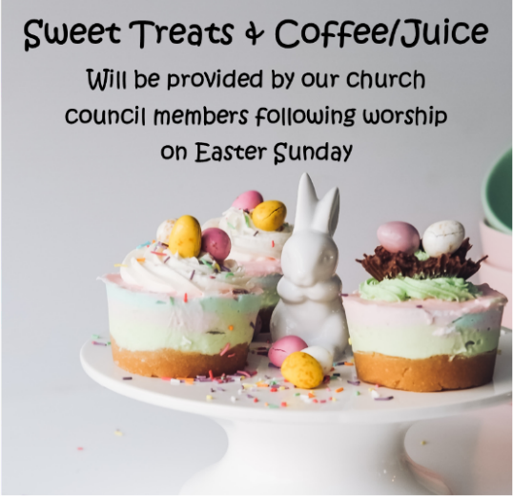
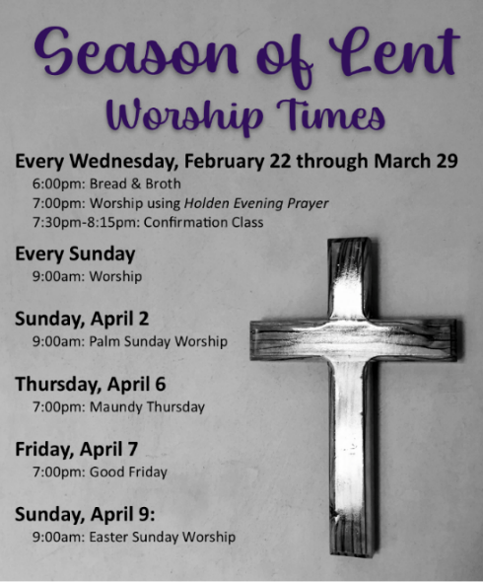
Thank you for observing silence until you have left the church.
This service was adapted from one created A Sancified Art, Sarah Are with additions from Meta Herrick Carlson’s Speak It Plain.

