Good Shepherd Lutheran Church
Pastor: Rev. Katie Anderson | Music Director: Rev. Lois Swanson
Pastor’s Cell: (715) 245-1943 | Office Phone: (715) 387-2731
Pastor Email: gslcwi.pastor@gmail.com | Office Email: gslcwi.office@gmail.com
Website: GoodShepherdMarshfield.org | www.facebook.com/gslcwi
Fourth Sunday of Easter
April 30, 2023, 9:00 am
Introduction to the day…
Today is sometimes called “Good Shepherd Sunday.” Jesus is called the “gate” of the sheep in today’s gospel. The risen Christ opens the way to abundant life. He anoints our heads with oil and guides us beside the still waters of our baptism. Each Sunday he spreads a feast before us amid the world’s violence and war. We go forth to be signs of the resurrection and extend God’s tender care to all creation.
ANNOUNCEMENTS
GATHERING
GATHERING SONG I Know That My Redeemer Lives ELW 619
THANKSGIVING FOR BAPTISM
Blessed be the holy Trinity, ☩ one God,
by whose hand we are given new birth,
by whose speaking we are given new life.
Amen.
Joined to Christ in the waters of baptism,
we are welcomed, restored, and supported
as citizens of the new creation.
Let us give thanks for the gift of baptism.
Holy God,
holy and merciful,
holy and mighty,
you are the river of life,
you are the everlasting wellspring.
In mercy and might you have freed us from death
and raised us with Jesus, the firstborn of the dead.
In baptismal waters our old life is washed away,
and in them we are born anew.
Glory to you for oceans and lakes,
for rivers and streams.
Honor to you for waters that wash us clean,
quench our thirst, and nurture both crops and creatures.
Praise to you for the life-giving water of baptism,
the outpouring of the Spirit of the new creation.
Wash away our sin and all that separates us from you.
Empower our witness to your resurrection.
Strengthen our resolve in seeking justice for all.
Satisfy the world’s need through this living water.
Where drought dries the earth, bring refreshment.
Where despair prevails, grant hope.
Where chaos reigns, bring peace.
We ask this through Christ,
who with you and the Spirit reigns forever.
Amen.

PRAYER OF THE DAY
O God our shepherd, you know your sheep by name and lead us to safety through the valleys of death. Guide us by your voice, that we may walk in certainty and security to the joyous feast prepared in your house, through Jesus Christ, our Savior and Lord, who lives and reigns with you and the Holy Spirit, one God, now and forever. Amen.
CHILDREN’S MESSAGE
CHILDREN’S SONG Jesus Loves Me ELW 595
SCRIPTURE READINGS
FIRST READING: Acts 2:42-47
⁴²[The baptized] devoted themselves to the apostles’ teaching and fellowship, to the breaking of bread and the prayers.
⁴³Awe came upon everyone, because many wonders and signs were being done by the apostles. ⁴⁴All who believed were together and had all things in common; ⁴⁵they would sell their possessions and goods and distribute the proceeds to all, as any had need. ⁴⁶Day by day, as they spent much time together in the temple, they broke bread at home and ate their food with glad and generous hearts, ⁴⁷praising God and having the goodwill of all the people. And day by day the Lord added to their number those who were being saved.
Word of God, word of life.
Thanks be to God.
PSALM: Psalm 23
¹The Lord| is my shepherd;
I shall not | be in want.
²The Lord makes me lie down | in green pastures
and leads me be- | side still waters.
³You restore my | soul, O Lord,
and guide me along right pathways | for your name’s sake.
⁴Though I walk through the valley of the shadow of death, I shall | fear no evil;
for you are with me; your rod and your staff, they | comfort me. R
⁵You prepare a table before me in the presence | of my enemies;
you anoint my head with oil, and my cup is | running over.
⁶Surely goodness and mercy shall follow me all the days | of my life,
and I will dwell in the house of the | Lord forever.
SECOND READING: 1 Peter 2:19-25
¹⁹It is a credit to you if, being aware of God, you endure pain while suffering unjustly. ²⁰If you endure when you are beaten for doing wrong, what credit is that? But if you endure when you do right and suffer for it, you have God’s approval. ²¹For to this you have been called, because Christ also suffered for you, leaving you an example, so that you should follow in his steps.
²²“He committed no sin,
and no deceit was found in his mouth.”
²³When he was abused, he did not return abuse; when he suffered, he did not threaten; but he entrusted himself to the one who judges justly. ²⁴He himself bore our sins in his body on the cross, so that, free from sins, we might live for righteousness; by his wounds you have been healed. ²⁵For you were going astray like sheep, but now you have returned to the shepherd and guardian of your souls.
Word of God, word of life.
Thanks be to God.
GOSPEL ACCLAMATION ELW 174
GOSPEL: John 10:1-10
[Jesus said:] ¹“Very truly, I tell you, anyone who does not enter the sheepfold by the gate but climbs in by another way is a thief and a bandit. ²The one who enters by the gate is the shepherd of the sheep. ³The gatekeeper opens the gate for him, and the sheep hear his voice. He calls his own sheep by name and leads them out. ⁴When he has brought out all his own, he goes ahead of them, and the sheep follow him because they know his voice. ⁵They will not follow a stranger, but they will run from him because they do not know the voice of strangers.” ⁶Jesus used this figure of speech with them, but they did not understand what he was saying to them.
⁷So again Jesus said to them, “Very truly, I tell you, I am the gate for the sheep. ⁸All who came before me are thieves and bandits; but the sheep did not listen to them. ⁹I am the gate. Whoever enters by me will be saved, and will come in and go out and find pasture. ¹⁰The thief comes only to steal and kill and destroy. I came that they may have life, and have it abundantly.”
The gospel of the Lord.
Praise to you, O Christ.
SERMON
HYMN OF THE DAY Will You Come and Follow Me ELW 798
APOSTLES’ CREED
I believe in God, the Father almighty,
creator of heaven and earth.
I believe in Jesus Christ, God's only Son, our Lord,
who was conceived by the power of the Holy Spirit,
born of the Virgin Mary,
suffered under Pontius Pilate,
was crucified, died, and was buried;
he descended to the dead.
On the third day he rose again;
he ascended into heaven,
he is seated at the right hand of the Father,
and he will come to judge the living and the dead.
I believe in the Holy Spirit,
the holy catholic Church,
the communion of saints,
the forgiveness of sins,
the resurrection of the body,
and the life everlasting. Amen
PRAYERS OF INTERCESSION
…Hear us, O God.
Your mercy is great.
Rejoicing in the victory of Christ’s resurrection, we lift our prayers and praise to you, almighty and eternal God; through Jesus Christ, our risen Lord.
Amen.

PEACE
The peace of Christ be with you always.
And also with you.
HOLY COMMUNION
OFFERING In addition to our normal offering, a Special Benevolence in April (collected in a special envelope) will go to Orenda Center - PDC. They are dedicated to the safety and empowerment of those impacted by domestic abuse and sexual assault.
OFFERING SONG The King of Love My Shepherd Is ELW 502
OFFERTORY PRAYER
Generous God,
in this meal you offer your very self.
We give thanks for these gifts of the earth.
In the breaking of this bread
reveal to us the Risen One.
In the pouring of this wine
pour us out in service to the world;
through Christ our Lord.
Amen.
GREAT THANKSGIVING
The Lord be with you.
And also with you.
Lift up your hearts.
We lift them to the Lord.
Let us give our thanks to the Lord our God.
It is right to give our thanks and praise.
HOLY, HOLY, HOLY (Sung)
Holy, holy, holy Lord, God of pow’r God of might,
heaven and earth are full of your glory.
Hosanna, hosanna, hosanna in the highest.
Blessed is he who comes in the name of the Lord.
Hosanna in the highest.
Words: Hans Peterson, 2008 Dakota Road Music, Used by permission. CCLI License # 669990
THANKSGIVING AT THE TABLE
Blessed are you, O God of the universe.
Your mercy is everlasting
and your faithfulness endures from age to age.
Praise to you for creating the heavens and the earth.
Praise to you for saving the earth from the waters of the flood.
Praise to you for bringing the Israelites safely through the sea.
Praise to you for leading your people through the wilderness
to the land of milk and honey.
Praise to you for the words and deeds of Jesus, your anointed one.
Praise to you for the death and resurrection of Christ.
Praise to you for your Spirit poured out on all nations.
In the night in which he was betrayed,
our Lord Jesus took bread, and gave thanks;
broke it, and gave it to his disciples, saying:
Take and eat; this is my body, given for you.
Do this for the remembrance of me.
Again, after supper, he took the cup, gave thanks,
and gave it for all to drink, saying:
This cup is the new covenant in my blood,
shed for you and for all people for the forgiveness of sin.
Do this for the remembrance of me.
With this bread and cup
we remember our Lord’s passover from death to life
as we proclaim the mystery of faith:
Christ has died.
Christ is risen.
Christ will come again.
O God of resurrection and new life:
Pour out your Holy Spirit on us
and on these gifts of bread and wine.
Bless this feast.
Grace our table with your presence.
Come, Holy Spirit.
Reveal yourself to us in the breaking of the bread.
Raise us up as the body of Christ for the world.
Breathe new life into us.
Send us forth,
burning with justice, peace, and love.
Come, Holy Spirit.
With your holy ones of all times and places,
with the earth and all its creatures,
with sun and moon and stars,
we praise you, O God,
blessed and holy Trinity,
now and forever.
Amen.
THE LORD’S PRAYER
Our Father, who art in heaven,
hallowed be thy name,
thy kingdom come,
thy will be done,
on earth as it is in heaven.
Give us this day our daily bread;
and forgive us our trespasses,
as we forgive those
who trespass against us;
and lead us not into temptation,
but deliver us from evil.
For thine is the kingdom,
and the power, and the glory,
forever and ever. Amen.
INVITATION TO COMMUNION - Certified gluten-free crackers are in the bowl on the communion plate.
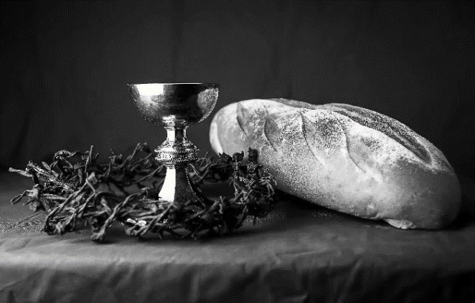
Come and know Christ,
broken and poured out for you.

HOLY COMMUNION
PRAYER AFTER COMMUNION
Gracious God,
in you we live and move and have our being.
With your word and this meal of grace,
you have nourished our life together.
Strengthen us to show your love
and serve the world in Jesus’ name.
Amen.
SENDING
BLESSING
The God of all,
who raised ☩ Jesus from the dead,
bless you by the power of the Holy Spirit
to live in the new creation.
Amen.
SONG Savior, like a Shepherd Lead Us ELW 789
DISMISSAL
Go in peace. Serve the Risen One.
Thanks be to God.
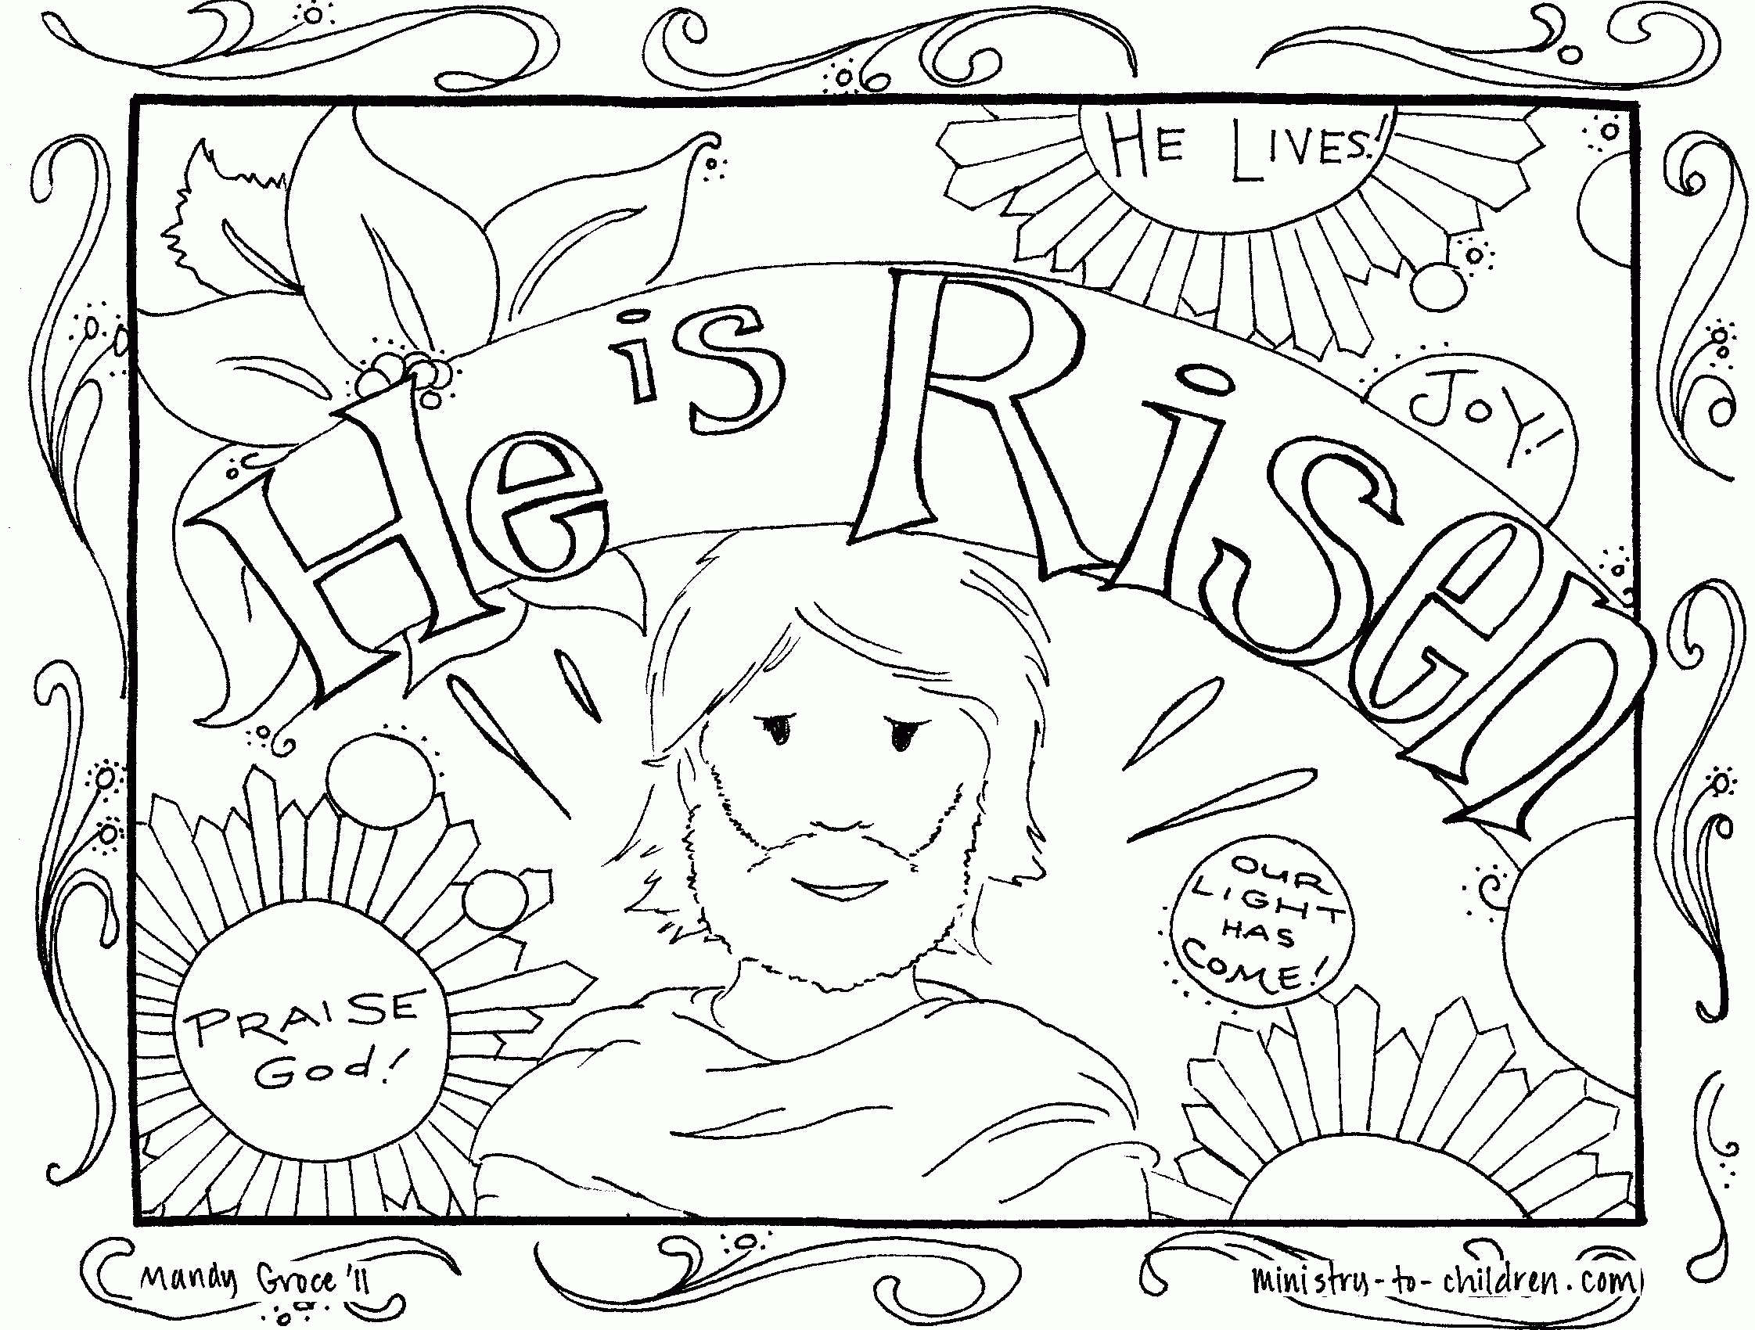
Upcoming Worship Assistants
 | Usher | Lector | Communion | Offering Counters
April 30 | Charles & Mary Schlafke | Kris Tarter | Dave & Sue Schraeder | Heidi Binder | Kami Weis
May 7  Confirmation | May & Jon Hill | Linda Schrieber | Dave & Sue Schraeder | Pam Mundt | May Hill
May 14 | Susan Schoolman | Nancy Tibbett | Dave & Shelly Schneider | Dan Mundt | Jon Hill
May 21 | Dave & Sue Schraeder | Leslie Mader | Andrea Hovick  Sarah Kopitzke | Nancy Leonard | Breanna Butler
May 28 | Dennis & Linda Schuttee | Christine Tipping | Tammy Neumann  Nancy Leonard | Robin Beeman | David Schneider

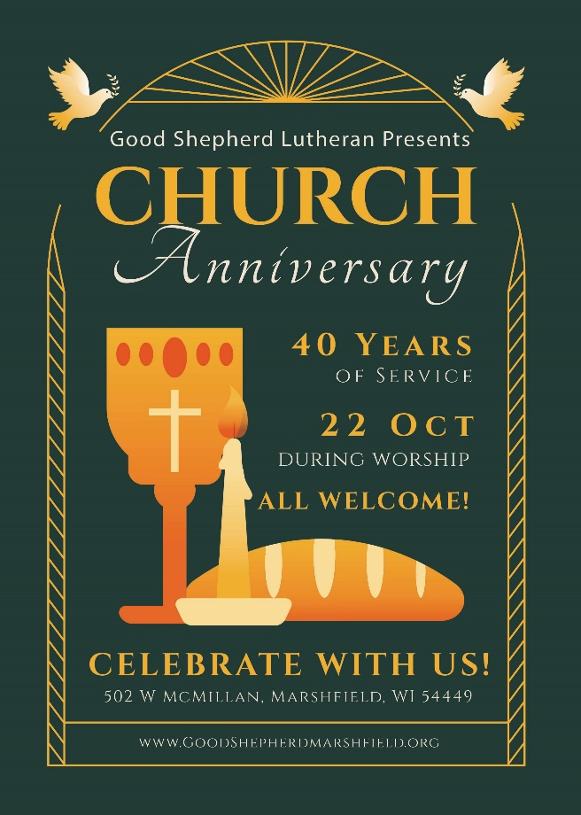
Coming up at GSLC
Sunday, April 30 | 9:00 am | Worship Service  - Fourth Sunday of Easter  - John 10:1-10; Christ the shepherd  - Sunday School
Tuesday, May 2 | 6:00 pm | Executive Committee Meeting
 | 7:00 pm | AA meeting in the fellowship hall
Wednesday, May 3 | 7:00 pm | Midweek Worship Service
Thursday, May 4 | 11:30-2:00 | Purple Angels
Sunday, May 7 | 9:00 am | Worship Service  - Confirmation: Christopher Stuttgen  - Baptism: Damon Blanchard  - Last Sunday School of the year
