Good Shepherd Lutheran Church
Pastor: Rev. Katie Anderson | Music Director: Rev. Lois Swanson
Pastor’s Cell: (715) 245-1943 | Office Phone: (715) 387-2731
Pastor Email: gslcwi.pastor@gmail.com | Office Email: gslcwi.office@gmail.com
Website: GoodShepherdMarshfield.org | www.facebook.com/gslcwi
Palm Sunday
April 2, 2023, 9:00 am
Introduction to the day…
Today, we encounter the paradox that defines our faith: Jesus Christ is glorified king and humiliated servant. We too are full of paradox: like Peter, we fervently desire to follow Christ, but find ourselves afraid, denying God. We wave palms in celebration today as Christ comes into our midst, and we follow with trepidation as his path leads to death on the cross. Amid it all we are invited into this paradoxical promise of life through Christ’s broken body and outpoured love in a meal of bread and wine. We begin this week that stands at the center of the church year, anticipating the completion of God’s astounding work.
ANNOUNCEMENTS
GATHERING
GATHERING SONG Hosanna, Loud Hosanna
- Hosanna, loud hosanna,  The little children sang;  Through pillared court and Temple  The lovely anthem rang.  To Jesus, who had blessed them,  Close folded to His breast,  The children sang their praises,  The simplest and the best. | - "Hosanna in the highest!"  That ancient song we sing,  For Christ is our Redeemer,  The Lord of heaven our King.  Oh, may we ever praise Him  With heart and life and voice  And in His blissful presence  Eternally rejoice.
- From Olivet they followed
Mid an exultant crowd,
The victor palm-branch waving
And chanting clear and loud.
The Lord of men and angels
Rode on in lowly state
Nor scorned that little children
Should on His bidding wait.
CONFESSION AND FORGIVENESS
Blessed be the holy Trinity, ☩ one God,
who journeys with us these forty days,
and sustains us with the gift of grace.
Amen.
Let us acknowledge before God and one another
our need for repentance and God’s mercy.
Silence is kept for reflection.
Holy God,
we confess to you our faults and failings.
Too often we neglect and do not trust your holy word;
we take for ourselves instead of giving to others;
we spoil rather than steward your creation;
we cause hurt though you call us to heal;
we choose fear over compassion.
Forgive us, renew us, and lead us,
as we seek to follow in your way of life.
Amen.
Hear the good news:
God so loved the world that God gave the only Son,
so that all may receive life.
This promise is for you!
God embraces you with divine mercy,
☩ forgives you in Christ’s name,
and revives you in the Spirit’s power.
Amen.
PRAYER OF THE DAY
Sovereign God, you have established your rule in the human heart through the servanthood of Jesus Christ. By your Spirit, keep us in the joyful procession of those who with their tongues confess Jesus as Lord and with their lives praise him as Savior, who lives and reigns with you and the Holy Spirit, one God, now and forever. Amen.
CHILDREN’S MESSAGE
CHILDREN’S SONG I am a C-H-R-I-S-T-I-A-N
I am a C,
I am a C-H,
I am a C-H-R-I-S-T-I-A-N, and I have C-H-R-I-S-T, in my H-E-A-R-T,
and I will L-I-V-E E-T-E-R-N-A-L-L-Y.
SCRIPTURE READINGS
PSALM: Psalm 118:1-2, 19-29
¹O give thanks to the LORD, for he is good;
his steadfast love endures forever!
²Let Israel say,
"His steadfast love endures forever."
¹⁹Open to me the gates of righteousness,
that I may enter through them
and give thanks to the LORD.
²⁰This is the gate of the LORD;
the righteous shall enter through it.
²¹I thank you that you have answered me
and have become my salvation.
²²The stone that the builders rejected
has become the chief cornerstone.
²³This is the LORD's doing;
it is marvelous in our eyes.
²⁴This is the day that the LORD has made;
let us rejoice and be glad in it.
²⁵Save us, we beseech you, O LORD!
O LORD, we beseech you, give us success!
²⁶Blessed is the one who comes in the name of the LORD.
We bless you from the house of the LORD.
²⁷The LORD is God, and he has given us light.
Bind the festal procession with branches, up to the horns of the altar.
²⁸You are my God, and I will give thanks to you;
you are my God, I will extol you.
²⁹O give thanks to the LORD, for he is good,
for his steadfast love endures forever.

READING: Philippians 2:5-11
⁵Let the same mind be in you that was in Christ Jesus,
⁶who, though he was in the form of God,
did not regard equality with God
as something to be exploited,
⁷but emptied himself,
taking the form of a slave,
being born in human likeness.
And being found in human form,
⁸he humbled himself
and became obedient to the point of death—
even death on a cross.
⁹Therefore God also highly exalted him
and gave him the name
that is above every name,
¹⁰so that at the name of Jesus
every knee should bend,
in heaven and on earth and under the earth,
¹¹and every tongue should confess
that Jesus Christ is Lord,
to the glory of God the Father.
Word of God, word of life.
Thanks be to God.
GOSPEL ACCLAMATION Tree of Life
Return to the Lord, your God,
who is gracious and merciful, slow to anger,
and abounding in steadfast love,
and abounding in steadfast love.
GOSPEL: Matthew 21:1-11
¹When they had come near Jerusalem and had reached Bethphage, at the Mount of Olives, Jesus sent two disciples, ²saying to them, “Go into the village ahead of you, and immediately you will find a donkey tied, and a colt with her; untie them and bring them to me. ³If anyone says anything to you, just say this, ‘The Lord needs them.’ And he will send them immediately.” ⁴This took place to fulfill what had been spoken through the prophet, saying,
⁵“Tell the daughter of Zion,
Look, your king is coming to you,
humble, and mounted on a donkey,
and on a colt, the foal of a donkey.”
⁶The disciples went and did as Jesus had directed them; ⁷they brought the donkey and the colt, and put their cloaks on them, and he sat on them. ⁸A very large crowd spread their cloaks on the road, and others cut branches from the trees and spread them on the road. ⁹The crowds that went ahead of him and that followed were shouting,
“Hosanna to the Son of David!
Blessed is the one who comes in the name of the Lord!
Hosanna in the highest heaven!”
¹⁰When he entered Jerusalem, the whole city was in turmoil, asking, “Who is this?” ¹¹The crowds were saying, “This is the prophet Jesus from Nazareth in Galilee.”
The gospel of the Lord.
Praise to you, O Christ.
SERMON
HYMN OF THE DAY All Glory, Land and Honor ELW 344
APOSTLES’ CREED
I believe in God, the Father almighty,
creator of heaven and earth.
I believe in Jesus Christ, God's only Son, our Lord,
who was conceived by the power of the Holy Spirit,
born of the Virgin Mary,
suffered under Pontius Pilate,
was crucified, died, and was buried;
he descended to the dead.
On the third day he rose again;
he ascended into heaven,
he is seated at the right hand of the Father,
and he will come to judge the living and the dead.
I believe in the Holy Spirit,
the holy catholic Church,
the communion of saints,
the forgiveness of sins,
the resurrection of the body,
and the life everlasting. Amen
PRAYERS OF INTERCESSION
…Merciful God,
receive our prayer.
We lift our prayers to you, O God, trusting in your steadfast love and your promise to renew your whole creation; through Jesus Christ our Savior.
Amen.
PEACE
The peace of Christ be with you always.
And also with you.
HOLY COMMUNION
OFFERING In addition to our normal offering, a Special Benevolence in April (collected in a special envelope) will go to PDC – Orenda Center. PDC is dedicated to the safety and empowerment of those impacted by domestic abuse and sexual assault. Our mission is to assist those in distress by identifying options and resources, promoting safety, building hope, and strengthening individuals, families, and our community through case management, advocacy and education.
OFFERING SONG Ride On, Ride On in Majesty! ELW 346
OFFERTORY PRAYER
God of good gifts,
receive these and all our offerings
as we present them in faithful service
for the sake of your gospel.
Prepare our hearts to receive you in this meal
as you pour out your very presence
through Christ Jesus, the wellspring of eternal life.
Amen.
GREAT THANKSGIVING
The Lord be with you.
And also with you.
Lift up your hearts.
We lift them to the Lord.
Let us give our thanks to the Lord our God.
It is right to give our thanks and praise.

HOLY, HOLY, HOLY (Sung) Tree of Life
Holy, holy, holy Lord, God of power and might,
heaven and earth are full of your glory.
Hosanna, hosanna, hosanna in the highest.
Blessed is he, blessed is he who comes in the name of the Lord.
Hosanna, hosanna, hosanna in the highest, hosanna in the highest.
THANKSGIVING AT THE TABLE

Blessed are you, O God of the universe.
Your mercy is everlasting
and your faithfulness endures from age to age.
Praise to you for creating the heavens and the earth.
Praise to you for saving the earth from the waters of the flood.
Praise to you for bringing the Israelites safely through the sea.
Praise to you for leading your people through the wilderness
to the land of milk and honey.
Praise to you for the words and deeds of Jesus, your anointed one.
Praise to you for the death and resurrection of Christ.
Praise to you for your Spirit poured out on all nations.
In the night in which he was betrayed,
our Lord Jesus took bread, and gave thanks;
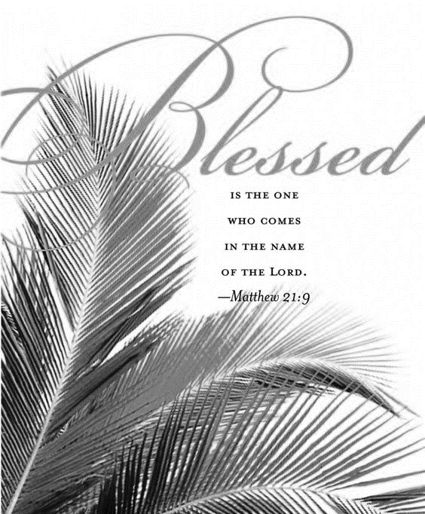
broke it, and gave it to his disciples, saying:
Take and eat; this is my body, given for you.
Do this for the remembrance of me.
Again, after supper, he took the cup, gave thanks,
and gave it for all to drink, saying:
This cup is the new covenant in my blood,
shed for you and for all people for the forgiveness of sin.
Do this for the remembrance of me.
With this bread and cup
we remember our Lord’s passover from death to life
as we proclaim the mystery of faith:
Christ has died.
Christ is risen.
Christ will come again.
O God of resurrection and new life:
Pour out your Holy Spirit on us
and on these gifts of bread and wine.
Bless this feast.
Grace our table with your presence.
Come, Holy Spirit.
Reveal yourself to us in the breaking of the bread.
Raise us up as the body of Christ for the world.
Breathe new life into us.
Send us forth,
burning with justice, peace, and love.
Come, Holy Spirit.
With your holy ones of all times and places,
with the earth and all its creatures,
with sun and moon and stars,
we praise you, O God,
blessed and holy Trinity,
now and forever.
Amen.
THE LORD’S PRAYER
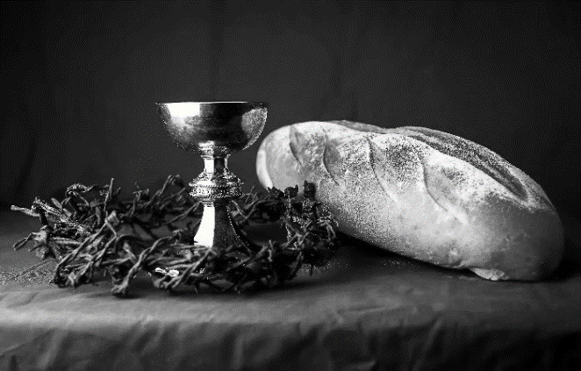
Our Father, who art in heaven,
hallowed be thy name,
thy kingdom come,
thy will be done,
on earth as it is in heaven.
Give us this day our daily bread;
and forgive us our trespasses,
as we forgive those
who trespass against us;
and lead us not into temptation,
but deliver us from evil.
For thine is the kingdom,
and the power, and the glory,
forever and ever. Amen.
INVITATION TO COMMUNION - Certified gluten-free crackers are in the bowl on the communion plate.
Come and receive Jesus, our strength in the wilderness.
HOLY COMMUNION
PRAYER AFTER COMMUNION
Embodied God,
at your table, we have tasted the goodness of Jesus.
With the eyes of our hearts open to your promise,
empower us to hear the needs of our neighbors
and touch the world with your love.
Amen.

SENDING
BLESSING
God, the giver of love,
☩ Christ, the resurrection and the life,
and the Holy Spirit of rebirth
bless you in this Lenten journey.
Amen.
SONG Lead On, O King Eternal! ELW 805
DISMISSAL
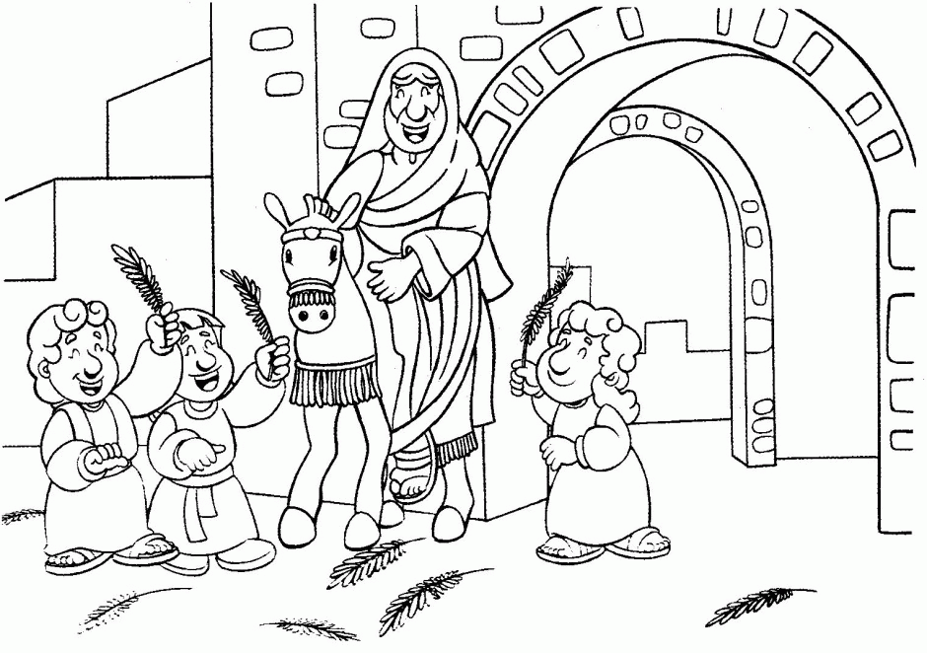
Go in peace. Serve in love.
Thanks be to God.

Upcoming Worship Assistants
 | Usher | Lector | Communion | Offering Counters
April 2 | Ruth & Ed Raatz | Leslie Mader | Dan & Pam Mundt | Pam Mundt | May Hill
April 9  Easter | Brett & Breanna Butler | Andrea Hovick | Dave & Sue Schraeder | Dan Mundt | Jon Hill
April 16 | Ben & Jannalee Lindquist | Julie Will | Bruce & Nancy Tibbett | Nancy Leonard | Breanna Butler
April 23 | Ron Rothfusz | Shelly Schneider | Bob & Laurel Peterson | Robin Beeman | Dave Schneider
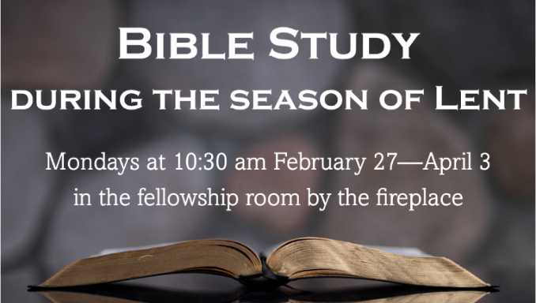
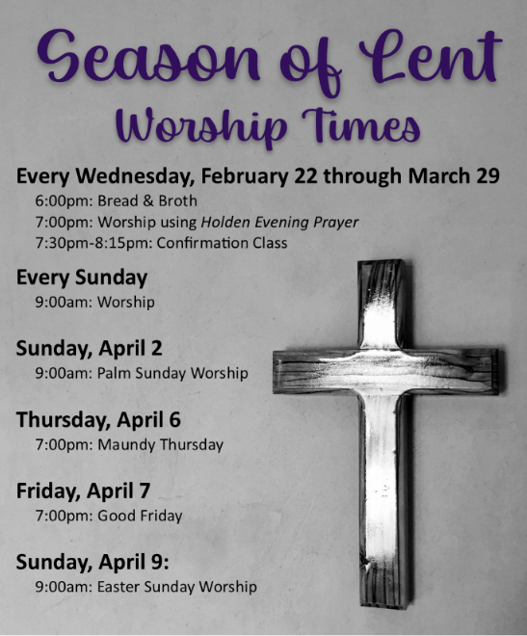

Coming up at GSLC
Monday, April 3 | 10:30-11:30 am | Bible Study by the fireplace
Tuesday, April 4 | 9:30-10:30 am | Children’s of WI playgroup – all parents & children under 4 welcome
 | 6:00 pm | Executive Committee Meeting
 | 7:00 pm | AA meeting in the fellowship hall
Thursday, April 6 | 12-2:00 pm | Purple Angels Memory Cafe
 | 7:00 pm | Maundy Thursday Service  First Communion for 3rd grade students
Friday, April 7 | 7:00 pm | Good Friday Service
Sunday, April 9 | 9:00 am | Easter Worship Service  - Sweet Treats provided by council members following worship
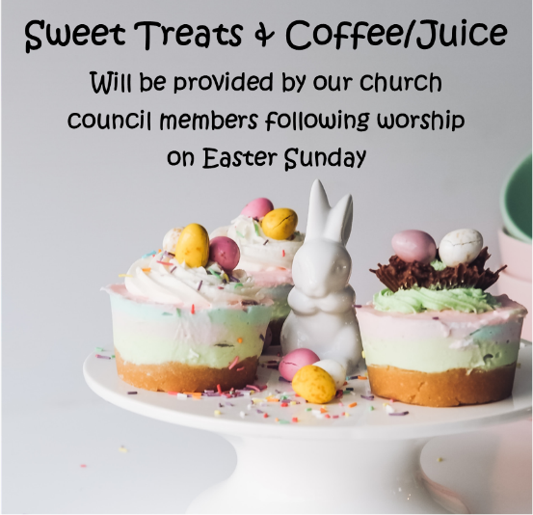
Christ in Our Home daily devotional booklet is available in the church entrance for April, May, & June.
Spark children's magazine and Living Lutheran magazine are available in the entrance of the church.

