Good Shepherd Lutheran Church
Pastor: Rev. Katie Anderson | Music Director: Rev. Lois Swanson
Pastor’s Cell: (715) 245-1943 | Office Phone: (715) 387-2731
Pastor Email: gslcwi.pastor@gmail.com | Office Email: gslcwi.office@gmail.com
Website: GoodShepherdMarshfield.org | www.facebook.com/gslcwi
Second Sunday of Easter
April 16, 2023, 9:00 am
Introduction to the day…
In today’s gospel the risen Christ appears to the disciples and offers them the gift of peace. Even amid doubts and questions, we experience the resurrection in our Sunday gathering around word and meal, and in our everyday lives. Throughout the coming Sundays of Easter the first two readings will be from the Acts of the Apostles and the first letter of Peter. Even as the early Christians proclaimed the resurrection, we rejoice in the new birth and living hope we receive in baptism.
ANNOUNCEMENTS
GATHERING
GATHERING SONG Christ is Risen! Alleluia ELW 382
THANKSGIVING FOR BAPTISM
Blessed be the holy Trinity, ☩ one God,
by whose hand we are given new birth,
by whose speaking we are given new life.
Amen.
Joined to Christ in the waters of baptism,
we are welcomed, restored, and supported
as citizens of the new creation.
Let us give thanks for the gift of baptism.
Holy God,
holy and merciful,
holy and mighty,
you are the river of life,
you are the everlasting wellspring.
In mercy and might you have freed us from death
and raised us with Jesus, the firstborn of the dead.
In baptismal waters our old life is washed away,
and in them we are born anew.
Glory to you for oceans and lakes,
for rivers and streams.
Honor to you for waters that wash us clean,
quench our thirst, and nurture both crops and creatures.
Praise to you for the life-giving water of baptism,
the outpouring of the Spirit of the new creation.
Wash away our sin and all that separates us from you.
Empower our witness to your resurrection.
Strengthen our resolve in seeking justice for all.
Satisfy the world’s need through this living water.
Where drought dries the earth, bring refreshment.
Where despair prevails, grant hope.
Where chaos reigns, bring peace.
We ask this through Christ,
who with you and the Spirit reigns forever.
Amen.

PRAYER OF THE DAY
Almighty and eternal God, the strength of those who believe and the hope of those who doubt, may we, who have not seen, have faith in you and receive the fullness of Christ’s blessing, who lives and reigns with you and the Holy Spirit, one God, now and forever. Amen.
CHILDREN’S MESSAGE
CHILDREN’S SONG Alive, Alive
Alive, alive, alive forevermore, my Jesus is alive, alive forevermore.
Alive, alive, alive forevermore, my Jesus is alive!
Refrain:
Sing Hallelujah! Sing Hallelujah! My Jesus is alive forevermore.
Sing Hallelujah! Sing Hallelujah! My Jesus is alive.
He conquered death and lives forevermore, my Jesus is alive, alive forevermore.
He conquered death and lives forevermore, my Jesus is alive! Refrain
He reigns, He reigns, on high forevermore, my Jesus is alive, alive forevermore. He reigns, He reigns, on high forevermore, my Jesus is alive. Refrain(2x)
SCRIPTURE READINGS
FIRST READING: Acts 2:14a, 22-32
^{14a}Peter, standing with the eleven, raised his voice and addressed [the crowd], ²²“You that are Israelites, listen to what I have to say: Jesus of Nazareth, a man attested to you by God with deeds of power, wonders, and signs that God did through him among you, as you yourselves know—²³this man, handed over to you according to the definite plan and foreknowledge of God, you crucified and killed by the hands of those outside the law. ²⁴But God raised him up, having freed him from death, because it was impossible for him to be held in its power. ²⁵For David says concerning him,
‘I saw the Lord always before me, for he is at my right hand so that I will not be shaken;
²⁶therefore my heart was glad, and my tongue rejoiced; moreover my flesh will live in hope.
²⁷For you will not abandon my soul to Hades, or let your Holy One experience corruption.
²⁸You have made known to me the ways of life;
you will make me full of gladness with your presence.’
²⁹“Fellow Israelites, I may say to you confidently of our ancestor David that he both died and was buried, and his tomb is with us to this day. ³⁰Since he was a prophet, he knew that God had sworn with an oath to him that he would put one of his descendants on his throne. ³¹Foreseeing this, David spoke of the resurrection of the Messiah, saying,
‘He was not abandoned to Hades,
nor did his flesh experience corruption.’
³²This Jesus God raised up, and of that all of us are witnesses.”
Word of God, word of life.
Thanks be to God.
PSALM: Psalm 16
¹Protect me, O God, for I take refuge in you;
I have said to the Lord, “You are my Lord, my good above all other.”
²All my delight is in the godly that are in the land,
upon those who are noble among the people.
³But those who run after other gods
shall have their troubles multiplied.
⁴I will not pour out drink offerings to such gods,
never take their names upon my lips.
⁵O Lord, you are my portion and my cup;
it is you who uphold my lot.
⁶My boundaries enclose a pleasant land;
indeed, I have a rich inheritance.
⁷I will bless the Lord who gives me counsel;
my heart teaches me night after night.
⁸I have set the Lord always before me;
because God is at my right hand, I shall not be shaken.
⁹My heart, therefore, is glad, and my spirit rejoices;
my body also shall rest in hope.
¹⁰For you will not abandon me to the grave,
nor let your holy one see the pit.
¹¹You will show me the path of life;
in your presence there is fullness of joy, and in your right hand are pleasures forevermore.
SECOND READING: 1 Peter 1:3-9
³Blessed be the God and Father of our Lord Jesus Christ! By his great mercy he has given us a new birth into a living hope through the resurrection of Jesus Christ from the dead, ⁴and into an inheritance that is imperishable, undefiled, and unfading, kept in heaven for you, ⁵who are being protected by the power of God through faith for a salvation ready to be revealed in the last time. ⁶In this you rejoice, even if now for a little while you have had to suffer various trials, ⁷so that the genuineness of your faith—being more precious than gold that, though perishable, is tested by fire—may be found to result in praise and glory and honor when Jesus Christ is revealed. ⁸Although you have not seen him, you love him; and even though you do not see him now, you believe in him and rejoice with an indescribable and glorious joy, ⁹for you are receiving the outcome of your faith, the salvation of your souls.
Word of God, word of life.
Thanks be to God.
GOSPEL ACCLAMATION ELW 174
GOSPEL: John 20:19-31
¹⁹When it was evening on that day, the first day of the week, and the doors of the house where the disciples had met were locked for fear of the Jews, Jesus came and stood among them and said, “Peace be with you.” ²⁰After he said this, he showed them his hands and his side. Then the disciples rejoiced when they saw the Lord. ²¹Jesus said to them again, “Peace be with you. As the Father has sent me, so I send you.” ²²When he had said this, he breathed on them and said to them, “Receive the Holy Spirit. ²³If you forgive the sins of any, they are forgiven them; if you retain the sins of any, they are retained.”
²⁴But Thomas (who was called the Twin), one of the twelve, was not with them when Jesus came. ²⁵So the other disciples told him, “We have seen the Lord.” But he said to them, “Unless I see the mark of the nails in his hands, and put my finger in the mark of the nails and my hand in his side, I will not believe.”
²⁶A week later his disciples were again in the house, and Thomas was with them. Although the doors were shut, Jesus came and stood among them and said, “Peace be with you.” ²⁷Then he said to Thomas, “Put your finger here and see my hands. Reach out your hand and put it in my side. Do not doubt but believe.” ²⁸Thomas answered him, “My Lord and my God!” ²⁹Jesus said to him, “Have you believed because you have seen me? Blessed are those who have not seen and yet have come to believe.”
³⁰Now Jesus did many other signs in the presence of his disciples, which are not written in this book. ³¹But these are written so that you may come to believe that Jesus is the Messiah, the Son of God, and that through believing you may have life in his name.
The gospel of the Lord.
Praise to you, O Christ.
SERMON
HYMN OF THE DAY Love Divine, All Loves Excelling ELW 631
APOSTLES’ CREED
I believe in God, the Father almighty,
creator of heaven and earth.
I believe in Jesus Christ, God's only Son, our Lord,
who was conceived by the power of the Holy Spirit,
born of the Virgin Mary,
suffered under Pontius Pilate,
was crucified, died, and was buried;
he descended to the dead.
On the third day he rose again;
he ascended into heaven,
he is seated at the right hand of the Father,
and he will come to judge the living and the dead.
I believe in the Holy Spirit,
the holy catholic Church,
the communion of saints,
the forgiveness of sins,
the resurrection of the body,
and the life everlasting. Amen
PRAYERS OF INTERCESSION
…Hear us,O God.
Your mercy is great.
Rejoicing in the victory of Christ’s resurrection, we lift our prayers and praise to you, almighty and eternal God; through Jesus Christ, our risen Lord.
Amen.
PEACE
The peace of Christ be with you always.
And also with you.
HOLY COMMUNION
OFFERING In addition to our normal offering, a Special Benevolence in April (collected in a special envelope) will go to Orenda Center - PDC. They are dedicated to the safety and empowerment of those impacted by domestic abuse and sexual assault.
OFFERING SONG When We Are Living ELW 639
OFFERTORY PRAYER
Generous God,
in this meal you offer your very self.
We give thanks for these gifts of the earth.
In the breaking of this bread
reveal to us the Risen One.
In the pouring of this wine
pour us out in service to the world;
through Christ our Lord.
Amen.
GREAT THANKSGIVING
The Lord be with you.
And also with you.
Lift up your hearts.
We lift them to the Lord.
Let us give our thanks to the Lord our God.
It is right to give our thanks and praise.
HOLY, HOLY, HOLY (Sung)
Holy, holy, holy Lord, God of pow’r God of might,
heaven and earth are full of your glory.
Hosanna, hosanna, hosanna in the highest.
Blessed is he who comes in the name of the Lord.
Hosanna in the highest.
Words: Hans Peterson, 2008 Dakota Road Music, Used by permission. CCLI License # 669990
THANKSGIVING AT THE TABLE

Blessed are you, O God of the universe.
Your mercy is everlasting
and your faithfulness endures from age to age.
Praise to you for creating the heavens and the earth.
Praise to you for saving the earth from the waters of the flood.
Praise to you for bringing the Israelites safely through the sea.
Praise to you for leading your people through the wilderness
to the land of milk and honey.
Praise to you for the words and deeds of Jesus, your anointed one.
Praise to you for the death and resurrection of Christ.
Praise to you for your Spirit poured out on all nations.
In the night in which he was betrayed,
our Lord Jesus took bread, and gave thanks;
broke it, and gave it to his disciples, saying:
Take and eat; this is my body, given for you.
Do this for the remembrance of me.
Again, after supper, he took the cup, gave thanks,
and gave it for all to drink, saying:
This cup is the new covenant in my blood,
shed for you and for all people for the forgiveness of sin.
Do this for the remembrance of me.

With this bread and cup
we remember our Lord’s passover from death to life
as we proclaim the mystery of faith:
Christ has died.
Christ is risen.
Christ will come again.
O God of resurrection and new life:
Pour out your Holy Spirit on us
and on these gifts of bread and wine.
Bless this feast.
Grace our table with your presence.
Come, Holy Spirit.
Reveal yourself to us in the breaking of the bread.
Raise us up as the body of Christ for the world.
Breathe new life into us.
Send us forth,
burning with justice, peace, and love.
Come, Holy Spirit.
With your holy ones of all times and places,
with the earth and all its creatures,
with sun and moon and stars,
we praise you, O God,
blessed and holy Trinity,
now and forever.
Amen.

THE LORD’S PRAYER
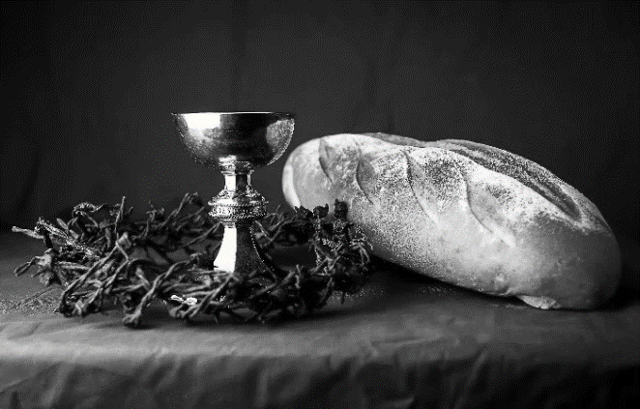
Our Father, who art in heaven,
hallowed be thy name,
thy kingdom come,
thy will be done,
on earth as it is in heaven.
Give us this day our daily bread;
and forgive us our trespasses,
as we forgive those
who trespass against us;
and lead us not into temptation,
but deliver us from evil.
For thine is the kingdom,
and the power, and the glory,
forever and ever. Amen.
INVITATION TO COMMUNION - Certified gluten-free crackers are in the bowl on the communion plate.
Come and know Christ,
broken and poured out for you.
HOLY COMMUNION

PRAYER AFTER COMMUNION
Gracious God,
in you we live and move and have our being.
With your word and this meal of grace,
you have nourished our life together.
Strengthen us to show your love
and serve the world in Jesus’ name.
Amen.
SENDING
BLESSING
The God of all,
who raised ☩ Jesus from the dead,
bless you by the power of the Holy Spirit
to live in the new creation.
Amen.
SONG Thine Is the Glory ELW 376
DISMISSAL
Go in peace. Serve the Risen One.
Thanks be to God.
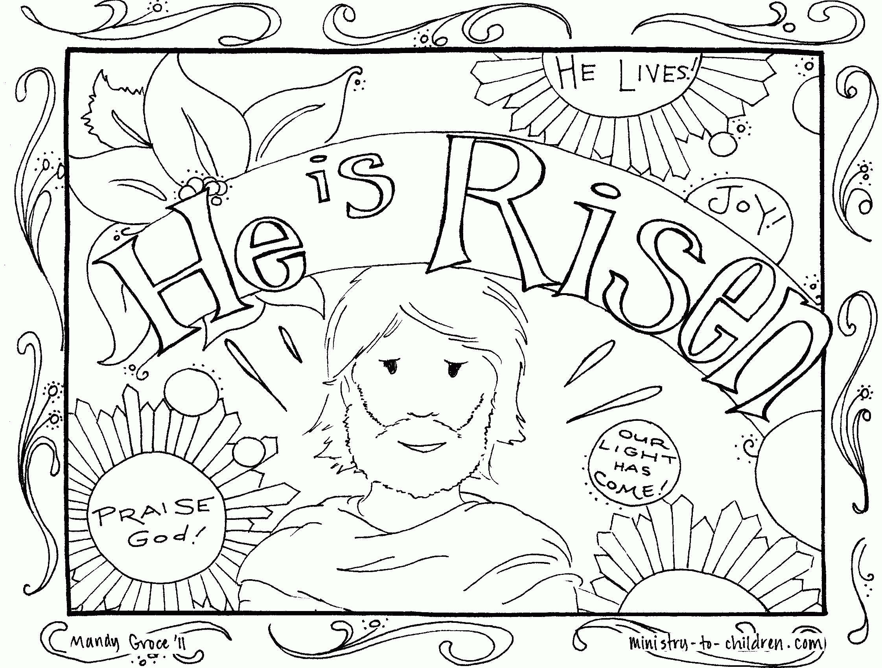
Upcoming Worship Assistants
 | Usher | Lector | Communion | Offering Counters
April 16 | Ben & Jannalee Lindquist | Julie Will | Bruce & Nancy Tibbett | Nancy Leonard | Breanna Butler
April 23 | Ron Rothfusz | Shelly Schneider | Bob & Laurel Peterson | Robin Beeman | David Schneider
April 30 | Charles & Mary Schlafke | Kris Tarter | Christopher Stuttgen  Danielle Stuttgen | Heidi Binder | Kami Weis
May 7  Confirmation | May & Jon Hill | Linda Schrieber | Dave & Sue Schraeder | Pam Mundt | May Hill
May 14 | Susan Schoolman | Nancy Tibbett | Dave & Shelly Schneider | Dan Mundt | Jon Hill

Coming up at GSLC
Sunday, April 16 | 9:00 am | Worship Service—Guest Pastor Joyce Heintz  - Second Sunday of Easter  - John 20:19-31; Beholding the wounds of the risen Christ.  Sunday School
Tuesday, April 18 | 9:30-10:30 am | Children’s of WI playgroup – all parents & children under 4 welcome
 | 2:00 pm | Chapel at Three Oaks
 | 7:00 pm | AA meeting in the fellowship hall
Wednesday, April 19 | 7:00 pm | Midweek Worship Service
 | 7:30 pm | Confirmation Class for 7th & 8th grade
Sunday, April 23 | 9:00 am | Worship Service  - Third Sunday of Easter  - Luke 24:13-35; Eating with the risen Christ.  Sunday School

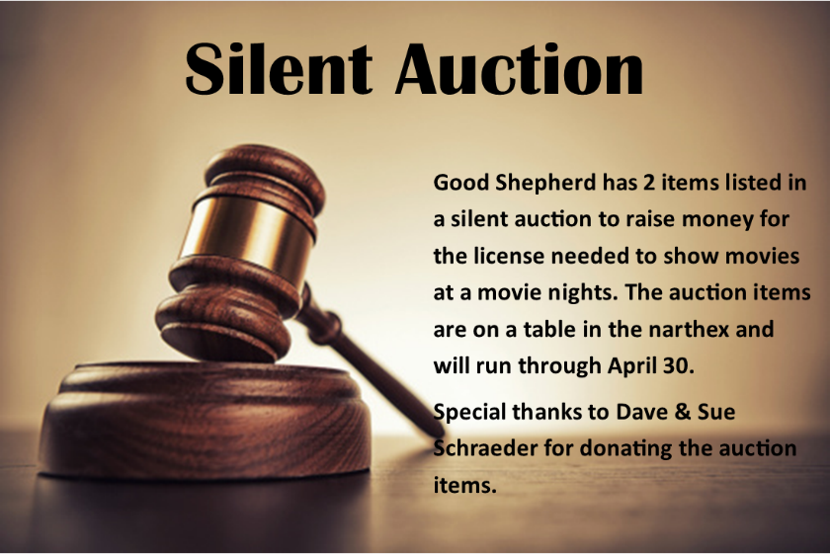

Easter Garden Donations
Carol Copet
in celebration of a Happy Easter
Rob & Leslie Mader
in honor of our children, Erin & Bethany
Dan & Pam Mundt
in memory of Gerry & Chuck Parsch and Gladys & Emil Mundt
in memory of Christopher Mundt
Chuck & Mary Schlafke
in celebration of a Happy Easter
Dave & Shelly Schneider
in celebration of Evan, Zoe, Erin & Taylor Schneider
Dave & Sue Schraeder
in celebration of our family & church family
Keith & Michelle Stuttgen
in celebration of Samantha, Maria, Christopher, & Danielle
John & Jane Wagner
in memory of Christopher Wagner

