Good Shepherd Lutheran Church
Pastor: Rev. Katie Anderson | Music Director: Rev. Lois Swanson
Pastor’s Cell: (715) 245-1943 | Office Phone: (715) 387-2731
Pastor Email: gslcwi.pastor@gmail.com | Office Email: gslcwi.office@gmail.com
Website: GoodShepherdMarshfield.org | www.facebook.com/gslcwi
Second Sunday in Lent
March 5, 2023, 9:00 am
Introduction to the day…
During Lent we journey with all those around the world who will be baptized at the Easter Vigil. In today’s gospel Jesus tells Nicodemus that he must be born of water and Spirit. At the font we are a given a new birth as children of God. As God made a covenant with Abraham, in baptism God promises to raise us up with Christ to new life. From worship we are sent forth to proclaim God’s love for all the world.
ANNOUNCEMENTS
GATHERING
GATHERING SONG Come and Gather from Tree of Life with music available in narthex
Refrain
Come and gather beneath the tree of life.
Come and gather beneath the tree of life—
root of wisdom, branch of peace, fruit of healing and release.
Come and gather beneath the tree of life.
2. Flowing from this tree of grace and passion,
Oh how sweet the taste, how deep and rich the well-spring of your love. (Refrain)
3. Come and drink the waters of salvation,
Come and die to sin, rise up to life with-in the Reign of God. (Refrain)
CONFESSION AND FORGIVENESS
Blessed be the holy Trinity, ☩ one God,
who journeys with us these forty days,
and sustains us with the gift of grace.
Amen.
Let us acknowledge before God and one another
our need for repentance and God’s mercy.
Silence is kept for reflection.
Holy God,
we confess to you our faults and failings.
Too often we neglect and do not trust your holy word;
we take for ourselves instead of giving to others;
we spoil rather than steward your creation;
we cause hurt though you call us to heal;
we choose fear over compassion.
Forgive us, renew us, and lead us,
as we seek to follow in your way of life.
Amen.
Hear the good news:
God so loved the world that God gave the only Son,
so that all may receive life.
This promise is for you!
God embraces you with divine mercy,
☩ forgives you in Christ’s name,
and revives you in the Spirit’s power.
Amen.
PRAYER OF THE DAY
O God, our leader and guide, in the waters of baptism you bring us to new birth to live as your children. Strengthen our faith in your promises, that by your Spirit we may lift up your life to all the world through your Son, Jesus Christ, our Savior and Lord, who lives and reigns with you and the Holy Spirit, one God, now and forever.
Amen.
CHILDREN’S MESSAGE
CHILDREN’S SONG Footprints on the Water
When I was a little fish, swimming happily
I heard the sound of footsteps walk'in on the sea
I swam up to the surface and much to my surprise,
there on top of the water right before my eyes
Chorus
And I saw footprints on the water, footprints on the sea.
Footprints on the water, I could not believe.
I saw Jesus, Jesus walking on the waves.
Footprints on the water that day.
Then a man named Peter stepped out on the waves.
He tried to walk to Jesus, then he sank away.
This is how it happened,
I heard Jesus say, “Take courage, it is I so don't be afraid.
Chorus (repeat)
SCRIPTURE READINGS
FIRST READING: Genesis 12:1-4a
¹The Lord said to Abram, “Go from your country and your kindred and your father’s house to the land that I will show you. ²I will make of you a great nation, and I will bless you, and make your name great, so that you will be a blessing. ³I will bless those who bless you, and the one who curses you I will curse; and in you all the families of the earth shall be blessed.”
^{4a}So Abram went, as the Lord had told him; and Lot went with him.
Word of God, word of life.
Thanks be to God.
PSALM: Psalm 121
¹I lift up my eyes to the hills;
from where is my help to come?
²My help comes from the Lord,
the maker of heaven and earth.
³The Lord will not let your foot be moved
nor will the one who watches over you fall asleep.
⁴Behold, the keeper of Israel
will neither slumber nor sleep;
⁵the Lord watches over you;
the Lord is your shade at your right hand;
⁶the sun will not strike you by day,
nor the moon by night.
⁷The Lord will preserve you from all evil
and will keep your life.
⁸The Lord will watch over your going out and your coming in,
from this time forth forevermore.

SECOND READING: Romans 4:1-5, 13-17
¹What then are we to say was gained by Abraham, our ancestor according to the flesh? ²For if Abraham was justified by works, he has something to boast about, but not before God. ³For what does the scripture say? “Abraham believed God, and it was reckoned to him as righteousness.” ⁴Now to one who works, wages are not reckoned as a gift but as something due. ⁵But to one who without works trusts him who justifies the ungodly, such faith is reckoned as righteousness.
¹³For the promise that he would inherit the world did not come to Abraham or to his descendants through the law but through the righteousness of faith. ¹⁴If it is the adherents of the law who are to be the heirs, faith is null and the promise is void. ¹⁵For the law brings wrath; but where there is no law, neither is there violation.
¹⁶For this reason it depends on faith, in order that the promise may rest on grace and be guaranteed to all his descendants, not only to the adherents of the law but also to those who share the faith of Abraham (for he is the father of all of us, ¹⁷as it is written, “I have made you the father of many nations”)—in the presence of the God in whom he believed, who gives life to the dead and calls into existence the things that do not exist.
Word of God, word of life.
Thanks be to God.
GOSPEL ACCLAMATION Tree of Life
Return to the Lord, your God,
who is gracious and merciful, slow to anger,
and abounding in steadfast love,
and abounding in steadfast love.
GOSPEL: John 3:1-17
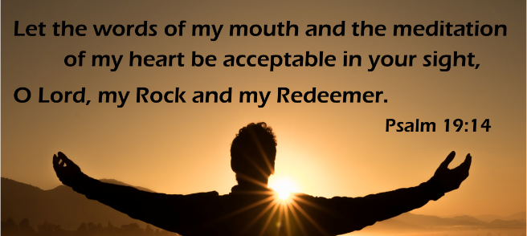
¹Now there was a Pharisee named Nicodemus, a leader of the Jews. ²He came to Jesus by night and said to him, “Rabbi, we know that you are a teacher who has come from God; for no one can do these signs that you do apart from the presence of God.” ³Jesus answered him, “Very truly, I tell you, no one can see the kingdom of God without being born from above.” ⁴Nicodemus said to him, “How can anyone be born after having grown old? Can one enter a second time into the mother’s womb and be born?” ⁵Jesus answered, “Very truly, I tell you, no one can enter the kingdom of God without being born of water and Spirit. ⁶What is born of the flesh is flesh, and what is born of the Spirit is spirit. ⁷Do not be astonished that I said to you, ‘You must be born from above.’ ⁸The wind blows where it chooses, and you hear the sound of it, but you do not know where it comes from or where it goes. So it is with everyone who is born of the Spirit.” ⁹Nicodemus said to him, “How can these things be?” ¹⁰Jesus answered him, “Are you a teacher of Israel, and yet you do not understand these things?
¹¹“Very truly, I tell you, we speak of what we know and testify to what we have seen; yet you do not receive our testimony. ¹²If I have told you about earthly things and you do not believe, how can you believe if I tell you about heavenly things? ¹³No one has ascended into heaven except the one who descended from heaven, the Son of Man. ¹⁴And just as Moses lifted up the serpent in the wilderness, so must the Son of Man be lifted up, ¹⁵that whoever believes in him may have eternal life.
¹⁶“For God so loved the world that he gave his only Son, so that everyone who believes in him may not perish but may have eternal life.
¹⁷“Indeed, God did not send the Son into the world to condemn the world, but in order that the world might be saved through him.”
The gospel of the Lord.
Praise to you, O Christ.
SERMON

HYMN OF THE DAY God Loved the World ELW 323

APOSTLES’ CREED
I believe in God, the Father almighty,
Do you or someone you know need an extra prayer said? There are PRAYER REQUEST CARDS
on the table in the narthex. Requests can be kept confidential, with Pastor, or can be made public to the congregation via Shepherd Staff email and in prayer at worship.
creator of heaven and earth.
I believe in Jesus Christ, God's only Son, our Lord,
who was conceived by the power of the Holy Spirit,
born of the Virgin Mary,
suffered under Pontius Pilate,
was crucified, died, and was buried;
he descended to the dead.
On the third day he rose again;
he ascended into heaven,
he is seated at the right hand of the Father,
and he will come to judge the living and the dead.
I believe in the Holy Spirit,
the holy catholic Church,
the communion of saints,
the forgiveness of sins,
the resurrection of the body,
and the life everlasting. Amen
PRAYERS OF INTERCESSION
…Merciful God,
receive our prayer.
We lift our prayers to you, O God, trusting in your steadfast love and your promise to renew your whole creation; through Jesus Christ our Savior.
Amen.
PEACE
The peace of Christ be with you always.
And also with you.
HOLY COMMUNION
OFFERING In addition to our normal offering, a Special Benevolence in March (collected in a special envelope) will go to Feed My Starving Children. Their mission is to feed God’s starving children hungry in body and spirit.
OFFERING SONG O Living Breath of God ELW 407
OFFERTORY PRAYER
God of good gifts,
receive these and all our offerings
as we present them in faithful service
for the sake of your gospel.
Prepare our hearts to receive you in this meal
as you pour out your very presence
through Christ Jesus, the wellspring of eternal life.
Amen.
GREAT THANKSGIVING
The Lord be with you.
And also with you.
Lift up your hearts.
We lift them to the Lord.
Let us give our thanks to the Lord our God.
It is right to give our thanks and praise.

HOLY, HOLY, HOLY (Sung) Tree of Life
Holy, holy, holy Lord, God of power and might,
heaven and earth are full of your glory.
Hosanna, hosanna, hosanna in the highest.
Blessed is he, blessed is he who comes in the name of the Lord.
Hosanna, hosanna, hosanna in the highest, hosanna in the highest.
THANKSGIVING AT THE TABLE

Blessed are you, O God of the universe.
Your mercy is everlasting
and your faithfulness endures from age to age.
Praise to you for creating the heavens and the earth.
Praise to you for saving the earth from the waters of the flood.
Praise to you for bringing the Israelites safely through the sea.
Praise to you for leading your people through the wilderness
to the land of milk and honey.
Praise to you for the words and deeds of Jesus, your anointed one.
Praise to you for the death and resurrection of Christ.
Praise to you for your Spirit poured out on all nations.
In the night in which he was betrayed,
our Lord Jesus took bread, and gave thanks;
broke it, and gave it to his disciples, saying:
Take and eat; this is my body, given for you.
Do this for the remembrance of me.
Again, after supper, he took the cup, gave thanks,
and gave it for all to drink, saying:
This cup is the new covenant in my blood,
shed for you and for all people for the forgiveness of sin.
Do this for the remembrance of me.

With this bread and cup
we remember our Lord’s passover from death to life
as we proclaim the mystery of faith:
Christ has died.
Christ is risen.
Christ will come again.
O God of resurrection and new life:
Pour out your Holy Spirit on us
and on these gifts of bread and wine.
Bless this feast.
Grace our table with your presence.
Come, Holy Spirit.
Reveal yourself to us in the breaking of the bread.
Raise us up as the body of Christ for the world.
Breathe new life into us.
Send us forth,
burning with justice, peace, and love.
Come, Holy Spirit.
With your holy ones of all times and places,
with the earth and all its creatures,
with sun and moon and stars,
we praise you, O God,
blessed and holy Trinity,
now and forever.
Amen.

THE LORD’S PRAYER
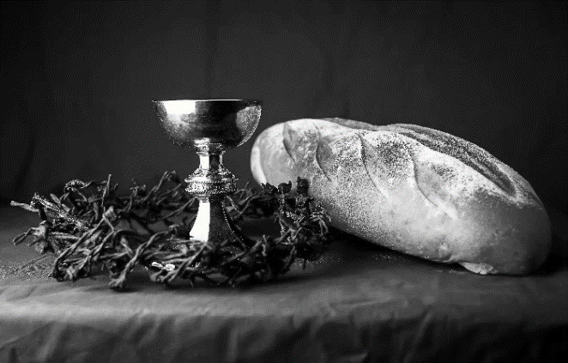
Our Father, who art in heaven,
hallowed be thy name,
thy kingdom come,
thy will be done,
on earth as it is in heaven.
Give us this day our daily bread;
and forgive us our trespasses,
as we forgive those
who trespass against us;
and lead us not into temptation,
but deliver us from evil.
For thine is the kingdom,
and the power, and the glory,
forever and ever. Amen.
INVITATION TO COMMUNION - Certified gluten-free crackers are in the bowl on the communion plate.
Come and receive Jesus, our strength in the wilderness.
HOLY COMMUNION

PRAYER AFTER COMMUNION
Embodied God,
at your table, we have tasted the goodness of Jesus.
With the eyes of our hearts open to your promise,
empower us to hear the needs of our neighbors
and touch the world with your love.
Amen.
SENDING
BLESSING
God, the giver of love,
☩ Christ, the resurrection and the life,
and the Holy Spirit of rebirth
bless you in this Lenten journey.
Amen.
SONG Lift High the Cross ELW 660
DISMISSAL
Go in peace. Serve in love.
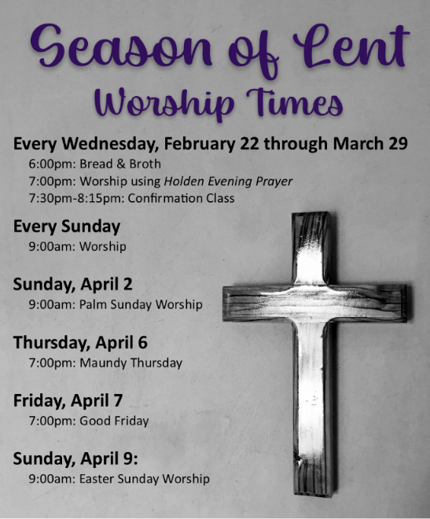
Thanks be to God.
Upcoming Worship Assistants
 | Usher | Lector | Communion | Offering Counters
March 5 | Tammy Neumann | Andrea Hovick | Dave & Sue Schaeder | Dan Mundt | Jon Hill
March 12 | Rob & Leslie Mader | Laurel Peterson | Ron Rothfusz  Andrea Hovick | Nancy Leonard | Breanna Butler

Coming up at GSLC
Monday, March 6 | 10:30-11:30 am |  | Bible Study by the fireplace
Tuesday, February 28 |  | 9:30-10:30 am | Children’s of WI playgroup – all parents & children under 4 welcome
 |  | 7:00 pm | AA meeting in the fellowship hall
Wednesday, March 1 |  | 6:00 pm | Bread & Broth
 |  | 7:00 pm | Midweek Worship Service
 |  | 7:30 pm | Confirmation Class for 7th & 8th grade
Thursday, March 2 |  | 12-2:00 pm | Purple Angels Memory Cafe
Sunday, March 5 |  | 9:00 am | Worship Service  - Second Sunday in Lent  - John 3:1-17; the mission of Christ: to save the world.  - Sunday School
