Good Shepherd Lutheran Church
Pastor: Rev. Katie Anderson | Music Director: Rev. Lois Swanson
Pastor’s Cell: (715) 245-1943 | Office Phone: (715) 387-2731
Pastor Email: gslcwi.pastor@gmail.com | Office Email: gslcwi.office@gmail.com
Website: GoodShepherdMarshfield.org | www.facebook.com/gslcwi
Fifth Sunday in Lent
March 26, 2023, 9:00 am
Introduction to the day…
In today’s gospel Jesus reveals his power over death by raising Lazarus from the dead. The prophet Ezekiel prophesies God breathing new life into dry bones. To those in exile or living in the shadows of death, these stories proclaim God’s promise of resurrection. In baptism we die with Christ that we might also be raised with him to new life. At the Easter Vigil we will welcome the newly baptized as we remember God’s unfailing promise in our baptism.
ANNOUNCEMENTS
GATHERING
GATHERING SONG Come and Gather from Tree of Life with music available in narthex
Refrain
Come and gather beneath the tree of life.
Come and gather beneath the tree of life—
root of wisdom, branch of peace, fruit of healing and release.
Come and gather beneath the tree of life.
1. Here we raise the saving cross of Jesus,
singing praise to him who leads us on from death into new life. (Refrain)
2. Flowing from this tree of grace and passion,
Oh how sweet the taste, how deep and rich the well-spring of your love. (Refrain)
CONFESSION AND FORGIVENESS
Blessed be the holy Trinity, ☩ one God,
who journeys with us these forty days,
and sustains us with the gift of grace.
Amen.
Let us acknowledge before God and one another
our need for repentance and God’s mercy.
Silence is kept for reflection.
Holy God,
we confess to you our faults and failings.
Too often we neglect and do not trust your holy word;
we take for ourselves instead of giving to others;
we spoil rather than steward your creation;
we cause hurt though you call us to heal;
we choose fear over compassion.
Forgive us, renew us, and lead us,
as we seek to follow in your way of life.
Amen.
Hear the good news:
God so loved the world that God gave the only Son,
so that all may receive life.
This promise is for you!
God embraces you with divine mercy,
☩ forgives you in Christ’s name,
and revives you in the Spirit’s power.
Amen.
PRAYER OF THE DAY
Almighty God, your Son came into the world to free us all from sin and death. Breathe upon us the power of your Spirit, that we may be raised to new life in Christ and serve you in righteousness all our days, through Jesus Christ, our Savior and Lord, who lives and reigns with you and the Holy Spirit, one God, now and forever. Amen.
CHILDREN’S MESSAGE
SCRIPTURE READINGS
FIRST READING: Ezekiel 37:1-14
¹The hand of the Lord came upon me, and he brought me out by the spirit of the Lord and set me down in the middle of a valley; it was full of bones. ²He led me all around them; there were very many lying in the valley, and they were very dry. ³He said to me, “Mortal, can these bones live?” I answered, “O Lord God, you know.” ⁴Then he said to me, “Prophesy to these bones, and say to them: O dry bones, hear the word of the Lord. ⁵Thus says the Lord God to these bones: I will cause breath to enter you, and you shall live. ⁶I will lay sinews on you, and will cause flesh to come upon you, and cover you with skin, and put breath in you, and you shall live; and you shall know that I am the Lord.”
⁷So I prophesied as I had been commanded; and as I prophesied, suddenly there was a noise, a rattling, and the bones came together, bone to its bone. ⁸I looked, and there were sinews on them, and flesh had come upon them, and skin had covered them; but there was no breath in them. ⁹Then he said to me, “Prophesy to the breath, prophesy, mortal, and say to the breath: Thus says the Lord God: Come from the four winds, O breath, and breathe upon these slain, that they may live.” ¹⁰I prophesied as he commanded me, and the breath came into them, and they lived, and stood on their feet, a vast multitude.
¹¹Then he said to me, “Mortal, these bones are the whole house of Israel. They say, ‘Our bones are dried up, and our hope is lost; we are cut off completely.’ ¹²Therefore prophesy, and say to them, Thus says the Lord God: I am going to open your graves, and bring you up from your graves, O my people; and I will bring you back to the land of Israel. ¹³And you shall know that I am the Lord, when I open your graves, and bring you up from your graves, O my people. ¹⁴I will put my spirit within you, and you shall live, and I will place you on your own soil; then you shall know that I, the Lord, have spoken and will act, says the Lord.”
Word of God, word of life.
Thanks be to God.
PSALM: Psalm 130
¹Out of the depths
I cry to you, O Lord;
²O Lord, hear my voice!
Let your ears be attentive to the voice of my supplication.
³If you were to keep watch over sins,
O Lord, who could stand?
⁴Yet with you is forgiveness,
in order that you may be feared.
⁵I wait for you, O Lord; my soul waits;
in your word is my hope.
⁶My soul waits for the Lord more than those who keep watch for the morning,
more than those who keep watch for the morning.
⁷O Israel, wait for the Lord, for with the Lord there is steadfast love;
with the Lord there is plenteous redemption.
⁸For the Lord shall redeem Israel
from | all their sins.
SECOND READING: Romans 8:6-11
⁶To set the mind on the flesh is death, but to set the mind on the Spirit is life and peace. ⁷For this reason the mind that is set on the flesh is hostile to God; it does not submit to God’s law—indeed it cannot, ⁸and those who are in the flesh cannot please God.
⁹But you are not in the flesh; you are in the Spirit, since the Spirit of God dwells in you. Anyone who does not have the Spirit of Christ does not belong to him. ¹⁰But if Christ is in you, though the body is dead because of sin, the Spirit is life because of righteousness. ¹¹If the Spirit of him who raised Jesus from the dead dwells in you, he who raised Christ from the dead will give life to your mortal bodies also through his Spirit that dwells in you.
Word of God, word of life.
Thanks be to God.
GOSPEL ACCLAMATION Tree of Life
Return to the Lord, your God,
who is gracious and merciful, slow to anger,
and abounding in steadfast love,
and abounding in steadfast love.
GOSPEL: John 11:1-45
¹Now a certain man was ill, Lazarus of Bethany, the village of Mary and her sister Martha. ²Mary was the one who anointed the Lord with perfume and wiped his feet with her hair; her brother Lazarus was ill. ³So the sisters sent a message to Jesus, “Lord, he whom you love is ill.” ⁴But when Jesus heard it, he said, “This illness does not lead to death; rather it is for God’s glory, so that the Son of God may be glorified through it.” ⁵Accordingly, though Jesus loved Martha and her sister and Lazarus, ⁶after having heard that Lazarus was ill, he stayed two days longer in the place where he was.
⁷Then after this he said to the disciples, “Let us go to Judea again.” ⁸The disciples said to him, “Rabbi, the Jews were just now trying to stone you, and are you going there again?” ⁹Jesus answered, “Are there not twelve hours of daylight? Those who walk during the day do not stumble, because they see the light of this world. ¹⁰But those who walk at night stumble, because the light is not in them.” ¹¹After saying this, he told them, “Our friend Lazarus has fallen asleep, but I am going there to awaken him.” ¹²The disciples said to him, “Lord, if he has fallen asleep, he will be all right.” ¹³Jesus, however, had been speaking about his death, but they thought that he was referring merely to sleep. ¹⁴Then Jesus told them plainly, “Lazarus is dead. ¹⁵For your sake I am glad I was not there, so that you may believe. But let us go to him.” ¹⁶Thomas, who was called the Twin, said to his fellow disciples, “Let us also go, that we may die with him.”
¹⁷When Jesus arrived, he found that Lazarus had already been in the tomb four days. ¹⁸Now Bethany was near Jerusalem, some two miles away, ¹⁹and many of the Jews had come to Martha and Mary to console them about their brother. ²⁰When Martha heard that Jesus was coming, she went and met him, while Mary stayed at home. ²¹Martha said to Jesus, “Lord, if you had been here, my brother would not have died. ²²But even now I know that God will give you whatever you ask of him.” ²³Jesus said to her, “Your brother will rise again.” ²⁴Martha said to him, “I know that he will rise again in the resurrection on the last day.” ²⁵Jesus said to her, “I am the resurrection and the life. Those who believe in me, even though they die, will live, ²⁶and everyone who lives and believes in me will never die. Do you believe this?” ²⁷She said to him, “Yes, Lord, I believe that you are the Messiah, the Son of God, the one coming into the world.”
²⁸When she had said this, she went back and called her sister Mary, and told her privately, “The Teacher is here and is calling for you.” ²⁹And when she heard it, she got up quickly and went to him. ³⁰Now Jesus had not yet come to the village, but was still at the place where Martha had met him. ³¹The Jews who were with her in the house, consoling her, saw Mary get up quickly and go out. They followed her because they thought that she was going to the tomb to weep there. ³²When Mary came where Jesus was and saw him, she knelt at his feet and said to him, “Lord, if you had been here, my brother would not have died.” ³³When Jesus saw her weeping, and the Jews who came with her also weeping, he was greatly disturbed in spirit and deeply moved. ³⁴He said, “Where have you laid him?” They said to him, “Lord, come and see.” ³⁵Jesus began to weep. ³⁶So the Jews said, “See how he loved him!” ³⁷But some of them said, “Could not he who opened the eyes of the blind man have kept this man from dying?”
³⁸Then Jesus, again greatly disturbed, came to the tomb. It was a cave, and a stone was lying against it. ³⁹Jesus said, “Take away the stone.” Martha, the sister of the dead man, said to him, “Lord, already there is a stench because he has been dead four days.” ⁴⁰Jesus said to her, “Did I not tell you that if you believed, you would see the glory of God?” ⁴¹So they took away the stone. And Jesus looked upward and said, “Father, I thank you for having heard me. ⁴²I knew that you always hear me, but I have said this for the sake of the crowd standing here, so that they may believe that you sent me.” ⁴³When he had said this, he cried with a loud voice, “Lazarus, come out!” ⁴⁴The dead man came out, his hands and feet bound with strips of cloth, and his face wrapped in a cloth. Jesus said to them, “Unbind him, and let him go.”
⁴⁵Many of the Jews therefore, who had come with Mary and had seen what Jesus did, believed in him.
The gospel of the Lord.
Praise to you, O Christ.
SERMON
HYMN OF THE DAY When We Are Living ELW 639
APOSTLES’ CREED
I believe in God, the Father almighty,
creator of heaven and earth.
I believe in Jesus Christ, God's only Son, our Lord,
who was conceived by the power of the Holy Spirit,
born of the Virgin Mary,
suffered under Pontius Pilate,
was crucified, died, and was buried;
he descended to the dead.
On the third day he rose again;
he ascended into heaven,
he is seated at the right hand of the Father,
and he will come to judge the living and the dead.
I believe in the Holy Spirit,
the holy catholic Church,
the communion of saints,
the forgiveness of sins,
the resurrection of the body,
and the life everlasting. Amen
PRAYERS OF INTERCESSION
…Merciful God,
receive our prayer.
We lift our prayers to you, O God, trusting in your steadfast love and your promise to renew your whole creation; through Jesus Christ our Savior.
Amen.
PEACE
The peace of Christ be with you always.
And also with you.
HOLY COMMUNION
OFFERING In addition to our normal offering, a Special Benevolence in March (collected in a special envelope) will go to Feed My Starving Children. Their mission is to feed God’s starving children hungry in body and spirit.
OFFERING SONG Oh, for a Thousand Tongues to Sing ELW 886
OFFERTORY PRAYER
God of good gifts,
receive these and all our offerings
as we present them in faithful service
for the sake of your gospel.
Prepare our hearts to receive you in this meal
as you pour out your very presence
through Christ Jesus, the wellspring of eternal life.
Amen.
GREAT THANKSGIVING
The Lord be with you.
And also with you.
Lift up your hearts.
We lift them to the Lord.
Let us give our thanks to the Lord our God.
It is right to give our thanks and praise.
HOLY, HOLY, HOLY (Sung) Tree of Life
Holy, holy, holy Lord, God of power and might,
heaven and earth are full of your glory.
Hosanna, hosanna, hosanna in the highest.
Blessed is he, blessed is he who comes in the name of the Lord.
Hosanna, hosanna, hosanna in the highest, hosanna in the highest.
THANKSGIVING AT THE TABLE

Blessed are you, O God of the universe.
Your mercy is everlasting
and your faithfulness endures from age to age.
Praise to you for creating the heavens and the earth.
Praise to you for saving the earth from the waters of the flood.
Praise to you for bringing the Israelites safely through the sea.
Praise to you for leading your people through the wilderness
to the land of milk and honey.
Praise to you for the words and deeds of Jesus, your anointed one.
Praise to you for the death and resurrection of Christ.
Praise to you for your Spirit poured out on all nations.
In the night in which he was betrayed,
our Lord Jesus took bread, and gave thanks;
broke it, and gave it to his disciples, saying:
Take and eat; this is my body, given for you.
Do this for the remembrance of me.
Again, after supper, he took the cup, gave thanks,
and gave it for all to drink, saying:
This cup is the new covenant in my blood,
shed for you and for all people for the forgiveness of sin.
Do this for the remembrance of me.

With this bread and cup
we remember our Lord’s passover from death to life
as we proclaim the mystery of faith:
Christ has died.
Christ is risen.
Christ will come again.
O God of resurrection and new life:
Pour out your Holy Spirit on us
and on these gifts of bread and wine.
Bless this feast.
Grace our table with your presence.
Come, Holy Spirit.
Reveal yourself to us in the breaking of the bread.
Raise us up as the body of Christ for the world.
Breathe new life into us.
Send us forth,
burning with justice, peace, and love.
Come, Holy Spirit.
With your holy ones of all times and places,
with the earth and all its creatures,
with sun and moon and stars,
we praise you, O God,
blessed and holy Trinity,
now and forever.
Amen.

THE LORD’S PRAYER
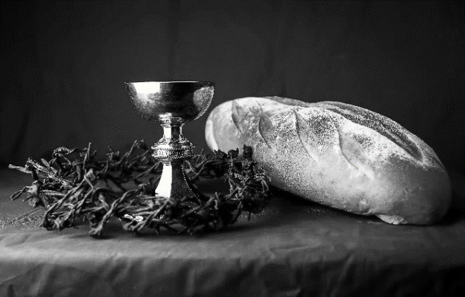
Our Father, who art in heaven,
hallowed be thy name,
thy kingdom come,
thy will be done,
on earth as it is in heaven.
Give us this day our daily bread;
and forgive us our trespasses,
as we forgive those
who trespass against us;
and lead us not into temptation,
but deliver us from evil.
For thine is the kingdom,
and the power, and the glory,
forever and ever. Amen.
INVITATION TO COMMUNION - Certified gluten-free crackers are in the bowl on the communion plate.
Come and receive Jesus, our strength in the wilderness.
HOLY COMMUNION
PRAYER AFTER COMMUNION
Embodied God,
at your table, we have tasted the goodness of Jesus.
With the eyes of our hearts open to your promise,
empower us to hear the needs of our neighbors
and touch the world with your love.
Amen.
SENDING
BLESSING
God, the giver of love,
☩ Christ, the resurrection and the life,
and the Holy Spirit of rebirth
bless you in this Lenten journey.
Amen.
SONG My Life is in You, Lord
My life is in You, Lord, my strength is in You, Lord,  My hope is in You, Lord, in You, it's in You.  My life is in You, Lord, my strength is in You, Lord,  My hope is in You, Lord, in You, it's in You. | I will praise You with all of my life,  I will praise You with all of my strength.  With all of my life. With all of my strength.  All of my hope is in You.  in You, it's in You, my life!
(Daniel Gardnerc/o Integrity Music, Inc.) CCLI License No. 669990

DISMISSAL
Go in peace. Serve in love.
Thanks be to God.
If you would like to volunteer to lector or help with communion on Easter Sunday, please contact the church office.

Upcoming Worship Assistants
 | Usher | Lector | Communion | Offering Counters
March 26 | John & Jennifer Rickinger | Linda Schreiber | Ron Rothfusz  Nancy Leonard | Heidi Binder | Kami Weis
April 2 | Ruth & Ed Raatz | Leslie Mader | Dan & Pam Mundt | Pam Mundt | May Hill
April 9  Easter | Volunteer | Volunteer | Volunteer | Dan Mundt | Jon Hill
April 16 | Ben & Jannalee Lindquist | Julie Will | Bob & Laurel Peterson | Nancy Leonard | Breanna Butler
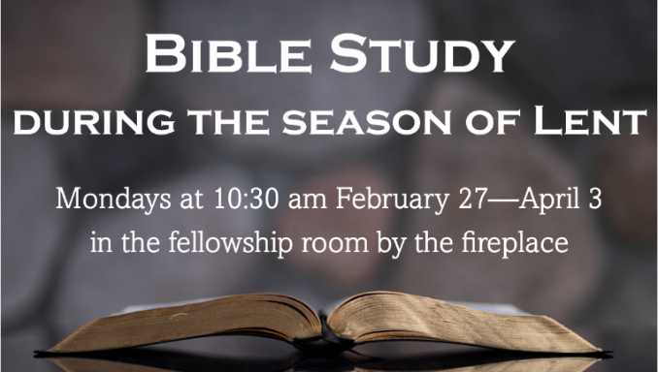
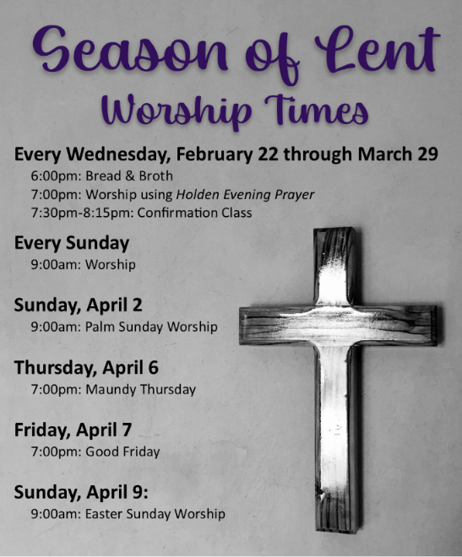

Coming up at GSLC
Monday, March 20 | 10:30-11:30 am | Bible Study by the fireplace
Tuesday, March 21 | 9:30-10:30 am | Children’s of WI playgroup – all parents & children under 4 welcome
 | 2:00 pm | Chapel at Three Oaks
 | 7:00 pm | AA meeting in the fellowship hall
Wednesday, March 22 | 6:00 pm | Bread & Broth
 | 7:00 pm | Midweek Worship Service
 | 7:30 pm | Confirmation Class for 7th & 8th grade
Sunday, March 26 | 9:00 am | Worship Service  - Fifth Sunday in Lent  - John 11:1-45; Baptismal image: the raising of Lazarus  - No Sunday School (Spring Break)
Christ in Our Home daily devotional booklet is available in the church entrance for April, May, & June.
Spark children's magazine and Living Lutheran magazine are available in the entrance of the church.

