Good Shepherd Lutheran Church
Pastor: Rev. Katie Anderson | Music Director: Rev. Lois Swanson
Pastor’s Cell: (715) 245-1943 | Office Phone: (715) 387-2731
Pastor Email: gslcwi.pastor@gmail.com | Office Email: gslcwi.office@gmail.com
Website: GoodShepherdMarshfield.org | www.facebook.com/gslcwi
Fourth Sunday in Lent
March 19, 2023, 9:00 am
Introduction to the day…
Baptism is sometimes called enlightenment. The gospel for this Sunday is the story of the man born blind healed by Christ. “I was blind, now I see,” declares the man. In baptism God opens our eyes to see the truth of who we are: God’s beloved children. As David was anointed king of Israel, in baptism God anoints our head with oil, and calls us to bear witness to the light of Christ in our daily lives.
ANNOUNCEMENTS
GATHERING
GATHERING SONG Come and Gather from Tree of Life with music available in narthex
Refrain
Come and gather beneath the tree of life.
Come and gather beneath the tree of life—
root of wisdom, branch of peace, fruit of healing and release.
Come and gather beneath the tree of life.
4. Here beneath the branches of your mercy,
We invoke your name, remember how your love has set us free. (Refrain)
5. Rooted in the rich earth of your Gospel,
may we bear the fruits your Word has planted deep within our hearts. (Refrain)
CONFESSION AND FORGIVENESS
Blessed be the holy Trinity, ☩ one God,
who journeys with us these forty days,
and sustains us with the gift of grace.
Amen.
Let us acknowledge before God and one another
our need for repentance and God’s mercy.
Silence is kept for reflection.
Holy God,
we confess to you our faults and failings.
Too often we neglect and do not trust your holy word;
we take for ourselves instead of giving to others;
we spoil rather than steward your creation;
we cause hurt though you call us to heal;
we choose fear over compassion.
Forgive us, renew us, and lead us,
as we seek to follow in your way of life.
Amen.
Hear the good news:
God so loved the world that God gave the only Son,
so that all may receive life.
This promise is for you!
God embraces you with divine mercy,
☩ forgives you in Christ’s name,
and revives you in the Spirit’s power.
Amen.

PRAYER OF THE DAY
Bend your ear to our prayers, Lord Christ, and come among us. By your gracious life and death for us, bring light into the darkness of our hearts, and anoint us with your Spirit, for you live and reign with the Father and the Holy Spirit, one God, now and forever. Amen.
CHILDREN’S MESSAGE
SCRIPTURE READINGS
FIRST READING: 1 Samuel 16:1-13
¹The Lord said to Samuel, “How long will you grieve over Saul? I have rejected him from being king over Israel. Fill your horn with oil and set out; I will send you to Jesse the Bethlehemite, for I have provided for myself a king among his sons.” ²Samuel said, “How can I go? If Saul hears of it, he will kill me.” And the Lord said, “Take a heifer with you, and say, ‘I have come to sacrifice to the Lord.’ ³Invite Jesse to the sacrifice, and I will show you what you shall do; and you shall anoint for me the one whom I name to you.” ⁴Samuel did what the Lord commanded, and came to Bethlehem. The elders of the city came to meet him trembling, and said, “Do you come peaceably?” ⁵He said, “Peaceably; I have come to sacrifice to the Lord; sanctify yourselves and come with me to the sacrifice.” And he sanctified Jesse and his sons and invited them to the sacrifice.
⁶When they came, he looked on Eliab and thought, “Surely the Lord’s anointed is now before the Lord.” ⁷But the Lord said to Samuel, “Do not look on his appearance or on the height of his stature, because I have rejected him; for the Lord does not see as mortals see; they look on the outward appearance, but the Lord looks on the heart.” ⁸Then Jesse called Abinadab, and made him pass before Samuel. He said, “Neither has the Lord chosen this one.” ⁹Then Jesse made Shammah pass by. And he said, “Neither has the Lord chosen this one.” ¹⁰Jesse made seven of his sons pass before Samuel, and Samuel said to Jesse, “The Lord has not chosen any of these.” ¹¹Samuel said to Jesse, “Are all your sons here?” And he said, “There remains yet the youngest, but he is keeping the sheep.” And Samuel said to Jesse, “Send and bring him; for we will not sit down until he comes here.” ¹²He sent and brought him in. Now he was ruddy, and had beautiful eyes, and was handsome. The Lord said, “Rise and anoint him; for this is the one.” ¹³Then Samuel took the horn of oil, and anointed him in the presence of his brothers; and the spirit of the Lord came mightily upon David from that day forward. Samuel then set out and went to Ramah.
Word of God, word of life.
Thanks be to God.
PSALM: Psalm 23
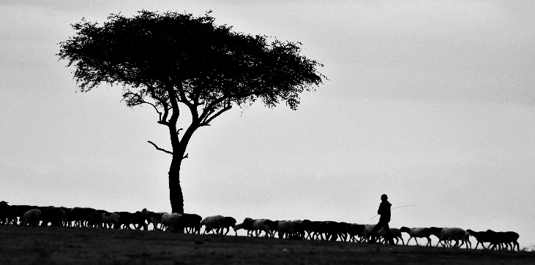
¹The Lord is my shepherd;
I shall not be in want.
²The Lord makes me lie down in green pastures
and leads me beside still waters.
³You restore my soul, O Lord,
and guide me along right pathways for your name’s sake.
⁴Though I walk through the valley of the shadow of death, I shall fear no evil;
for you are with me; your rod and your staff, they comfort me.
⁵You prepare a table before me in the presence of my enemies;
you anoint my head with oil, and my cup is running over.
⁶Surely goodness and mercy shall follow me all the days of my life,
and I will dwell in the house of the Lord forever.

SECOND READING: Ephesians 5:8-14
⁸Once you were darkness, but now in the Lord you are light. Live as children of light—⁹for the fruit of the light is found in all that is good and right and true. ¹⁰Try to find out what is pleasing to the Lord. ¹¹Take no part in the unfruitful works of darkness, but instead expose them. ¹²For it is shameful even to mention what such people do secretly; ¹³but everything exposed by the light becomes visible, ¹⁴for everything that becomes visible is light. Therefore it says,
“Sleeper, awake!
Rise from the dead,
and Christ will shine on you.”
Word of God, word of life.
Thanks be to God.
GOSPEL ACCLAMATION Tree of Life
Return to the Lord, your God,
who is gracious and merciful, slow to anger,
and abounding in steadfast love,
and abounding in steadfast love.
GOSPEL: John 9:1-41
¹As [Jesus] walked along, he saw a man blind from birth. ²His disciples asked him, “Rabbi, who sinned, this man or his parents, that he was born blind?” ³Jesus answered, “Neither this man nor his parents sinned; he was born blind so that God’s works might be revealed in him. ⁴We must work the works of him who sent me while it is day; night is coming when no one can work. ⁵As long as I am in the world, I am the light of the world.” ⁶When he had said this, he spat on the ground and made mud with the saliva and spread the mud on the man’s eyes, ⁷saying to him, “Go, wash in the pool of Siloam” (which means Sent). Then he went and washed and came back able to see. ⁸The neighbors and those who had seen him before as a beggar began to ask, “Is this not the man who used to sit and beg?” ⁹Some were saying, “It is he.” Others were saying, “No, but it is someone like him.” He kept saying, “I am the man.” ¹⁰But they kept asking him, “Then how were your eyes opened?” ¹¹He answered, “The man called Jesus made mud, spread it on my eyes, and said to me, ‘Go to Siloam and wash.’ Then I went and washed and received my sight.” ¹²They said to him, “Where is he?” He said, “I do not know.”
¹³They brought to the Pharisees the man who had formerly been blind. ¹⁴Now it was a sabbath day when Jesus made the mud and opened his eyes. ¹⁵Then the Pharisees also began to ask him how he had received his sight. He said to them, “He put mud on my eyes. Then I washed, and now I see.” ¹⁶Some of the Pharisees said, “This man is not from God, for he does not observe the sabbath.” But others said, “How can a man who is a sinner perform such signs?” And they were divided. ¹⁷So they said again to the blind man, “What do you say about him? It was your eyes he opened.” He said, “He is a prophet.”
¹⁸The Jews did not believe that he had been blind and had received his sight until they called the parents of the man who had received his sight ¹⁹and asked them, “Is this your son, who you say was born blind? How then does he now see?” ²⁰His parents answered, “We know that this is our son, and that he was born blind; ²¹but we do not know how it is that now he sees, nor do we know who opened his eyes. Ask him; he is of age. He will speak for himself.” ²²His parents said this because they were afraid of the Jews; for the Jews had already agreed that anyone who confessed Jesus to be the Messiah would be put out of the synagogue. ²³Therefore his parents said, “He is of age; ask him.”
²⁴So for the second time they called the man who had been blind, and they said to him, “Give glory to God! We know that this man is a sinner.” ²⁵He answered, “I do not know whether he is a sinner. One thing I do know, that though I was blind, now I see.” ²⁶They said to him, “What did he do to you? How did he open your eyes?” ²⁷He answered them, “I have told you already, and you would not listen. Why do you want to hear it again? Do you also want to become his disciples?” ²⁸Then they reviled him, saying, “You are his disciple, but we are disciples of Moses. ²⁹We know that God has spoken to Moses, but as for this man, we do not know where he comes from.” ³⁰The man answered, “Here is an astonishing thing! You do not know where he comes from, and yet he opened my eyes. ³¹We know that God does not listen to sinners, but he does listen to one who worships him and obeys his will. ³²Never since the world began has it been heard that anyone opened the eyes of a person born blind. ³³If this man were not from God, he could do nothing.” ³⁴They answered him, “You were born entirely in sins, and are you trying to teach us?” And they drove him out.
³⁵Jesus heard that they had driven him out, and when he found him, he said, “Do you believe in the Son of Man?” ³⁶He answered, “And who is he, sir? Tell me, so that I may believe in him.” ³⁷Jesus said to him, “You have seen him, and the one speaking with you is he.” ³⁸He said, “Lord, I believe.” And he worshiped him. ³⁹Jesus said, “I came into this world for judgment so that those who do not see may see, and those who do see may become blind.” ⁴⁰Some of the Pharisees near him heard this and said to him, “Surely we are not blind, are we?” ⁴¹Jesus said to them, “If you were blind, you would not have sin. But now that you say, ‘We see,’ your sin remains.”
The gospel of the Lord.
Praise to you, O Christ.
SERMON
HYMN OF THE DAY Praise the One Who Breaks the Darkness ELW 843
APOSTLES’ CREED
I believe in God, the Father almighty,
creator of heaven and earth.
I believe in Jesus Christ, God's only Son, our Lord,
who was conceived by the power of the Holy Spirit,
born of the Virgin Mary,
suffered under Pontius Pilate,
was crucified, died, and was buried;
he descended to the dead.
On the third day he rose again;
he ascended into heaven,
he is seated at the right hand of the Father,
and he will come to judge the living and the dead.
I believe in the Holy Spirit,
the holy catholic Church,
the communion of saints,
the forgiveness of sins,
the resurrection of the body,
and the life everlasting. Amen
PRAYERS OF INTERCESSION
…Merciful God,
receive our prayer.
We lift our prayers to you, O God, trusting in your steadfast love and your promise to renew your whole creation; through Jesus Christ our Savior.
Amen.
PEACE
The peace of Christ be with you always.
And also with you.
HOLY COMMUNION
OFFERING In addition to our normal offering, a Special Benevolence in March (collected in a special envelope) will go to Feed My Starving Children. Their mission is to feed God’s starving children hungry in body and spirit.
OFFERING SONG I Want to Walk as a Child of the Light ELW 815
OFFERTORY PRAYER
God of good gifts,
receive these and all our offerings
as we present them in faithful service
for the sake of your gospel.
Prepare our hearts to receive you in this meal
as you pour out your very presence
through Christ Jesus, the wellspring of eternal life.
Amen.
GREAT THANKSGIVING
The Lord be with you.
And also with you.
Lift up your hearts.
We lift them to the Lord.
Let us give our thanks to the Lord our God.
It is right to give our thanks and praise.
HOLY, HOLY, HOLY (Sung) Tree of Life
Holy, holy, holy Lord, God of power and might,
heaven and earth are full of your glory.
Hosanna, hosanna, hosanna in the highest.
Blessed is he, blessed is he who comes in the name of the Lord.
Hosanna, hosanna, hosanna in the highest, hosanna in the highest.
THANKSGIVING AT THE TABLE

Blessed are you, O God of the universe.
Your mercy is everlasting
and your faithfulness endures from age to age.
Praise to you for creating the heavens and the earth.
Praise to you for saving the earth from the waters of the flood.
Praise to you for bringing the Israelites safely through the sea.
Praise to you for leading your people through the wilderness
to the land of milk and honey.
Praise to you for the words and deeds of Jesus, your anointed one.
Praise to you for the death and resurrection of Christ.
Praise to you for your Spirit poured out on all nations.
In the night in which he was betrayed,
our Lord Jesus took bread, and gave thanks;
broke it, and gave it to his disciples, saying:
Take and eat; this is my body, given for you.
Do this for the remembrance of me.
Again, after supper, he took the cup, gave thanks,
and gave it for all to drink, saying:
This cup is the new covenant in my blood,
shed for you and for all people for the forgiveness of sin.
Do this for the remembrance of me.

With this bread and cup
we remember our Lord’s passover from death to life
as we proclaim the mystery of faith:
Christ has died.
Christ is risen.
Christ will come again.
O God of resurrection and new life:
Pour out your Holy Spirit on us
and on these gifts of bread and wine.
Bless this feast.
Grace our table with your presence.
Come, Holy Spirit.
Reveal yourself to us in the breaking of the bread.
Raise us up as the body of Christ for the world.
Breathe new life into us.
Send us forth,
burning with justice, peace, and love.
Come, Holy Spirit.
With your holy ones of all times and places,
with the earth and all its creatures,
with sun and moon and stars,
we praise you, O God,
blessed and holy Trinity,
now and forever.
Amen.

THE LORD’S PRAYER
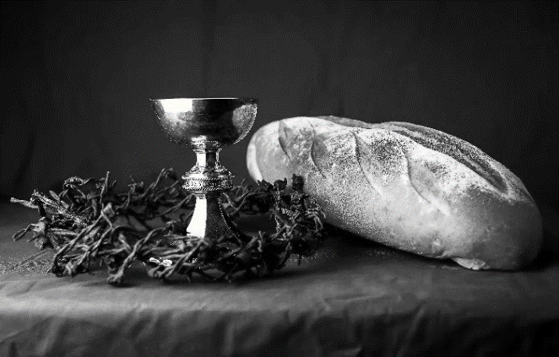
Our Father, who art in heaven,
hallowed be thy name,
thy kingdom come,
thy will be done,
on earth as it is in heaven.
Give us this day our daily bread;
and forgive us our trespasses,
as we forgive those
who trespass against us;
and lead us not into temptation,
but deliver us from evil.
For thine is the kingdom,
and the power, and the glory,
forever and ever. Amen.
INVITATION TO COMMUNION - Certified gluten-free crackers are in the bowl on the communion plate.
Come and receive Jesus, our strength in the wilderness.
HOLY COMMUNION
PRAYER AFTER COMMUNION
Embodied God,
at your table, we have tasted the goodness of Jesus.
With the eyes of our hearts open to your promise,
empower us to hear the needs of our neighbors
and touch the world with your love.
Amen.
SENDING
BLESSING
God, the giver of love,
☩ Christ, the resurrection and the life,
and the Holy Spirit of rebirth
bless you in this Lenten journey.
Amen.
SONG Be Thou My Vision ELW 793
DISMISSAL
Go in peace. Serve in love.
Thanks be to God.
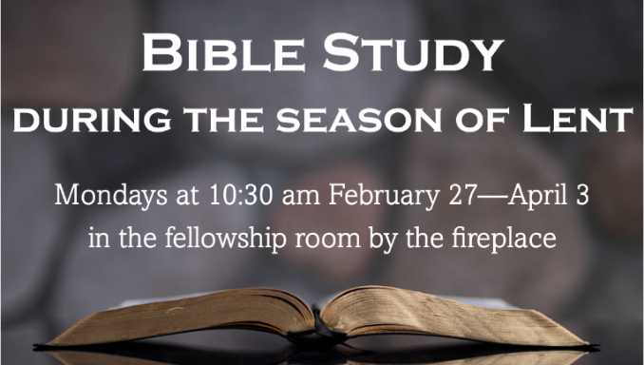
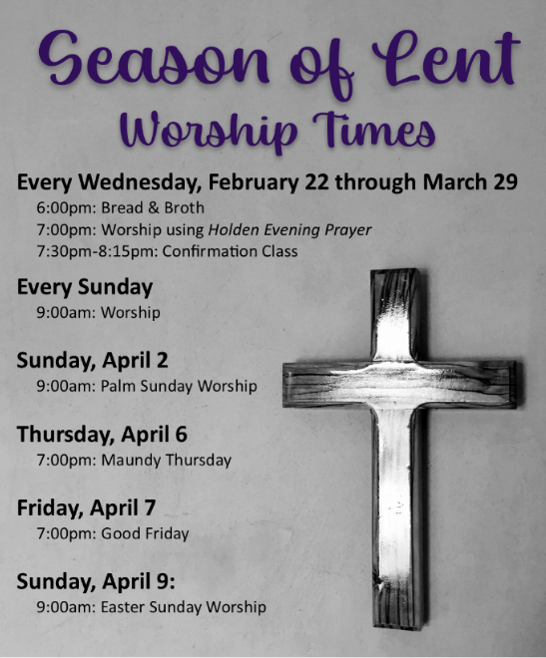
Christ in Our Home daily devotional booklet is available in the church entrance for April, May, & June.
Spark children's magazine and Living Lutheran magazine are available in the entrance of the church.
Upcoming Worship Assistants
 | Usher | Lector | Communion | Offering Counters
March 12 | Rob & Leslie Mader | Laurel Peterson | Ron Rothfusz  Andrea Hovick | Nancy Leonard | Breanna Butler
March 19 | Dave & Sue Schraeder | Nancy Leonard | Sarah Kopitzke  Tammy Neumann | Robin Beeman | David Schneider
March 26 | John & Jennifer Rickinger | Jane Wagner | John Wagner  Nancy Leonard | Heidi Binder | Kami Weis
April 2 | Ruth & Ed Raatz | Leslie Mader | Dan & Pam Mundt | Pam Mundt | May Hill
April 9  Easter | Volunteer | Volunteer | Volunteer | Dan Mundt | Jon Hill

Coming up at GSLC
Monday, March 20 | 10:30-11:30 am | Bible Study by the fireplace
Tuesday, March 21 | 9:30-10:30 am | Children’s of WI playgroup – all parents & children under 4 welcome
 | 2:00 pm | Chapel at Three Oaks
 | 7:00 pm | AA meeting in the fellowship hall
Wednesday, March 22 | 6:00 pm | Bread & Broth
 | 7:00 pm | Midweek Worship Service
 | 7:30 pm | Confirmation Class for 7th & 8th grade
Sunday, March 26 | 9:00 am | Worship Service  - Fifth Sunday in Lent  - John 11:1-45; Baptismal image: the raising of Lazarus  - No Sunday School (Spring Break)
