INVITATION TO COMMUNION
The risen Christ dwells with us here.
All who are hungry, all who are thirsty, come.
HOLY COMMUNION
O God, you have called your servants to ventures of which we cannot see the ending, by paths as yet untrodden, through perils unknown. Give us faith to go out with good courage, not knowing where we go, but only that your hand is leading us and your love supporting us; through Jesus Christ our Lord.
Amen
BLESSING
Let us bless the Lord.
Thanks be to God.
The peace of God, which surpasses all understanding, keep our hearts and our minds in Christ Jesus.
Amen.
CLOSING HYMN God, Whose Almighty Word ELW 673
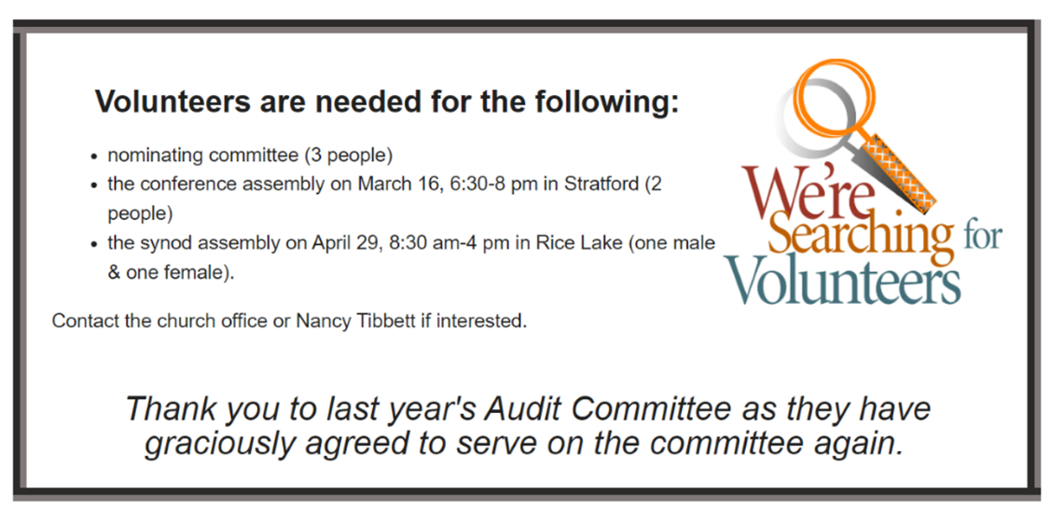
(You are encouraged to share the peace of Christ with one another.)
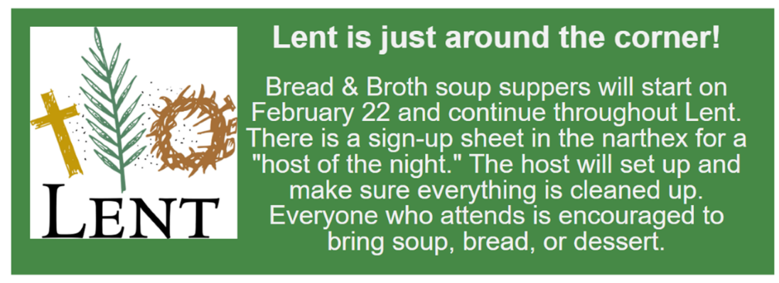
Good Shepherd Lutheran Church
Pastor: Rev Katie Anderson | Music Director: Rev Lois Swanson
502 West McMillian Street, Marshfield | Office Phone: (715) 387-2731
Pastor Email: gslcwi.pastor@gmail.com | Office Email: gslcwi.office@gmail.com
Website: GoodShepherdMarshfield.org | www.facebook.com/gslcwi

Wednesday Service (following order of service from ELW 309, Evening Prayer)
February 8, 2023, 7:00 pm
Welcome and Announcements
OPENING
SERVICE OF LIGHT (HOLDEN EVENING PRAYER)

HYMN OF LIGHT O Word of God Incarnate ELW 514
THANKSGIVING OF LIGHT
The Lord be with you.
And also with you.
Let us give thanks to the Lord our God.
We give you thanks, O God, for in the beginning you called light into being, and you set light in the sky to govern night and day.
In a pillar of cloud by day and a pillar of fire by night you led your people into freedom. Enlighten our darkness by the light of your Christ: may your Word be a lamp to our feet and a light to our path; for you are merciful, and you love your whole creation, and with all your creatures we give you glory, through your Son Jesus Christ, in the unity of the Holy Spirit, now and forever.
Amen
PSALMODY: Psalm 119:105-112
¹⁰⁵Your word is a lamp to my feet
and a light to my path.
¹⁰⁶I have sworn an oath and confirmed it,
to observe your righteous ordinances.
¹⁰⁷I am severely afflicted;
give me life, O LORD, according to your word.
¹⁰⁸Accept my offerings of praise, O LORD,
and teach me your ordinances.
¹⁰⁹I hold my life in my hand continually,
but I do not forget your law.
¹¹⁰The wicked have laid a snare for me,
but I do not stray from your precepts.
¹¹¹Your decrees are my heritage forever;
they are the joy of my heart.
¹¹²I incline my heart to perform your statutes
forever, to the end.
HYMN Word of God, Come Down on Earth ELW 510
WORD: 2 Corinthians 4:1-12
¹Therefore, since it is by God's mercy that we are engaged in this ministry, we do not lose heart. ²We have renounced the shameful things that one hides; we refuse to practice cunning or to falsify God's word; but by the open statement of the truth we commend ourselves to the conscience of everyone in the sight of God. ³And even if our gospel is veiled, it is veiled to those who are perishing. ⁴In their case the god of this world has blinded the minds of the unbelievers, to keep them from seeing the light of the gospel of the glory of Christ, who is the image of God. ⁵For we do not proclaim ourselves; we proclaim Jesus Christ as Lord and ourselves as your slaves for Jesus' sake. ⁶For it is the God who said, "Let light shine out of darkness," who has shone in our hearts to give the light of the knowledge of the glory of God in the face of Jesus Christ.
⁷But we have this treasure in clay jars, so that it may be made clear that this extraordinary power belongs to God and does not come from us. ⁸We are afflicted in every way, but not crushed; perplexed, but not driven to despair; ⁹persecuted, but not forsaken; struck down, but not destroyed; ¹⁰always carrying in the body the death of Jesus, so that the life of Jesus may also be made visible in our bodies. ¹¹For while we live, we are always being given up to death for Jesus' sake, so that the life of Jesus may be made visible in our mortal flesh. ¹²So death is at work in us, but life in you.
REFLECTION
Jesus said, I am the Light of the world.
Whoever follows me will never walk in darkness.
OFFERING In addition to our normal offering, a Special Benevolence in February (collected in a special envelope) will go to Shirley’s House of Hope.
HOLY COMMUNION
PRAYERS (ELW 316-317)
In peace, let us pray to the Lord.
Lord, have mercy.
…Let us pray to the Lord
Lord, have mercy.
Help, save, comfort, and defend us gracious Lord.
Giving thanks for all who have gone before us and are at rest rejoicing in the communion of all the saints, we commend ourselves, one another, and our whole life to you, through Christ our Lord.
To you, O Lord.
JESUS SPEAKS FROM THE TABLE
In the night in which he was betrayed, our Lord Jesus took bread, and gave thanks; broke it, and gave it to his disciples, saying: Take and eat; this is my body, given for you. Do this for the remembrance of me.
Again, after supper, he took the cup, gave thanks, and gave it for all to drink, saying: This cup is the new covenant in my blood, shed for you and for all people for the forgiveness of sin. Do this for the remembrance of me.
LORD’S PRAYER
Our Father, who art in heaven,
hallowed be thy name,
thy kingdom come,
thy will be done,
on earth as it is in heaven.
Give us this day our daily bread;
and forgive us our trespasses,
as we forgive those
who trespass against us;
and lead us not into temptation,
but deliver us from evil.
For thine is the kingdom,
and the power, and the glory,
forever and ever.
Amen.

