INVITATION TO COMMUNION
The risen Christ dwells with us here.
All who are hungry, all who are thirsty, come.
HOLY COMMUNION
O God, you have called your servants to ventures of which we cannot see the ending, by paths as yet untrodden, through perils unknown. Give us faith to go out with good courage, not knowing where we go, but only that your hand is leading us and your love supporting us; through Jesus Christ our Lord.
Amen
BLESSING
Let us bless the Lord.
Thanks be to God.
The peace of God, which surpasses all understanding, keep our hearts and our minds in Christ Jesus.
Amen.
CLOSING HYMN Spirit of God, Descend upon My Heart ELW 800
(You are encouraged to share the peace of Christ with one another.)
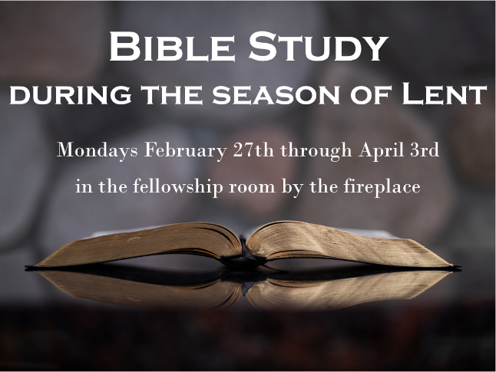
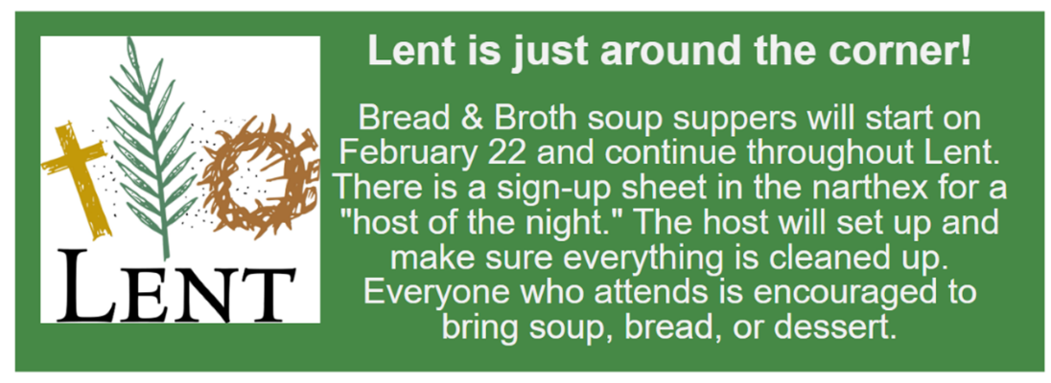
Good Shepherd Lutheran Church
Pastor: Rev Katie Anderson | Music Director: Rev Lois Swanson
502 West McMillian Street, Marshfield | Office Phone: (715) 387-2731
Pastor Email: gslcwi.pastor@gmail.com | Office Email: gslcwi.office@gmail.com
Website: GoodShepherdMarshfield.org | www.facebook.com/gslcwi

Wednesday Service (following order of service from ELW 309, Evening Prayer)
February 15, 2023, 7:00 pm
Welcome and Announcements
OPENING
SERVICE OF LIGHT (HOLDEN EVENING PRAYER)

HYMN OF LIGHT Open Now Thy Gates of Beauty ELW 533
THANKSGIVING OF LIGHT
The Lord be with you.
And also with you.
Let us give thanks to the Lord our God.
We give you thanks, O God, for in the beginning you called light into being, and you set light in the sky to govern night and day.
In a pillar of cloud by day and a pillar of fire by night you led your people into freedom. Enlighten our darkness by the light of your Christ: may your Word be a lamp to our feet and a light to our path; for you are merciful, and you love your whole creation, and with all your creatures we give you glory, through your Son Jesus Christ, in the unity of the Holy Spirit, now and forever.
Amen
PSALMODY: Psalm 119:57-64
⁵⁷The LORD is my portion;
I promise to keep your words.
⁵⁸I implore your favor with all my heart;
be gracious to me according to your promise.
⁵⁹When I think of your ways,
I turn my feet to your decrees;
⁶⁰I hurry and do not delay
to keep your commandments.
⁶¹Though the cords of the wicked ensnare me,
I do not forget your law.
⁶²At midnight I rise to praise you,
because of your righteous ordinances.
⁶³I am a companion of all who fear you,
of those who keep your precepts.
⁶⁴The earth, O LORD, is full of your steadfast love;
teach me your statutes.
HYMN O God, Our Help in Ages Past ELW 632
WORD: Luke 18:18-30
¹⁸A certain ruler asked him, "Good Teacher, what must I do to inherit eternal life?" ¹⁹Jesus said to him, "Why do you call me good? No one is good but God alone. ²⁰You know the commandments: 'You shall not commit adultery; You shall not murder; You shall not steal; You shall not bear false witness; Honor your father and mother.'" ²¹He replied, "I have kept all these since my youth." ²²When Jesus heard this, he said to him, "There is still one thing lacking. Sell all that you own and distribute the money to the poor, and you will have treasure in heaven; then come, follow me." ²³But when he heard this, he became sad; for he was very rich. ²⁴Jesus looked at him and said, "How hard it is for those who have wealth to enter the kingdom of God! ²⁵Indeed, it is easier for a camel to go through the eye of a needle than for someone who is rich to enter the kingdom of God."
²⁶Those who heard it said, "Then who can be saved?" ²⁷He replied, "What is impossible for mortals is possible for God."
²⁸Then Peter said, "Look, we have left our homes and followed you." ²⁹And he said to them, "Truly I tell you, there is no one who has left house or wife or brothers or parents or children, for the sake of the kingdom of God, ³⁰who will not get back very much more in this age, and in the age to come eternal life."
REFLECTION
Jesus said, I am the Light of the world.
Whoever follows me will never walk in darkness.
OFFERING In addition to our normal offering, a Special Benevolence in February (collected in a special envelope) will go to Shirley’s House of Hope.
HOLY COMMUNION
PRAYERS (ELW 316-317)
In peace, let us pray to the Lord.
Lord, have mercy.
…Let us pray to the Lord
Lord, have mercy.
Help, save, comfort, and defend us gracious Lord.
Giving thanks for all who have gone before us and are at rest rejoicing in the communion of all the saints, we commend ourselves, one another, and our whole life to you, through Christ our Lord.
To you, O Lord.
JESUS SPEAKS FROM THE TABLE
In the night in which he was betrayed, our Lord Jesus took bread, and gave thanks; broke it, and gave it to his disciples, saying: Take and eat; this is my body, given for you. Do this for the remembrance of me.
Again, after supper, he took the cup, gave thanks, and gave it for all to drink, saying: This cup is the new covenant in my blood, shed for you and for all people for the forgiveness of sin. Do this for the remembrance of me.
LORD’S PRAYER
Our Father, who art in heaven,
hallowed be thy name,
thy kingdom come,
thy will be done,
on earth as it is in heaven.
Give us this day our daily bread;
and forgive us our trespasses,
as we forgive those
who trespass against us;
and lead us not into temptation,
but deliver us from evil.
For thine is the kingdom,
and the power, and the glory,
forever and ever.
Amen.

