Good Shepherd Lutheran Church
Pastor: Rev. Katie Anderson | Music Director: Rev. Lois Swanson
Pastor’s Cell: (715) 245-1943 | Office Phone: (715) 387-2731
Pastor Email: gslcwi.pastor@gmail.com | Office Email: gslcwi.office@gmail.com
Website: GoodShepherdMarshfield.org | www.facebook.com/gslcwi
Baptism of Our Lord / First Sunday after Epiphany
January 8, 2023, 9:00 am
Introduction to the day…
In the waters of the Jordan, Jesus is revealed as the beloved Son of God. Through this great epiphany, Jesus fulfills all righteousness and becomes the servant of God who will bring forth justice and be a light to the nations. In the waters of baptism, we too are washed by the Word, anointed by the Spirit, and named God’s beloved children. Our baptismal mission is to proclaim good news to all who are oppressed or in need of God’s healing.
ANNOUNCEMENTS
GATHERING
GATHERING SONG Lord, I Lift Your Name on High ELW 857
CONFESSION AND FORGIVENESS
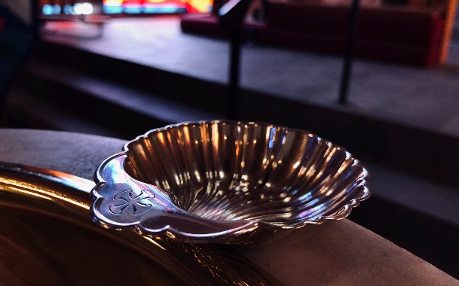
Blessed be the holy Trinity, ☩ one God,
who makes all things new,
whose mercy endures forever.
Amen.
Trusting in God’s mercy, let us confess our sin.
Silence is kept for reflection.
Holy One, source of our renewal,
we confess that we are wrapped up in sin,
and cannot free ourselves.
We have not practiced your righteousness.
Our hearts have turned away from you.
For the sake of the world you so love,
forgive us,
that we may be reconciled to one another
for the glory of your holy name.
Amen.
Thus says our God:
“The former things have come to pass
and new things I now declare.”
God’s mercy makes us new.
We are forgiven in the name of ☩ Christ our Savior.
Amen.
PRAYER OF THE DAY
O God our Father, at the baptism of Jesus you proclaimed him your beloved Son and anointed him with the Holy Spirit. Make all who are baptized into Christ faithful to their calling to be your daughters and sons, and empower us all with your Spirit, through Jesus Christ, our Savior and Lord, who lives and reigns with you and the Holy Spirit, one God, now and forever.
Amen.
CHILDREN’S MESSAGE
CHILDREN’S SONG Glorious Kingdom
And you shall call His name Jesus (repeat 3x)
For he will save the people from their sins.
Refrain:
He comes from the Glory,
He comes from the Glorious Kingdom (repeat)
And you shall call His name Jesus (repeat 3x)
For he will save the people from their sins.(Refrain)
SCRIPTURE READINGS
FIRST READING: Isaiah 42:1-9
¹Here is my servant, whom I uphold,
my chosen, in whom my soul delights;
I have put my spirit upon him;
he will bring forth justice to the nations.
²He will not cry or lift up his voice,
or make it heard in the street;
³a bruised reed he will not break,
and a dimly burning wick he will not quench;
he will faithfully bring forth justice.
⁴He will not grow faint or be crushed
until he has established justice in the earth;
and the coastlands wait for his teaching.
⁵Thus says God, the Lord,
who created the heavens and stretched them out,
who spread out the earth and what comes from it,
who gives breath to the people upon it
and spirit to those who walk in it:
⁶I am the Lord, I have called you in righteousness,
I have taken you by the hand and kept you;
I have given you as a covenant to the people,
a light to the nations,
⁷to open the eyes that are blind,
to bring out the prisoners from the dungeon,
from the prison those who sit in darkness.
⁸I am the Lord, that is my name;
my glory I give to no other,
nor my praise to idols.
⁹See, the former things have come to pass,
and new things I now declare;
before they spring forth,
I tell you of them.
Word of God, word of life.
Thanks be to God.
PSALM: Psalm 29
¹Ascribe to the Lord, you gods,
ascribe to the Lord glory and strength.
²Ascribe to the Lord the glory due God’s name;
worship the Lord in the beauty of holiness.
³The voice of the Lord is upon the waters; the God of glory thunders;
the Lord is upon the mighty waters.
⁴The voice of the Lord is a powerful voice;
the voice of the Lord is a voice of splendor.
⁵The voice of the Lord breaks the cedar trees;
the Lord breaks the cedars of Lebanon;
⁶the Lord makes Lebanon skip like a calf,
and Mount Hermon like a young wild ox.
⁷The voice of the Lord
bursts forth in lightning flashes.
⁸The voice of the Lord shakes the wilderness;
the Lord shakes the wilderness of Kadesh.
⁹The voice of the Lord makes the oak trees writhe and strips the forests bare.
And in the temple of the Lord all are crying, “Glory!”
¹⁰The Lord sits enthroned above the flood;
the Lord sits enthroned as king forevermore.
¹¹O Lord, give strength to your people;
give them, O Lord, the blessings of peace.
SECOND READING: Acts 10:34-43
³⁴Peter began to speak to [Cornelius and his household]: “I truly understand that God shows no partiality, ³⁵but in every nation anyone who fears him and does what is right is acceptable to him. ³⁶You know the message he sent to the people of Israel, preaching peace by Jesus Christ—he is Lord of all. ³⁷That message spread throughout Judea, beginning in Galilee after the baptism that John announced: ³⁸how God anointed Jesus of Nazareth with the Holy Spirit and with power; how he went about doing good and healing all who were oppressed by the devil, for God was with him. ³⁹We are witnesses to all that he did both in Judea and in Jerusalem. They put him to death by hanging him on a tree; ⁴⁰but God raised him on the third day and allowed him to appear, ⁴¹not to all the people but to us who were chosen by God as witnesses, and who ate and drank with him after he rose from the dead. ⁴²He commanded us to preach to the people and to testify that he is the one ordained by God as judge of the living and the dead. ⁴³All the prophets testify about him that everyone who believes in him receives forgiveness of sins through his name.”
Word of God, word of life.
Thanks be to God.
GOSPEL ACCLAMATION ELW 171
Alleluia. Lord, to whom shall we go?
You have the words of eternal life. Alleluia.
GOSPEL: Matthew 3:13-17
¹³Then Jesus came from Galilee to John at the Jordan, to be baptized by him. ¹⁴John would have prevented him, saying, “I need to be baptized by you, and do you come to me?” ¹⁵But Jesus answered him, “Let it be so now; for it is proper for us in this way to fulfill all righteousness.” Then he consented. ¹⁶And when Jesus had been baptized, just as he came up from the water, suddenly the heavens were opened to him and he saw the Spirit of God descending like a dove and alighting on him. ¹⁷And a voice from heaven said, “This is my Son, the Beloved, with whom I am well pleased.”
The gospel of the Lord.
Praise to you, O Christ.
SERMON
HYMN OF THE DAY Let Streams of Living Justice ELW 710
APOSTLES’ CREED
I believe in God, the Father almighty,
creator of heaven and earth.
I believe in Jesus Christ, God's only Son, our Lord,
who was conceived by the power of the Holy Spirit,
born of the Virgin Mary,
suffered under Pontius Pilate,
was crucified, died, and was buried;
he descended to the dead.
On the third day he rose again;
he ascended into heaven,
he is seated at the right hand of the Father,
and he will come to judge the living and the dead.
I believe in the Holy Spirit,
the holy catholic Church,
the communion of saints,
the forgiveness of sins,
the resurrection of the body,
and the life everlasting. Amen
PRAYERS OF INTERCESSION
…Merciful God,
Do you or someone you know need an extra prayer said? There are PRAYER REQUEST CARDS
on the table in the narthex. Requests can be kept confidential, with Pastor, or can be made public to the congregation via Shepherd Staff email and in prayer at worship.
receive our prayer.
We bring to you our needs and hopes, O God, trusting your wisdom and power revealed in Christ crucified.
Amen.

PEACE
The peace of Christ be with you always.
And also with you.
HOLY COMMUNION
OFFERING In addition to our normal offering, a Special Benevolence in January (collected in a special envelope) will go to the Ronald McDonald House of Marshfield.
OFFERING SONG Baptized in Water ELW 456
OFFERTORY PRAYER
Liberating God,
you break the bonds of injustice
and let the oppressed go free.
Receive these offerings in thanksgiving
for all your works of merciful power,
and shape us as people of your justice and freedom.
You we magnify and adore, through Jesus our Savior,
Amen.
GREAT THANKSGIVING
The Lord be with you.
And also with you.
Lift up your hearts.
We lift them to the Lord.
Let us give our thanks to the Lord our God.
It is right to give our thanks and praise.
HOLY, HOLY, HOLY (Sung) ELW 173
Holy, holy, holy Lord,
Lord God of power and might,
heaven and earth are full of your glory.
Hosanna in the highest.
Blessed is he who comes in the name of the Lord.
Hosanna in the highest.
THANKSGIVING AT THE TABLE

Holy One, the beginning and the end, the giver of life:
Blessed are you for the birth of creation.
Blessed are you in the darkness and in the light.
Blessed are you for your promise to your people.
Blessed are you in the prophets’ hopes and dreams.
Blessed are you for Mary’s openness to your will.
Blessed are you for your Son Jesus,
the Word made flesh.
In the night in which he was betrayed,
our Lord Jesus took bread, and gave thanks;
broke it, and gave it to his disciples, saying:
Take and eat; this is my body, given for you.
Do this for the remembrance of me.
Again, after supper, he took the cup, gave thanks,
and gave it for all to drink, saying:
This cup is the new covenant in my blood,
shed for you and for all people for the forgiveness of sin.
Do this for the remembrance of me.
Let us proclaim the mystery of faith:
Christ has died.
Christ is risen.
Christ will come again.
With this bread and cup
we remember your Word dwelling among us,
full of grace and truth.
We remember our new birth in his death and resurrection.
We look with hope for his coming.
Come, Lord Jesus.
Holy God, we long for your Spirit.
Come among us.
Bless this meal.
May your Word take flesh in us.
Awaken your people.
Fill us with your light.
Bring the gift of peace on earth.
Come, Holy Spirit.
All praise and glory are yours,
Holy One of Israel,
Word of God incarnate,
Power of the Most High,
one God, now and forever.
Amen.

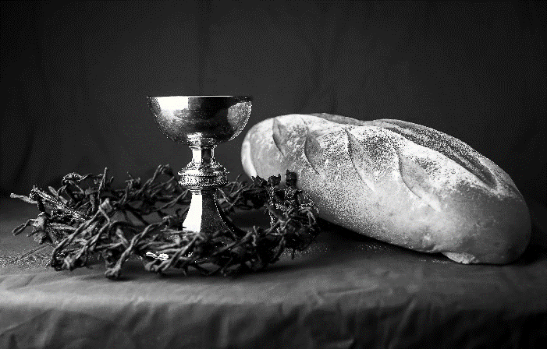
THE LORD’S PRAYER
Our Father, who art in heaven,
hallowed be thy name,
thy kingdom come,
thy will be done,
on earth as it is in heaven.
Give us this day our daily bread;
and forgive us our trespasses,
as we forgive those
who trespass against us;
and lead us not into temptation,
but deliver us from evil.
For thine is the kingdom,
and the power, and the glory,
forever and ever. Amen.
INVITATION TO COMMUNION - Certified gluten-free crackers are in the bowl on the communion plate.
Come and taste the joy of God!
HOLY COMMUNION
PRAYER AFTER COMMUNION
Holy One,
we thank you for the healing
that springs forth abundantly from this table.
Renew our strength to do justice,
love kindness,
and journey humbly with you.
Amen.
SENDING
BLESSING
The God who faithfully brings forth justice
and breaks the oppressor’s rod
☩ bless, strengthen, and uphold you,
today and always.
Amen.
SONG Let All Things Now Living ELW 881
DISMISSAL
Go in peace. Follow the way of Jesus.
Thanks be to God.

Coming up at GSLC
Sunday, January 8 | 9:00 am | Worship Service  - Baptism of Our Lord/First Sunday after Epiphany  - Matthew 3:13-17; the revelation of Christ as God’s servant.  - Sunday School
Tuesday, January 10 | 9:30-10:30 am | Children’s of WI playgroup – all parents & children under 4 welcome
 | 7:00 pm | AA meeting in the fellowship hall
Wednesday, January 11 | 7:00 pm | Midweek Worship Service
 | 7:30 pm | - Confirmation Class for 7th & 8th grade
Sunday, January 15 | 9:00 am | Worship Service  - Second Sunday after Epiphany  - John 1:29-42; Revelation of Christ as the Lamb of God.  - NO Sunday School  Budget Review (council members available)
Upcoming Worship Assistants
 | Usher | Lector | Communion | Offering Counters
January 8 | Christopher & Trina Ignatowski | Julie Will | Andrea Hovick  Sarah Kopitzke | Robin Beeman | David Schneider
January 15 | Dennis & Deb Janz | Shelly Schneider | Tammy Neumann  Nancy Leonard | Heidi Binder | Kami Weis
January 22 | Tim & Monica Jewell | Linda Schrieber | Dan & Pam Mundt | Pam Mundt | May Hill
January 29 | Richard & Sarah Kopitzke | Nancy Tibbett | Bob & Laurel Peterson | Dan Mundt | Jon Hill
