Good Shepherd Lutheran Church
Pastor: Rev. Katie Anderson | Music Director: Rev. Lois Swanson
Pastor’s Cell: (715) 245-1943 | Office Phone: (715) 387-2731
Pastor Email: gslcwi.pastor@gmail.com | Office Email: gslcwi.office@gmail.com
Website: GoodShepherdMarshfield.org | www.facebook.com/gslcwi
Fourth Sunday after Epiphany
January 29, 2023, 9:00 am
Introduction to the day…
Who are the blessed ones of God? For Micah, they are those who do justice, love kindness, and walk humbly with God. For Paul, they are the ones who find wisdom in the weakness of the cross. For Jesus, they are the poor, the meek, the merciful, the pure in heart, the peacemakers, those who mourn, and those who hunger for righteousness. In baptism we find our blessed identity and calling in this countercultural way of living and serving.
ANNOUNCEMENTS
GATHERING
GATHERING SONG Drawn to the Light ELW 593
CONFESSION AND FORGIVENESS
Blessed be the holy Trinity, ☩ one God,
who makes all things new, whose mercy endures forever.
Amen.
Trusting in God’s mercy, let us confess our sin.
Silence is kept for reflection.
Holy One, source of our renewal,
we confess that we are wrapped up in sin, and cannot free ourselves.
We have not practiced your righteousness.
Our hearts have turned away from you.
For the sake of the world you so love, forgive us,
that we may be reconciled to one another for the glory of your holy name.
Amen.
Thus says our God:
“The former things have come to pass and new things I now declare.”
God’s mercy makes us new. We are forgiven in the name of ☩ Christ our Savior.
Amen.
PRAYER OF THE DAY
Holy God, you confound the world’s wisdom in giving your kingdom to the lowly and the pure in heart. Give us such a hunger and thirst for justice, and perseverance in striving for peace, that in our words and deeds the world may see the life of your Son, Jesus Christ, our Savior and Lord.
Amen.
CHILDREN’S MESSAGE
CHILDREN’S SONG Clap Your Hands
Clap your hands and sing to the Lord, Hallelu, Hallelu, Halleujah.
Clap your hands and sing to the Lord, Hallelu, Hallelu, Halleujah.
Hallelujah, Hallelujah, Hallelujah Amen!
Hallelujah, Hallelujah, Hallelujah Amen!
Snap your fingers and sing to the Lord, Hallelu, Hallelu, Halleujah.
Snap your fingers and sing to the Lord, Hallelu, Hallelu, Halleujah.
Hallelujah, Hallelujah, Hallelujah Amen!
Hallelujah, Hallelujah, Hallelujah Amen!
Lift your heads and sing to the Lord, Hallelu, Hallelu, Halleujah.
Lift your heads and sing to the Lord, Hallelu, Hallelu, Halleujah.
Hallelujah, Hallelujah, Hallelujah Amen!
Hallelujah, Hallelujah, Hallelujah Amen!

SCRIPTURE READINGS
FIRST READING: Micah 6:1-8
¹Hear what the Lord says:
Rise, plead your case before the mountains,
and let the hills hear your voice.
²Hear, you mountains, the controversy of the Lord,
and you enduring foundations of the earth;
for the Lord has a controversy with his people,
and he will contend with Israel.
³“O my people, what have I done to you?
In what have I wearied you? Answer me!
⁴For I brought you up from the land of Egypt,
and redeemed you from the house of slavery;
and I sent before you Moses,
Aaron, and Miriam.
⁵O my people, remember now what King Balak of Moab devised,
what Balaam son of Beor answered him,
and what happened from Shittim to Gilgal,
that you may know the saving acts of the Lord.”
⁶“With what shall I come before the Lord,
and bow myself before God on high?
Shall I come before him with burnt offerings,
with calves a year old?
⁷Will the Lord be pleased with thousands of rams,
with ten thousands of rivers of oil?
Shall I give my firstborn for my transgression,
the fruit of my body for the sin of my soul?”
⁸He has told you, O mortal, what is good;
and what does the Lord require of you
but to do justice, and to love kindness,
and to walk humbly with your God?
Word of God, word of life.
Thanks be to God.
PSALM: Psalm 15
¹Lord, who may dwell in your tabernacle?
Who may abide upon your holy hill?
²Those who lead a blameless life and do what is right,
who speak the truth from their heart;
³they do not slander with the tongue, they do no evil to their friends;
they do not cast discredit upon a neighbor.
⁴In their sight the wicked are rejected, but they honor those who fear the Lord.
They have sworn upon their health and do not take back their word.
⁵They do not give their money in hope of gain, nor do they take bribes against the innocent.
Those who do these things shall never be overthrown.
SECOND READING: 1 Corinthians 1:18-31
¹⁸The message about the cross is foolishness to those who are perishing, but to us who are being saved it is the power of God. ¹⁹For it is written,
“I will destroy the wisdom of the wise, and the discernment of the discerning I will thwart.”
²⁰Where is the one who is wise? Where is the scribe? Where is the debater of this age? Has not God made foolish the wisdom of the world? ²¹For since, in the wisdom of God, the world did not know God through wisdom, God decided, through the foolishness of our proclamation, to save those who believe. ²²For Jews demand signs and Greeks desire wisdom, ²³but we proclaim Christ crucified, a stumbling block to Jews and foolishness to Gentiles, ²⁴but to those who are the called, both Jews and Greeks, Christ the power of God and the wisdom of God. ²⁵For God’s foolishness is wiser than human wisdom, and God’s weakness is stronger than human strength.
²⁶Consider your own call, brothers and sisters: not many of you were wise by human standards, not many were powerful, not many were of noble birth. ²⁷But God chose what is foolish in the world to shame the wise; God chose what is weak in the world to shame the strong; ²⁸God chose what is low and despised in the world, things that are not, to reduce to nothing things that are, ²⁹so that no one might boast in the presence of God. ³⁰He is the source of your life in Christ Jesus, who became for us wisdom from God, and righteousness and sanctification and redemption, ³¹in order that, as it is written, “Let the one who boasts, boast in the Lord.”
Word of God, word of life.
Thanks be to God.
GOSPEL ACCLAMATION ELW 171
Alleluia. Lord, to whom shall we go?
You have the words of eternal life. Alleluia.
GOSPEL: Matthew 5:1-12
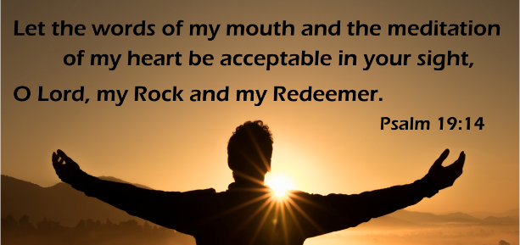
¹When Jesus saw the crowds, he went up the mountain; and after he sat down, his disciples came to him. ²Then he began to speak, and taught them, saying:
³“Blessed are the poor in spirit, for theirs is the kingdom of heaven.
⁴“Blessed are those who mourn, for they will be comforted.
⁵“Blessed are the meek, for they will inherit the earth.
⁶“Blessed are those who hunger and thirst for righteousness, for they will be filled.
⁷“Blessed are the merciful, for they will receive mercy.
⁸“Blessed are the pure in heart, for they will see God.
⁹“Blessed are the peacemakers, for they will be called children of God.
¹⁰“Blessed are those who are persecuted for righteousness’ sake, for theirs is the kingdom of heaven.
¹¹“Blessed are you when people revile you and persecute you and utter all kinds of evil against you falsely on my account. ¹²Rejoice and be glad, for your reward is great in heaven, for in the same way they persecuted the prophets who were before you.”
The gospel of the Lord.
Praise to you, O Christ.
SERMON

HYMN OF THE DAY Where Cross the Crowded Ways of Life ELW 714
APOSTLES’ CREED
I believe in God, the Father almighty,
creator of heaven and earth.
I believe in Jesus Christ, God's only Son, our Lord,
who was conceived by the power of the Holy Spirit,
born of the Virgin Mary,
suffered under Pontius Pilate,
was crucified, died, and was buried;
he descended to the dead.
On the third day he rose again;
he ascended into heaven,
he is seated at the right hand of the Father,
and he will come to judge the living and the dead.
Do you or someone you know need an extra prayer said? There are PRAYER REQUEST CARDS
on the table in the narthex. Requests can be kept confidential, with Pastor, or can be made public to the congregation via Shepherd Staff email and in prayer at worship.
I believe in the Holy Spirit,
the holy catholic Church,
the communion of saints,
the forgiveness of sins,
the resurrection of the body,
and the life everlasting. Amen

PRAYERS OF INTERCESSION
…Merciful God,
receive our prayer.
We bring to you our needs and hopes, O God, trusting your wisdom and power revealed in Christ crucified.
Amen.
PEACE
The peace of Christ be with you always.
And also with you.
HOLY COMMUNION
OFFERING In addition to our normal offering, a Special Benevolence in January (collected in a special envelope) will go to the Ronald McDonald House of Marshfield. RMHC of Marshfield keeps families with sick children close to each other and the care and resources they need.
OFFERING SONG Glory to the Love
Refrain
Glory to the Love, Glory to the Life. Glory to the Child of Light.
From heaven to earth across the universe glory to the peace of Christ.
1. Moving, reaching into our lives,
seeds of promise stirring inside. Refrain
2. Teaching, healing, seeking the lost,
turning tables, bearing the cross. Refrain
3. Guiding Spirit open us wide
to see Christ in each other’s eyes. Refrain
Peterson/Olson Text: © 2006, Dakota Road Music
OFFERTORY PRAYER
Liberating God,
you break the bonds of injustice and let the oppressed go free.
Receive these offerings in thanksgiving for all your works of merciful power,
and shape us as people of your justice and freedom.
You we magnify and adore, through Jesus our Savior,
Amen.
GREAT THANKSGIVING
The Lord be with you.
And also with you.
Lift up your hearts.
We lift them to the Lord.
Let us give our thanks to the Lord our God.
It is right to give our thanks and praise.
HOLY, HOLY, HOLY (Sung) ELW 173
Holy, holy, holy Lord,
Lord God of power and might,
heaven and earth are full of your glory.
Hosanna in the highest.
Blessed is he who comes in the name of the Lord.
Hosanna in the highest.

THANKSGIVING AT THE TABLE

Holy One, the beginning and the end, the giver of life:
Blessed are you for the birth of creation.
Blessed are you in the darkness and in the light.
Blessed are you for your promise to your people.
Blessed are you in the prophets’ hopes and dreams.
Blessed are you for Mary’s openness to your will.
Blessed are you for your Son Jesus,
the Word made flesh.
In the night in which he was betrayed,
our Lord Jesus took bread, and gave thanks;
broke it, and gave it to his disciples, saying:
Take and eat; this is my body, given for you.
Do this for the remembrance of me.
Again, after supper, he took the cup, gave thanks,
and gave it for all to drink, saying:
This cup is the new covenant in my blood,
shed for you and for all people for the forgiveness of sin.
Do this for the remembrance of me.
Let us proclaim the mystery of faith:
Christ has died.
Christ is risen.
Christ will come again.
With this bread and cup
we remember your Word dwelling among us,
full of grace and truth.
We remember our new birth in his death and resurrection.
We look with hope for his coming.
Come, Lord Jesus.
Holy God, we long for your Spirit.
Come among us.
Bless this meal.
May your Word take flesh in us.
Awaken your people.
Fill us with your light.
Bring the gift of peace on earth.
Come, Holy Spirit.
All praise and glory are yours,
Holy One of Israel,
Word of God incarnate,
Power of the Most High,
one God, now and forever.
Amen.

THE LORD’S PRAYER
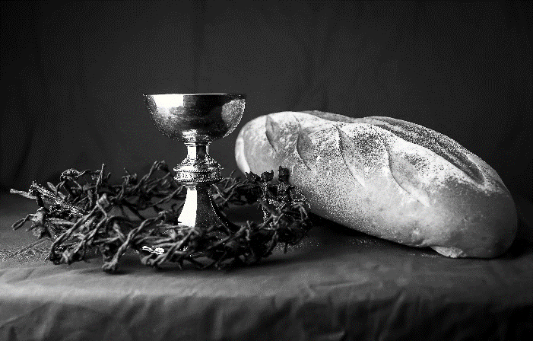
Our Father, who art in heaven,
hallowed be thy name,
thy kingdom come,
thy will be done,
on earth as it is in heaven.
Give us this day our daily bread;
and forgive us our trespasses,
as we forgive those
who trespass against us;
and lead us not into temptation,
but deliver us from evil.
For thine is the kingdom,
and the power, and the glory,
forever and ever. Amen.
INVITATION TO COMMUNION - Certified gluten-free crackers are in the bowl on the communion plate.
Come and taste the joy of God!
HOLY COMMUNION
PRAYER AFTER COMMUNION
Holy One,
we thank you for the healing
that springs forth abundantly from this table.
Renew our strength to do justice,
love kindness,
and journey humbly with you.
Amen.
SENDING
BLESSING
The God who faithfully brings forth justice
and breaks the oppressor’s rod
☩ bless, strengthen, and uphold you,
today and always.
Amen.
SONG Bring Forth the Kingdom
1. You are salt for the earth, O people:  salt for the kingdom of God!  Share the flavor of life, O people:  life in the kingdom of God! | 3. You are a seed of the word, O people:  bring forth the kingdom of God!  Seeds of mercy and seeds of justice  grow in the kingdom of God! Refrain
Refrain  Bring forth the kingdom of mercy,  bring forth the kingdom of peace;  Bring forth the kingdom of justice,  bring forth the city of God! | 4. We are a blest and a pilgrim people:  bound for the kingdom of God!  Love our journey and love our homeland:  love is the kingdom of God! Refrain
2. You are a light on the hill, O people:
light for the city of God!
Shine so holy and bright, O people:
shine for the kingdom of God! Refrain
Test & music: Marty Haugen. Test & music © 1986 GIA Publications Used by permission. CCLI LICENSE #669990
DISMISSAL
Go in peace. Follow the way of Jesus.
Annual Meeting following worship TODAY!
Thanks be to God.
Coming up at GSLC
Sunday, January 29 | 9:00 am | Worship Service  - Fourth Sunday after Epiphany  - Matthew 5:1-12; the teaching of Christ: Beatitudes.  - Sunday School
 | 10:00 am | Annual Meeting
Tuesday, January 31 | 9:30-10:30 am | Children’s of WI playgroup – all parents & children under 4 welcome
 | 7:00 pm | AA meeting in the fellowship hall
Wednesday, February 1 | 7:00 pm | - Midweek Worship Service
 | 7:30 pm | - Confirmation Class for 7th & 8th grade
Sunday, February 5 | 9:00 am | Worship Service  - Fifth Sunday after Epiphany  - Matthew 5:13-20; the teaching of Christ: salt and light.  - Sunday School

Upcoming Worship Assistants
 | Usher | Lector | Communion | Offering Counters
January 29 | Richard & Sarah Kopitzke | Nancy Tibbett | Bob & Laurel Peterson | Dan Mundt | Jon Hill
February 5 | Ben & Sue Lee | Richard Kopitzke | Dave & Shelly Schneider | Nancy Leonard | Audra Strasser
February 12 | Nancy Leonard | Tammy Neumann | Bruce & Nancy Tibbett | Robin Beeman | David Schneider
February 19 | Bob & Laurel Peterson | Kris Tarter | John Wagner  Ben Lindquist | Heidi Binder | Kami Weis
February 26 | Dan & Pam Mundt | Christine Tipping | Matt & Margo Barrier | Pam Mundt | May Hill

