Good Shepherd Lutheran Church
Pastor: Rev. Katie Anderson | Music Director: Rev. Lois Swanson
Pastor’s Cell: (715) 245-1943 | Office Phone: (715) 387-2731
Pastor Email: gslcwi.pastor@gmail.com | Office Email: gslcwi.office@gmail.com
Website: GoodShepherdMarshfield.org | www.facebook.com/gslcwi
Second Sunday after Epiphany
January 15, 2023, 9:00 am
Introduction to the day…
Today’s gospel opens with further reflection on Jesus’ baptism. He is the Lamb of God who takes away the sin of the world and the one anointed by the Spirit. In the liturgy, we come and see Christ revealed among us in word and meal. We go forth to invite others to come and worship the Holy One and to receive the gifts of grace and peace made known among us.
ANNOUNCEMENTS
GATHERING
GATHERING SONG Christ Be Our Light ELW 715
CONFESSION AND FORGIVENESS
Blessed be the holy Trinity, ☩ one God,
who makes all things new,
whose mercy endures forever.
Amen.
Trusting in God’s mercy, let us confess our sin.
Silence is kept for reflection.
Holy One, source of our renewal,
we confess that we are wrapped up in sin,
and cannot free ourselves.
We have not practiced your righteousness.
Our hearts have turned away from you.
For the sake of the world you so love,
forgive us,
that we may be reconciled to one another
for the glory of your holy name.
Amen.
Thus says our God:
“The former things have come to pass
and new things I now declare.”
God’s mercy makes us new.
We are forgiven in the name of ☩ Christ our Savior.
Amen.
PRAYER OF THE DAY
Holy God, our strength and our redeemer, by your Spirit hold us forever, that through your grace we may worship you and faithfully serve you, follow you and joyfully find you, through Jesus Christ, our Savior and Lord.
Amen.
CHILDREN’S MESSAGE
SCRIPTURE READINGS
FIRST READING: Isaiah 49:1-7
¹Listen to me, O coastlands, pay attention, you peoples from far away!
The Lord called me before I was born, while I was in my mother’s womb he named me.
²He made my mouth like a sharp sword, in the shadow of his hand he hid me;
he made me a polished arrow, in his quiver he hid me away.
³And he said to me, “You are my servant, Israel, in whom I will be glorified.”
⁴But I said, “I have labored in vain, I have spent my strength for nothing and vanity;
yet surely my cause is with the Lord, and my reward with my God.”
⁵And now the Lord says, who formed me in the womb to be his servant,
to bring Jacob back to him, and that Israel might be gathered to him,
for I am honored in the sight of the Lord, and my God has become my strength—
⁶he says,
“It is too light a thing that you should be my servant
to raise up the tribes of Jacob and to restore the survivors of Israel;
I will give you as a light to the nations, that my salvation may reach to the end of the earth.”
⁷Thus says the Lord, the Redeemer of Israel and his Holy One,
to one deeply despised, abhorred by the nations, the slave of rulers,
“Kings shall see and stand up, princes, and they shall prostrate themselves,
because of the Lord, who is faithful, the Holy One of Israel, who has chosen you.”
Word of God, word of life.
Thanks be to God.
PSALM: Psalm 40:1-11
¹I waited patiently upon the Lord,
who stooped to me and heard my cry.
²The Lord lifted me out of the desolate pit, out of the miry clay,
and set my feet upon a high cliff, making my footing sure.
³The Lord put a new song in my mouth, a song of praise to our God;
many shall see, and stand in awe, and put their trust in the Lord.
⁴Happy are they who trust in the Lord!
They do not turn to enemies or to those who follow lies.
⁵Great are the wonders you have done, O Lord my God! In your plans for us, none can be compared with you!
Oh, that I could make them known and tell them! But they are more than I can count.
⁶Sacrifice and offering you do not desire;
you have opened my ears: burnt-offering and sin-offering you have not required.
⁷And so I said, “Here I am; I come.
In the scroll of the book it is written of me:
⁸‘I love to do your will, O my God;
your law is deep within me.’ ”
⁹I proclaimed righteousness in the great assembly;
I have not restrained my lips, O Lord, you know.
¹⁰I have not hidden your righteousness in my heart; I have spoken of your faithfulness and your deliverance;
I have not concealed your steadfast love and truth from the great assembly.
¹¹You are the Lord; do not withhold your compassion from me;
may your steadfast love and your truth continually keep me safe.
SECOND READING: 1 Corinthians 1:1-9
¹Paul, called to be an apostle of Christ Jesus by the will of God, and our brother Sosthenes,
²To the church of God that is in Corinth, to those who are sanctified in Christ Jesus, called to be saints, together with all those who in every place call on the name of our Lord Jesus Christ, both their Lord and ours:
³Grace to you and peace from God our Father and the Lord Jesus Christ.
⁴I give thanks to my God always for you because of the grace of God that has been given you in Christ Jesus, ⁵for in every way you have been enriched in him, in speech and knowledge of every kind—⁶just as the testimony of Christ has been strengthened among you—⁷so that you are not lacking in any spiritual gift as you wait for the revealing of our Lord Jesus Christ. ⁸He will also strengthen you to the end, so that you may be blameless on the day of our Lord Jesus Christ. ⁹God is faithful; by him you were called into the fellowship of his Son, Jesus Christ our Lord.
Word of God, word of life.
Thanks be to God.
GOSPEL ACCLAMATION ELW 171
Alleluia. Lord, to whom shall we go?
You have the words of eternal life. Alleluia.
GOSPEL: John 1:29-42
²⁹[John the Baptist] saw Jesus coming toward him and declared, “³⁰This is he of whom I said, ‘After me comes a man who ranks ahead of me because he was before me.’ ³¹I myself did not know him; but I came baptizing with water for this reason, that he might be revealed to Israel.” ³²And John testified, “I saw the Spirit descending from heaven like a dove, and it remained on him. ³³I myself did not know him, but the one who sent me to baptize with water said to me, ‘He on whom you see the Spirit descend and remain is the one who baptizes with the Holy Spirit.’ ³⁴And I myself have seen and have testified that this is the Son of God.”
³⁵The next day John again was standing with two of his disciples, ³⁶and as he watched Jesus walk by, he exclaimed, “Look, here is the Lamb of God!” ³⁷The two disciples heard him say this, and they followed Jesus. ³⁸When Jesus turned and saw them following, he said to them, “What are you looking for?” They said to him, “Rabbi” (which translated means Teacher), “where are you staying?” ³⁹He said to them, “Come and see.” They came and saw where he was staying, and they remained with him that day. It was about four o’clock in the afternoon. ⁴⁰One of the two who heard John speak and followed him was Andrew, Simon Peter’s brother. ⁴¹He first found his brother Simon and said to him, “We have found the Messiah” (which is translated Anointed). ⁴²He brought Simon to Jesus, who looked at him and said, “You are Simon son of John. You are to be called Cephas” (which is translated Peter).
The gospel of the Lord.
Praise to you, O Christ.
SERMON
HYMN OF THE DAY Lamb of God ELW 336
APOSTLES’ CREED
I believe in God, the Father almighty,
creator of heaven and earth.
I believe in Jesus Christ, God's only Son, our Lord,
who was conceived by the power of the Holy Spirit,
born of the Virgin Mary,
suffered under Pontius Pilate,
was crucified, died, and was buried;
he descended to the dead.
On the third day he rose again;
he ascended into heaven,
he is seated at the right hand of the Father,
and he will come to judge the living and the dead.
I believe in the Holy Spirit,
the holy catholic Church,
the communion of saints,
the forgiveness of sins,
the resurrection of the body,
and the life everlasting. Amen
PRAYERS OF INTERCESSION
…Merciful God,
Do you or someone you know need an extra prayer said? There are PRAYER REQUEST CARDS
on the table in the narthex. Requests can be kept confidential, with Pastor, or can be made public to the congregation via Shepherd Staff email and in prayer at worship.
receive our prayer.
We bring to you our needs and hopes, O God, trusting your wisdom and power revealed in Christ crucified.
Amen.
PEACE
The peace of Christ be with you always.
And also with you.
HOLY COMMUNION
OFFERING In addition to our normal offering, a Special Benevolence in January (collected in a special envelope) will go to the Ronald McDonald House of Marshfield. RMHC of Marshfield keeps families with sick children close to each other and the care and resources they need.
OFFERING SONG You Have Come Down to the Lakeshore ELW 817
OFFERTORY PRAYER
Liberating God,
you break the bonds of injustice
and let the oppressed go free.
Receive these offerings in thanksgiving
for all your works of merciful power,
and shape us as people of your justice and freedom.
You we magnify and adore, through Jesus our Savior,
Amen.
GREAT THANKSGIVING
The Lord be with you.
And also with you.
Lift up your hearts.
We lift them to the Lord.
Let us give our thanks to the Lord our God.
It is right to give our thanks and praise.
HOLY, HOLY, HOLY (Sung) ELW 173
Holy, holy, holy Lord,
Lord God of power and might,
heaven and earth are full of your glory.
Hosanna in the highest.
Blessed is he who comes in the name of the Lord.
Hosanna in the highest.
THANKSGIVING AT THE TABLE

Holy One, the beginning and the end, the giver of life:
Blessed are you for the birth of creation.
Blessed are you in the darkness and in the light.
Blessed are you for your promise to your people.
Blessed are you in the prophets’ hopes and dreams.
Blessed are you for Mary’s openness to your will.
Blessed are you for your Son Jesus,
the Word made flesh.
In the night in which he was betrayed,
our Lord Jesus took bread, and gave thanks;
broke it, and gave it to his disciples, saying:
Take and eat; this is my body, given for you.
Do this for the remembrance of me.
Again, after supper, he took the cup, gave thanks,
and gave it for all to drink, saying:
This cup is the new covenant in my blood,
shed for you and for all people for the forgiveness of sin.
Do this for the remembrance of me.
Let us proclaim the mystery of faith:
Christ has died.
Christ is risen.
Christ will come again.
With this bread and cup
we remember your Word dwelling among us,
full of grace and truth.
We remember our new birth in his death and resurrection.
We look with hope for his coming.
Come, Lord Jesus.
Holy God, we long for your Spirit.
Come among us.
Bless this meal.
May your Word take flesh in us.
Awaken your people.
Fill us with your light.
Bring the gift of peace on earth.
Come, Holy Spirit.
All praise and glory are yours,
Holy One of Israel,
Word of God incarnate,
Power of the Most High,
one God, now and forever.
Amen.

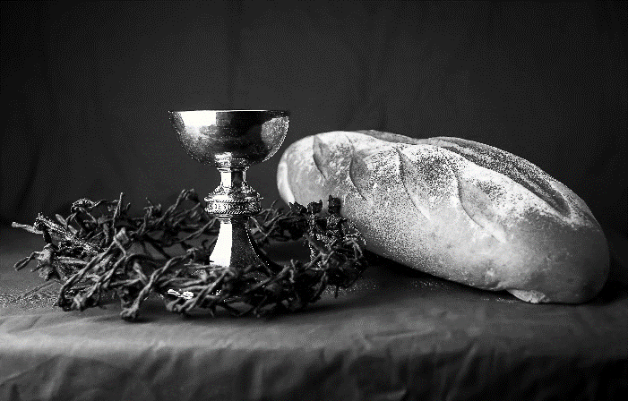
THE LORD’S PRAYER
Our Father, who art in heaven,
hallowed be thy name,
thy kingdom come,
thy will be done,
on earth as it is in heaven.
Give us this day our daily bread;
and forgive us our trespasses,
as we forgive those
who trespass against us;
and lead us not into temptation,
but deliver us from evil.
For thine is the kingdom,
and the power, and the glory,
forever and ever. Amen.
INVITATION TO COMMUNION - Certified gluten-free crackers are in the bowl on the communion plate.
Come and taste the joy of God!
HOLY COMMUNION
PRAYER AFTER COMMUNION
Holy One,
we thank you for the healing
that springs forth abundantly from this table.
Renew our strength to do justice,
love kindness,
and journey humbly with you.
Amen.
SENDING
BLESSING
The God who faithfully brings forth justice
and breaks the oppressor’s rod
☩ bless, strengthen, and uphold you,
today and always.
Amen.
SONG May the God of Hope Go With Us ACS 984
DISMISSAL
Go in peace. Follow the way of Jesus.
Thanks be to God.
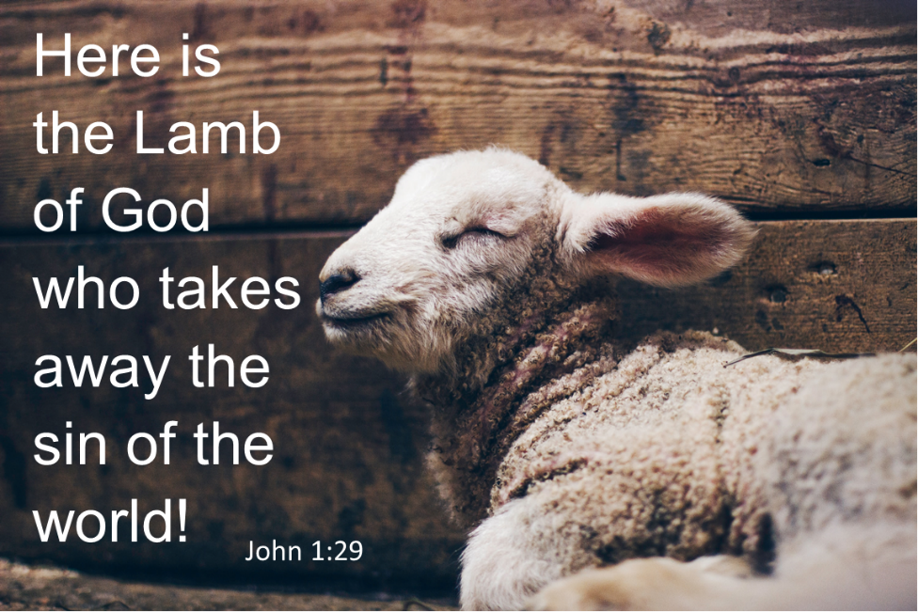

Coming up at GSLC
Sunday, January 15 | 9:00 am | Worship Service  - Second Sunday after Epiphany  - John 1:29-42; Revelation of Christ as the Lamb of God.  - NO Sunday School  - Budget Review (council members available)
Tuesday, January 17 | 9:30-10:30 am | Children’s of WI playgroup – all parents & children under 4 welcome
 | 2:00 pm | Chapel at Three Oaks
 | 7:00 pm | AA meeting in the fellowship hall
Wednesday, January 18 | 7:00 pm | - Midweek Worship Service
 | 7:30 pm | Confirmation Class for 7th & 8th grade
Thursday, January 19 | 9:00am-12:00pm | Host our Conference Pastor Meeting
Sunday, January 22 | 9:00 am | Worship Service  - Third Sunday after Epiphany  - Matthew 4:12-23; Revelation of Christ as a prophet.  - Sunday School  - Budget Review (council members available)
Upcoming Worship Assistants
 | Usher | Lector | Communion | Offering Counters
January 15 | Dennis & Deb Janz | Shelly Schneider | Tammy Neumann  Nancy Leonard | Heidi Binder | Kami Weis
January 22 | Tim & Monica Jewell | Linda Schrieber | Dan & Pam Mundt | Pam Mundt | May Hill
January 29 | Richard & Sarah Kopitzke | Nancy Tibbett | Bob & Laurel Peterson | Dan Mundt | Jon Hill
