Good Shepherd Lutheran Church
Pastor: Rev. Katie Anderson | Music Director: Rev. Lois Swanson
Pastor’s Cell: (715) 245-1943 | Office Phone: (715) 387-2731
Pastor Email: gslcwi.pastor@gmail.com | Office Email: gslcwi.office@gmail.com
Website: GoodShepherdMarshfield.org | www.facebook.com/gslcwi
First Sunday of Christmas
January 1, 2023, 9:00 am
No Sunday School
Introduction to the day…
As we celebrate the Twelve Days of Christmas, our gospel today confronts us with the death of innocent children at the hands of Herod. The birth of Christ does not remove the power of evil from our world, but its light gives us hope as we walk with all the “holy innocents” of past generations and today who have suffered unjustly. In our gathering around word and meal, God continues to redeem us, lift us up, and carry us as in days of old.
ANNOUNCEMENTS
GATHERING
GATHERING SONG It Came Upon the Midnight Clear ELW 282
CONFESSION AND FORGIVENESS
Blessed be the holy Trinity, ☩ one God,
the Word made flesh,
our life and our salvation.
Amen.
Trusting the goodness and lovingkindness of God our Savior,
let us confess our sin.
Silence is kept for reflection.
God of life,
you promise good news of great joy for all people,
and call us to be messengers of your peace.
We confess that too often we hoard our joy,
our resources, and our security.
We nurture conflict and build barriers.
We neglect the needs of our neighbors
and ignore the groaning of creation.
Have mercy on us.
Where we are self-centered, open our hearts.
Where we are reluctant, give us courage.
Where we are cynical, restore our trust.
Renew us with your grace
and give us again the hope of eternal life in you.
Amen.
Hear the good news:
We are children of God and heirs of God’s promises
through the outpouring of the Holy Spirit.
In ☩ Jesus we are forgiven and redeemed.
Sing with joy, for all the ends of the earth
shall know the salvation of God.
Amen.

KYRIE ELW 184
Kyrie eleison, on our world and on our way,
Kyrie eleison, ev’ry day.
For peace in the world, for the health of the church, for the unity of all;
for this holy house, for all who worship and praise,
let us pray to the Lord, let us pray to the Lord
Kyrie eleison, on our world and on our way,
Kyrie eleison, ev’ry day.
PRAYER OF THE DAY
O Lord God, you know that we cannot place our trust in our own powers. As you protected the infant Jesus, so defend us and all the needy from harm and adversity, through Jesus Christ, our Savior and Lord, who lives and reigns with you and the Holy Spirit, one God, now and forever.
Amen.
CHILDREN’S MESSAGE
SCRIPTURE READINGS
FIRST READING: Isaiah 63:7-9
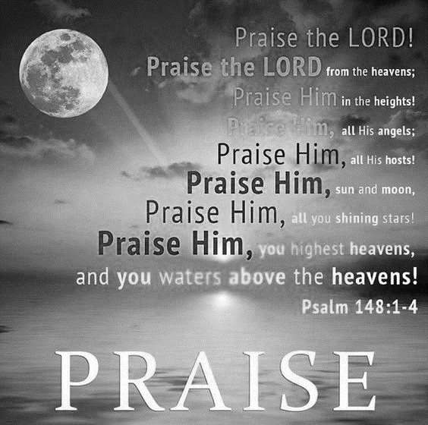
⁷I will recount the gracious deeds of the Lord,
the praiseworthy acts of the Lord,
because of all that the Lord has done for us,
and the great favor to the house of Israel
that he has shown them according to his mercy,
according to the abundance of his steadfast love.
⁸For he said, “Surely they are my people,
children who will not deal falsely”;
and he became their savior
⁹in all their distress.
It was no messenger or angel
but his presence that saved them;
in his love and in his pity he redeemed them;
he lifted them up and carried them all the days of old.
Word of God, word of life.
Thanks be to God.
PSALM: Psalm 148
¹Hallelujah! Praise the Lord from the heavens;
praise God in the heights.
²Praise the Lord, all you angels;
sing praise, all you hosts of heaven.
³Praise the Lord, sun and moon;
sing praise, all you shining stars.
⁴Praise the Lord, heaven of heavens,
and you waters above the heavens.
⁵Let them praise the name of the Lord,
who commanded, and they were created,
⁶who made them stand fast forever and ever,
giving them a law that shall not pass away.
⁷Praise the Lord from the earth,
you sea monsters and all deeps;
⁸fire and hail, snow and fog,
tempestuous wind, doing God’s will;
⁹mountains and all hills,
fruit trees and all cedars;
¹⁰wild beasts and all cattle,
creeping things and flying birds;
¹¹sovereigns of the earth and all peoples,
princes and all rulers of the world;
¹²young men and maidens,
old and young together.
¹³Let them praise the name of the Lord,
whose name only is exalted, whose splendor is over earth and heaven.
¹⁴The Lord has raised up strength for the people and praise for all faithful servants,
the children of Israel, a people who are near the Lord. Hallelujah!
SECOND READING: Hebrews 2:10-18
¹⁰It was fitting that God, for whom and through whom all things exist, in bringing many children to glory, should make the pioneer of their salvation perfect through sufferings. ¹¹For the one who sanctifies and those who are sanctified all have one Father. For this reason Jesus is not ashamed to call them brothers and sisters, ¹²saying,
“I will proclaim your name to my brothers and sisters,
in the midst of the congregation I will praise you.”
¹³And again,
“I will put my trust in him.”
And again,
“Here am I and the children whom God has given me.”
¹⁴Since, therefore, the children share flesh and blood, he himself likewise shared the same things, so that through death he might destroy the one who has the power of death, that is, the devil, ¹⁵and free those who all their lives were held in slavery by the fear of death. ¹⁶For it is clear that he did not come to help angels, but the descendants of Abraham. ¹⁷Therefore he had to become like his brothers and sisters in every respect, so that he might be a merciful and faithful high priest in the service of God, to make a sacrifice of atonement for the sins of the people. ¹⁸Because he himself was tested by what he suffered, he is able to help those who are being tested.
Word of God, word of life.
Thanks be to God.
GOSPEL ACCLAMATION ELW 188
Alleluia. Lord, to whom shall we go?
You have the words of eternal life. Alleluia.
Alleluia, alleluia. Alleluia.
Alleluia, alleluia.
GOSPEL: Matthew 2:13-23
¹³Now after [the wise men] had left, an angel of the Lord appeared to Joseph in a dream and said, “Get up, take the child and his mother, and flee to Egypt, and remain there until I tell you; for Herod is about to search for the child, to destroy him.” ¹⁴Then Joseph got up, took the child and his mother by night, and went to Egypt, ¹⁵and remained there until the death of Herod. This was to fulfill what had been spoken by the Lord through the prophet, “Out of Egypt I have called my son.”
¹⁶When Herod saw that he had been tricked by the wise men, he was infuriated, and he sent and killed all the children in and around Bethlehem who were two years old or under, according to the time that he had learned from the wise men. ¹⁷Then was fulfilled what had been spoken through the prophet Jeremiah:
¹⁸“A voice was heard in Ramah,
wailing and loud lamentation,
Rachel weeping for her children;
she refused to be consoled, because they are no more.”
¹⁹When Herod died, an angel of the Lord suddenly appeared in a dream to Joseph in Egypt and said, ²⁰“Get up, take the child and his mother, and go to the land of Israel, for those who were seeking the child’s life are dead.” ²¹Then Joseph got up, took the child and his mother, and went to the land of Israel. ²²But when he heard that Archelaus was ruling over Judea in place of his father Herod, he was afraid to go there. And after being warned in a dream, he went away to the district of Galilee. ²³There he made his home in a town called Nazareth, so that what had been spoken through the prophets might be fulfilled, “He will be called a Nazorean.”
The gospel of the Lord.
Praise to you, O Christ.
SERMON
HYMN OF THE DAY Gentle Joseph Heard a Warning ACS 1060
APOSTLES’ CREED
I believe in God, the Father almighty,
creator of heaven and earth.
I believe in Jesus Christ, God's only Son, our Lord,
who was conceived by the power of the Holy Spirit,
born of the Virgin Mary,
suffered under Pontius Pilate,
was crucified, died, and was buried;
he descended to the dead.
On the third day he rose again;
he ascended into heaven,
he is seated at the right hand of the Father,
and he will come to judge the living and the dead.
I believe in the Holy Spirit,
the holy catholic Church,
the communion of saints,
the forgiveness of sins,
the resurrection of the body,
and the life everlasting. Amen
PRAYERS OF INTERCESSION
…God of grace,
Do you or someone you know need an extra prayer said? There are PRAYER REQUEST CARDS
on the table in the narthex. Requests can be kept confidential, with Pastor, or can be made public to the congregation via Shepherd Staff email and in prayer at worship.
Hear our prayer.
Pondering the mystery of eternal love made flesh in Christ Jesus, we commend all for whom we pray to the mercy of God.
Amen.
PEACE
The peace of Christ be with you always.
And also with you.
HOLY COMMUNION
OFFERING In addition to our normal offering, a Special Benevolence in January (collected in a special envelope) will go to the Ronald McDonald House of Marshfield. RMHC of Marshfield keeps families with sick children close to each other and the care and resources they need.
OFFERING SONG What Child Is This ELW 296
OFFERTORY PRAYER
God of abundance,
receive and bless these gifts we have offered.
Join our hearts with the song of the angels,
and gather us at your table of celebration.
Strengthen us to share with all the world
the abundance of your grace upon grace,
poured out in Jesus Christ, the Word made flesh.
Amen.
GREAT THANKSGIVING
The Lord be with you.
And also with you.
Lift up your hearts.
We lift them to the Lord.
Let us give our thanks to the Lord our God.
It is right to give our thanks and praise.

HOLY, HOLY, HOLY (Sung) ELW 190
Holy, holy, holy Lord,
God of pow’r and might,
heaven and earth are full of your glory, full of your glory.
Hosanna, hosanna, hosanna in the highest.
Blessed is he who comes in the name of the Lord.
Hosanna, hosanna, hosanna in the highest.
THANKSGIVING AT THE TABLE

Holy One, the beginning and the end, the giver of life:
Blessed are you for the birth of creation.
Blessed are you in the darkness and in the light.
Blessed are you for your promise to your people.
Blessed are you in the prophets’ hopes and dreams.
Blessed are you for Mary’s openness to your will.
Blessed are you for your Son Jesus,
the Word made flesh.
In the night in which he was betrayed,
our Lord Jesus took bread, and gave thanks;
broke it, and gave it to his disciples, saying:
Take and eat; this is my body, given for you.
Do this for the remembrance of me.
Again, after supper, he took the cup, gave thanks,
and gave it for all to drink, saying:
This cup is the new covenant in my blood,
shed for you and for all people for the forgiveness of sin.
Do this for the remembrance of me.
Let us proclaim the mystery of faith:
Christ has died.
Christ is risen.
Christ will come again.
With this bread and cup
we remember your Word dwelling among us,
full of grace and truth.
We remember our new birth in his death and resurrection.
We look with hope for his coming.
Come, Lord Jesus.
Holy God, we long for your Spirit.
Come among us.
Bless this meal.
May your Word take flesh in us.
Awaken your people.
Fill us with your light.
Bring the gift of peace on earth.
Come, Holy Spirit.
All praise and glory are yours,
Holy One of Israel,
Word of God incarnate,
Power of the Most High,
one God, now and forever.
Amen.

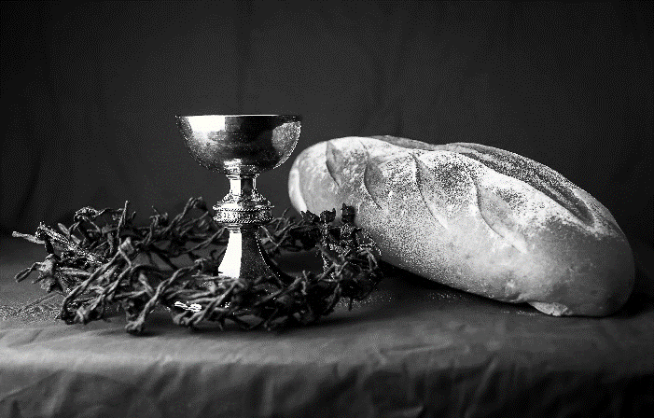
THE LORD’S PRAYER
Our Father, who art in heaven,
hallowed be thy name,
thy kingdom come,
thy will be done,
on earth as it is in heaven.
Give us this day our daily bread;
and forgive us our trespasses,
as we forgive those
who trespass against us;
and lead us not into temptation,
but deliver us from evil.
For thine is the kingdom,
and the power, and the glory,
forever and ever. Amen.
INVITATION TO COMMUNION - Certified gluten-free crackers are in the bowl on the communion plate.
Glory to God in the highest!
Come to the table of peace.
HOLY COMMUNION

PRAYER AFTER COMMUNION
God our redeemer,
you have fed us at this table
with gifts of grace, truth, and life.
As you have gathered us in joy,
send us forth as messengers of your peace.
Make us shine with the good news of your glory,
born to us in Jesus Christ, our Savior and Lord.
Amen.
SENDING
BLESSING
God bless you and keep you,
☩ Jesus grant you grace and truth,
and the Spirit send peace upon your hearts,
now and forever.
Amen.
SONG Good Christian Friends Rejoice ELW 288
DISMISSAL
Christ the Savior is born!
Go in peace. Proclaim this good news.
Thanks be to God.
Coming up at GSLC
Sunday, January 1 | 9:00 am | Worship Service  - First Sunday of Christmas  - Matthew 2:13-23; the slaughter of innocent children  - No Sunday School
Monday, January 2 |  | Church Office Closed
Tuesday, January 3 | 9:30-10:30 am | Children’s of WI playgroup – all parents & children under 4 welcome
 | 7:00 pm | AA meeting in the fellowship hall
Wednesday, January 4 | 7:00 pm | - Midweek Worship Service
 | 7:30 pm | Confirmation Class for 7th & 8th grade
Thursday, January 5 | 11:00am-2:00pm | Purple Angels Memory Cafe
Sunday, January 8 | 9:00 am | Worship Service  - Baptism of Our Lord/First Sunday after Epiphany  - Matthew 3:13-17; the revelation of Christ as God’s servant  - Sunday School
Upcoming Worship Assistants
 | Usher | Lector | Communion | Offering Counters
January 1 | Bob & Laurel Peterson | Leslie Mader | Volunteer | Nancy Leonard | Audra Strasser
January 8 | Christopher & Trina Ignatowski | Julie Will | Andrea Hovick  Sarah Kopitzke | Robin Beeman | David Schneider
January 15 | Dennis & Deb Janz | Shelly Schneider | Tammy Neumann  Nancy Leonard | Heidi Binder | Kami Weis
January 22 | Tim & Monica Jewell | Linda Schrieber | Dan & Pam Mundt | Pam Mundt | May Hill
January 29 | Richard & Sarah Kopitzke | Nancy Tibbett | Bob & Laurel Peterson | Dan Mundt | Jon Hill
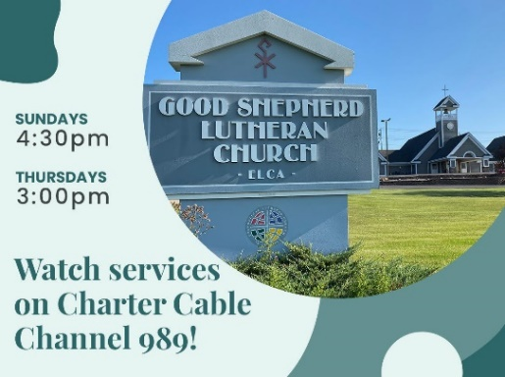
The Church Office will be closed on January 2.

